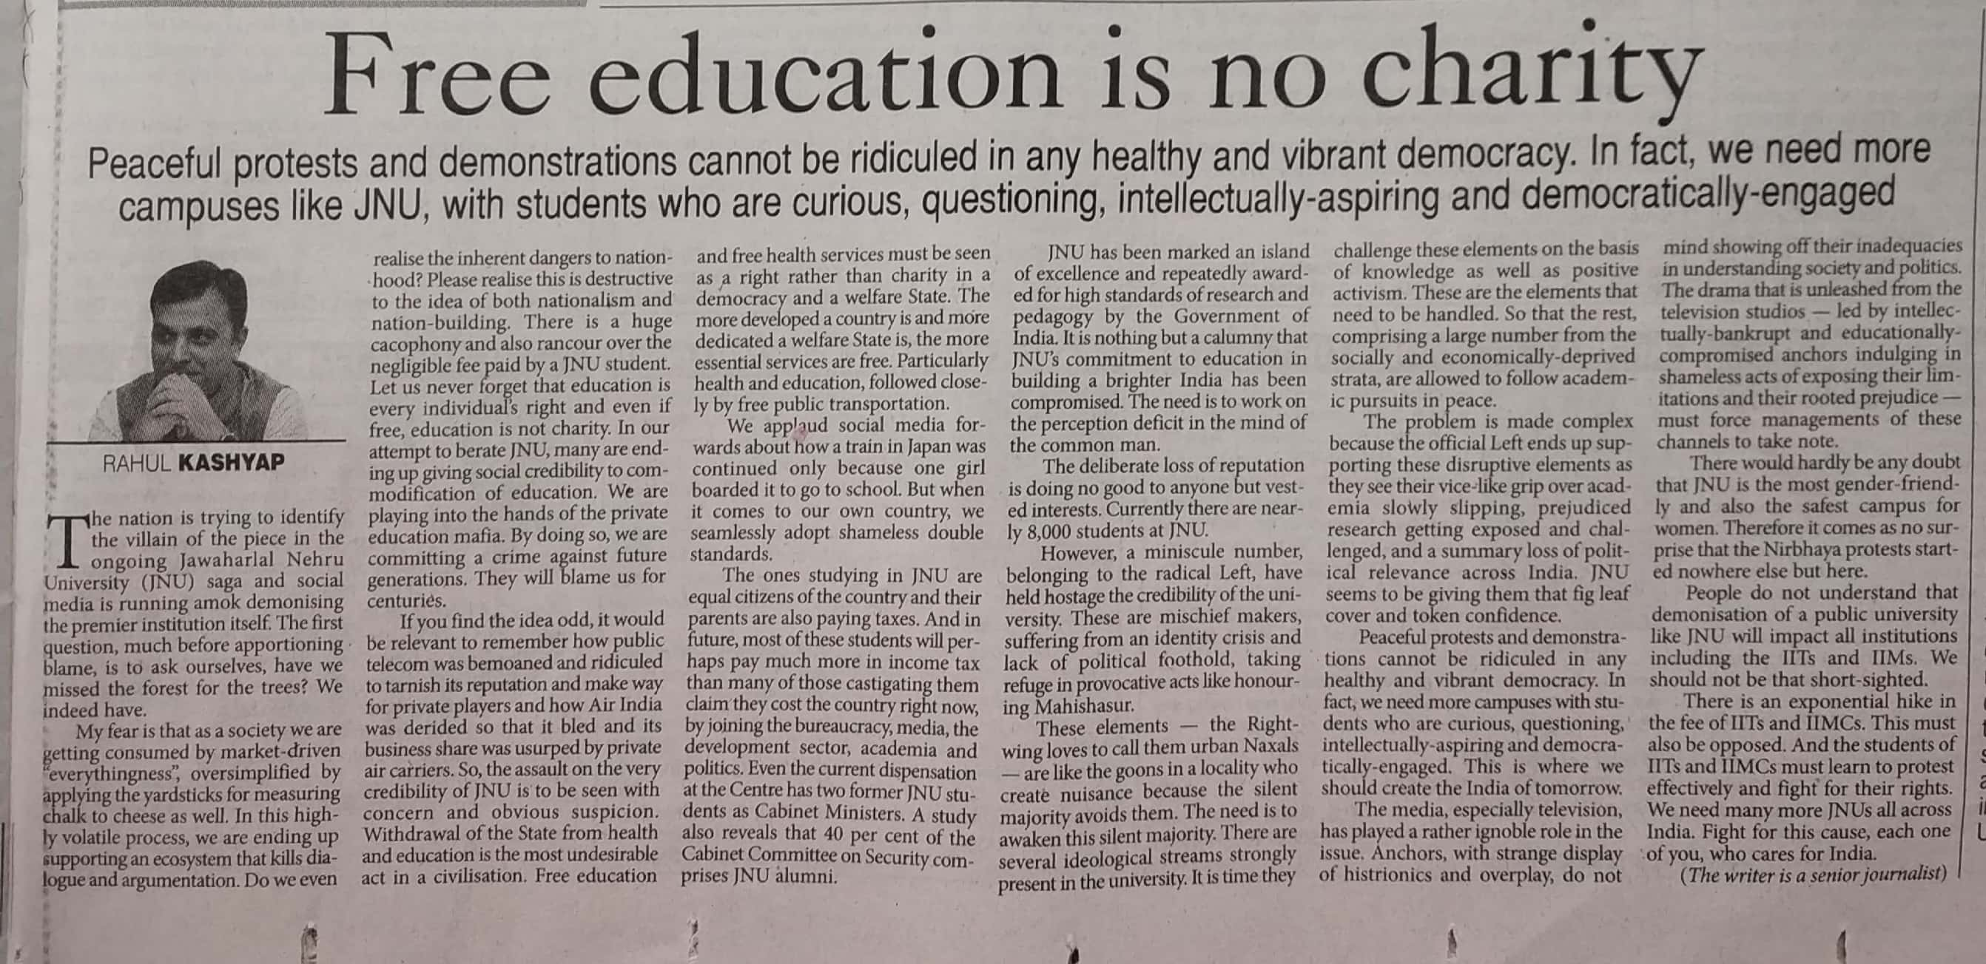

The Pioneer 14 Dec. 2019