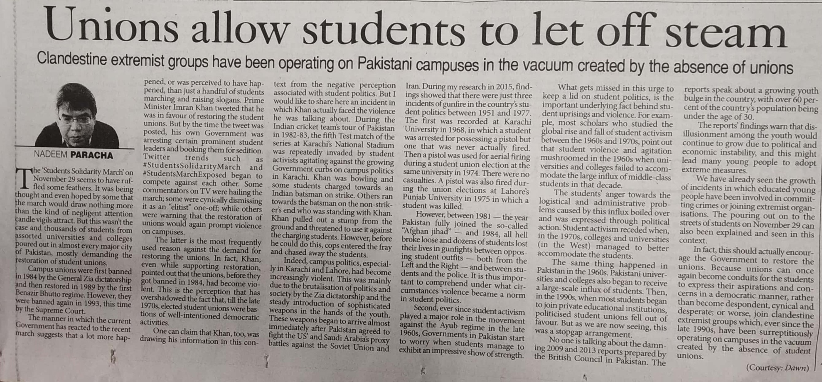

The Pioneer 17 Dec. 2019