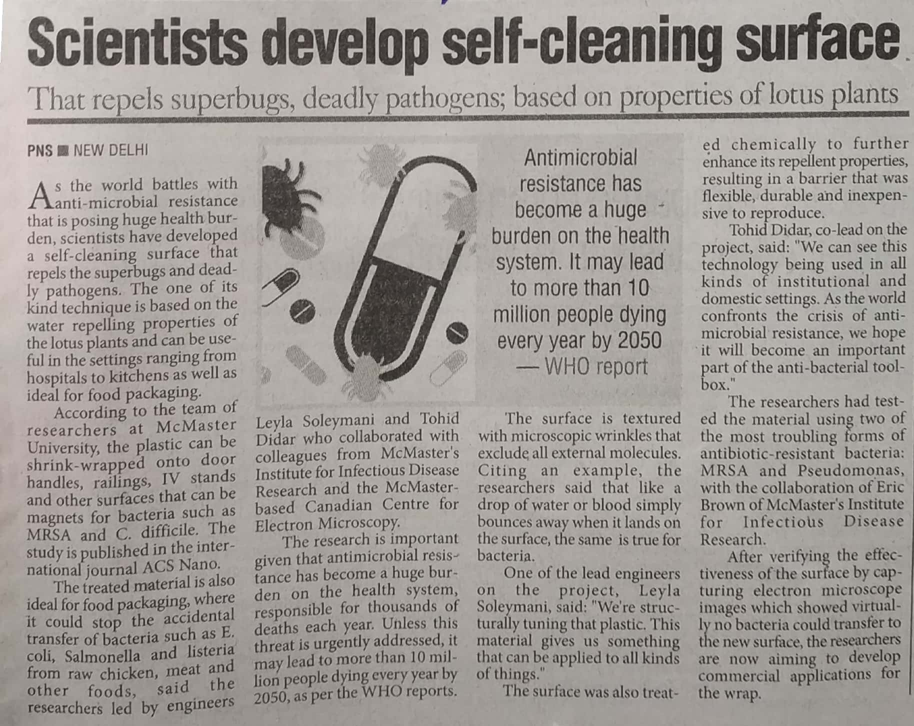

The Pioneer 19 Dec. 2019