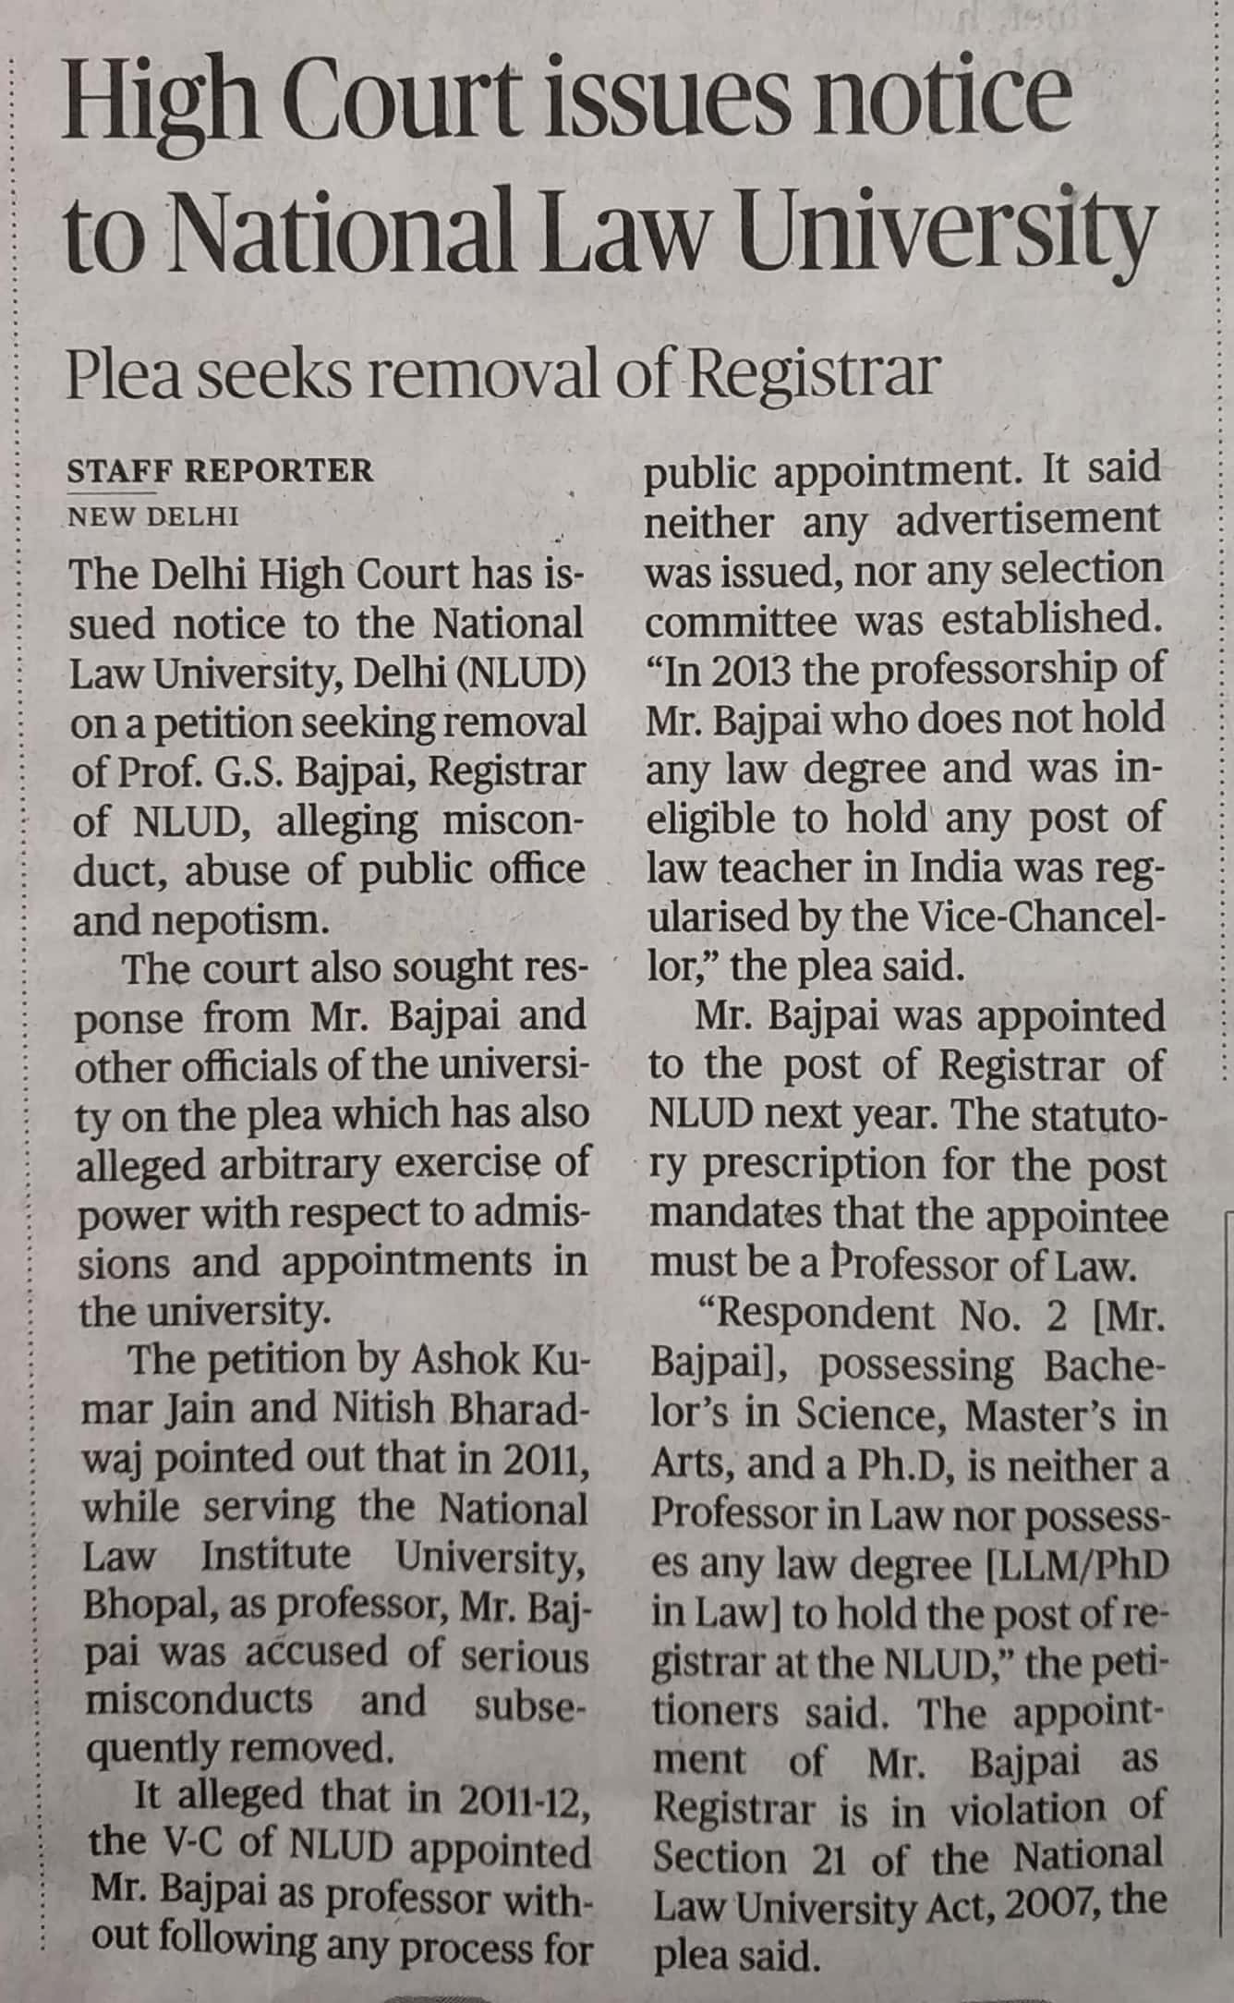

The Hindu 02 Dec. 2019