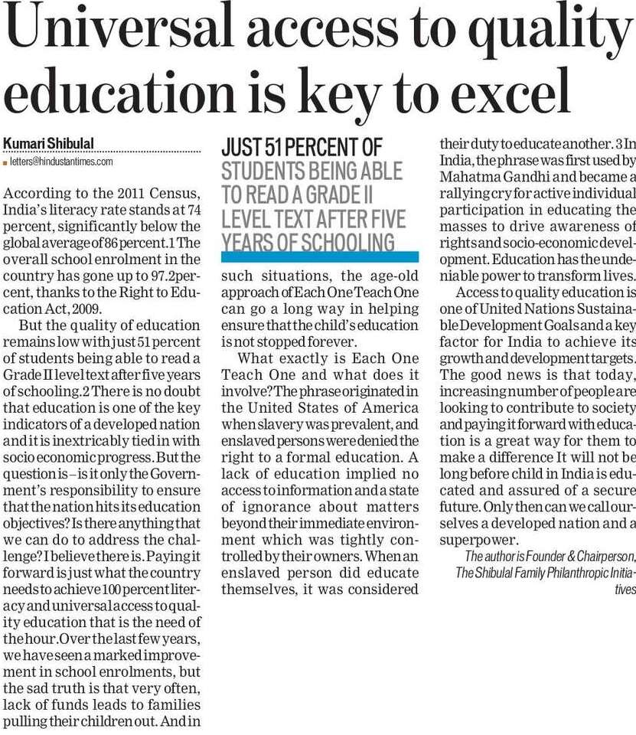

Hindustan Times 04 Dec. 2019