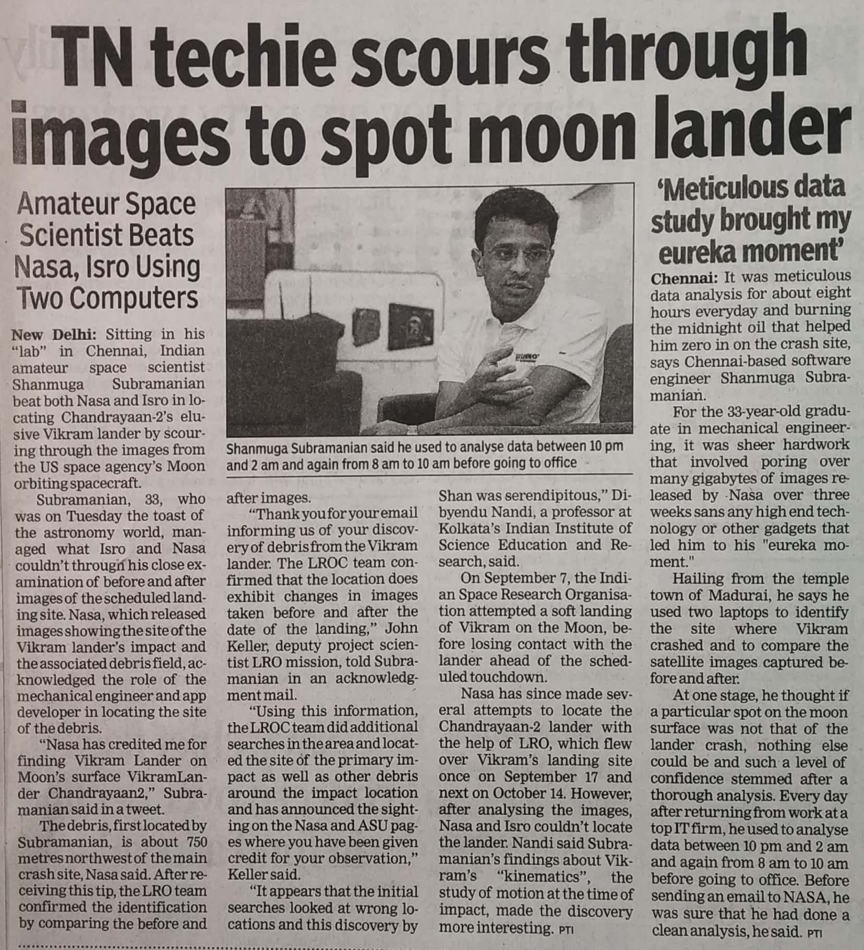

Times of India 04 Dec. 2019