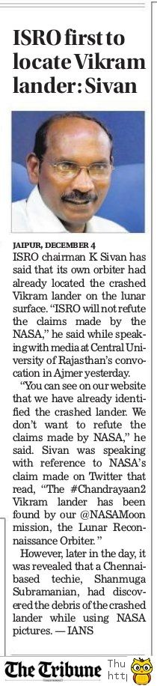

The Tribune 05 Dec. 2019