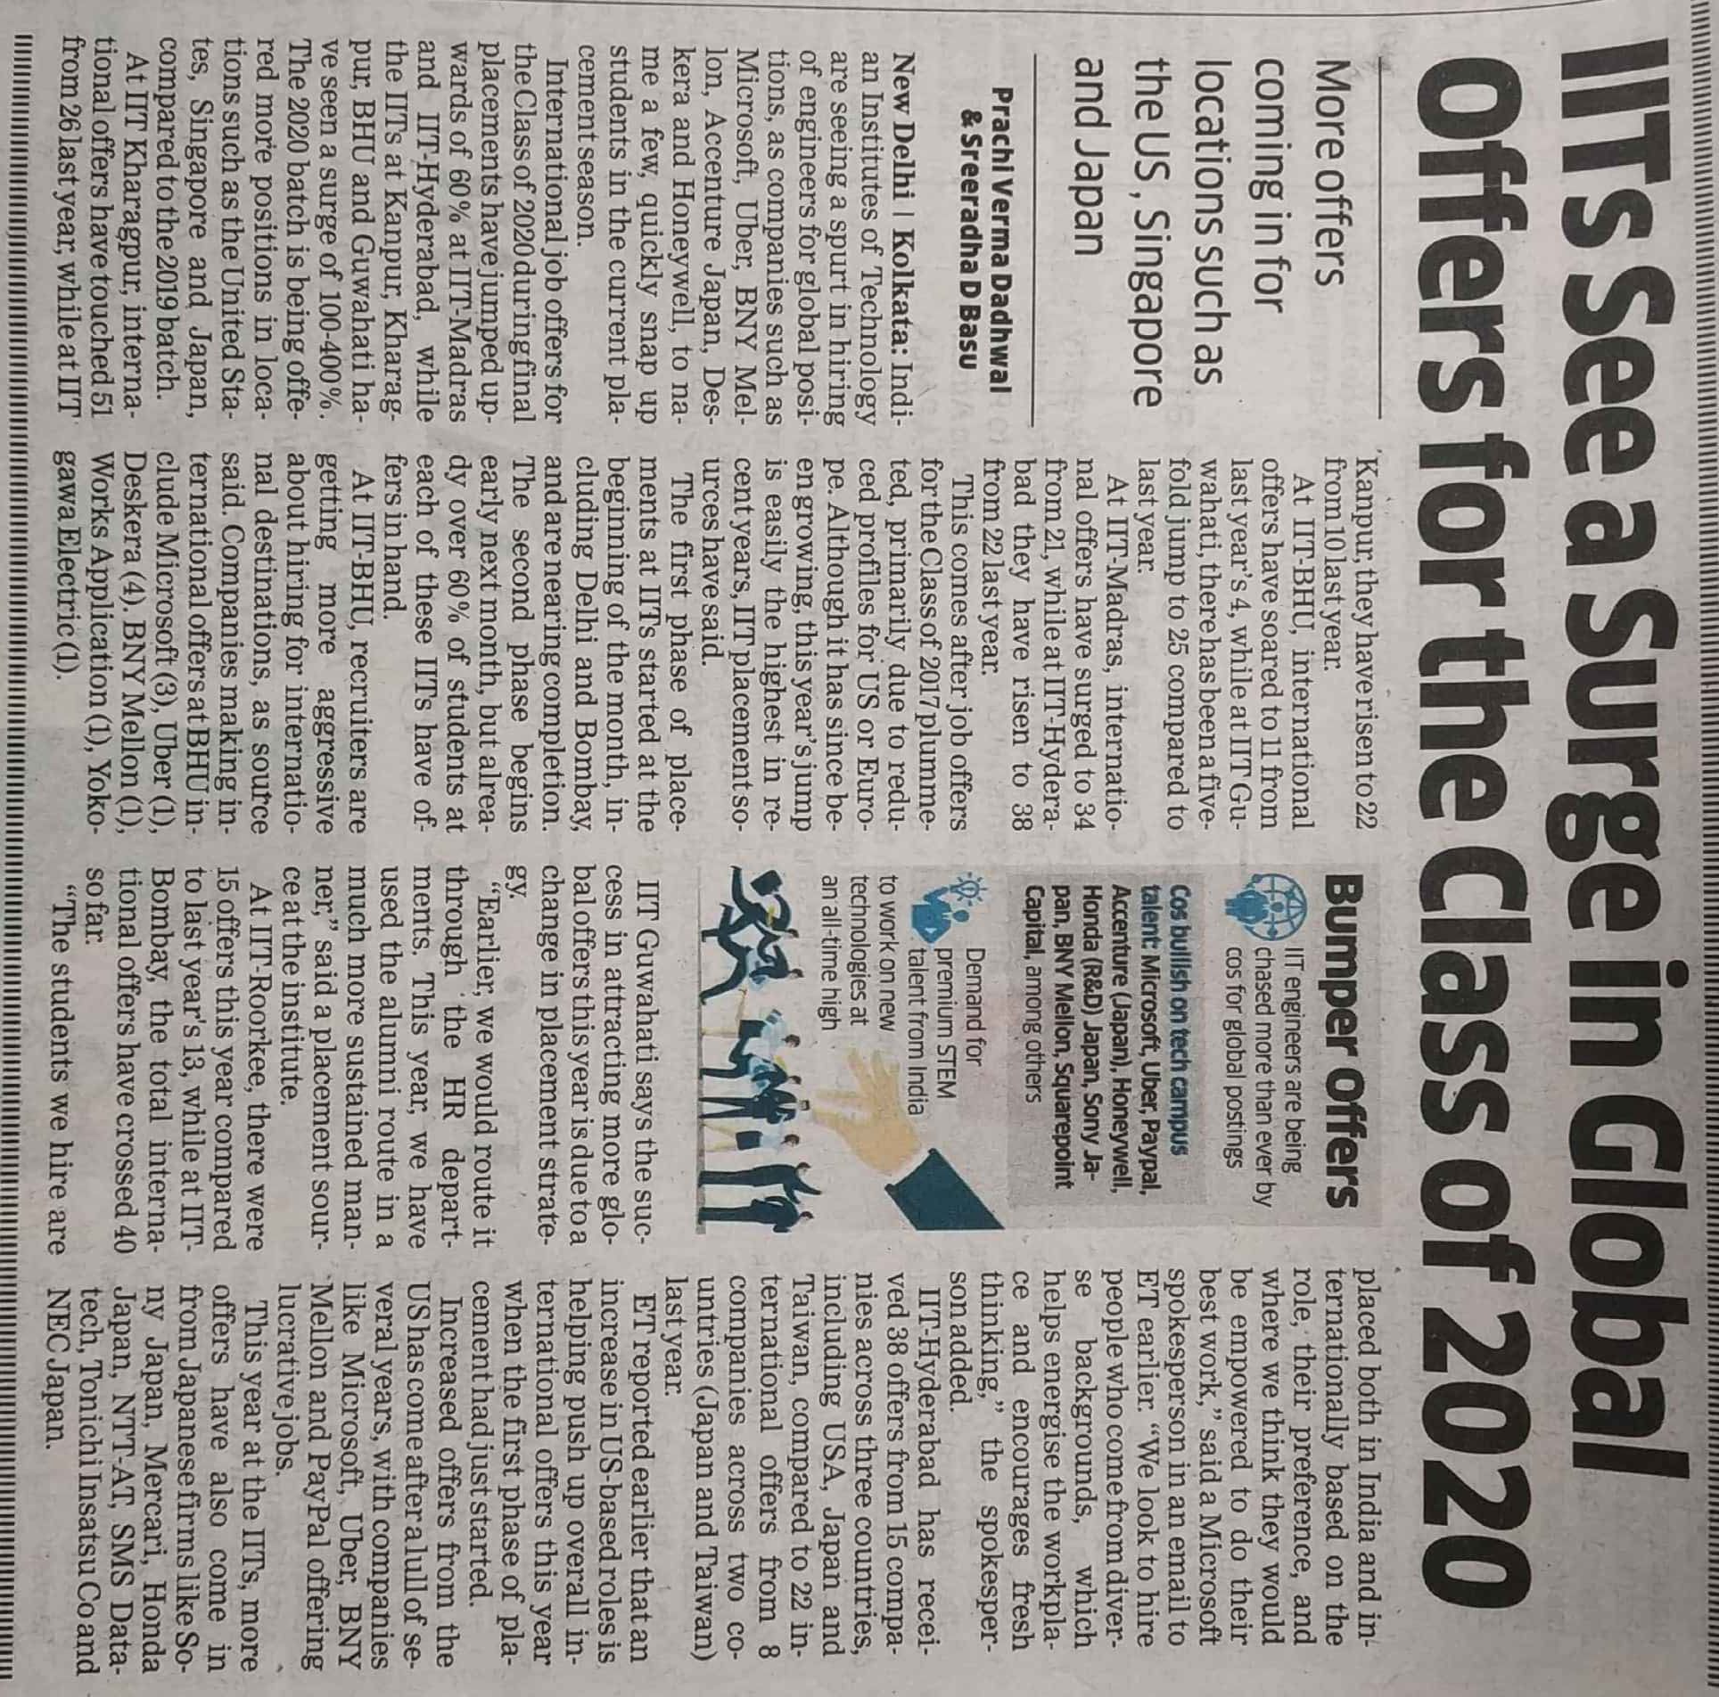

Economics Times 14 Dec. 2019