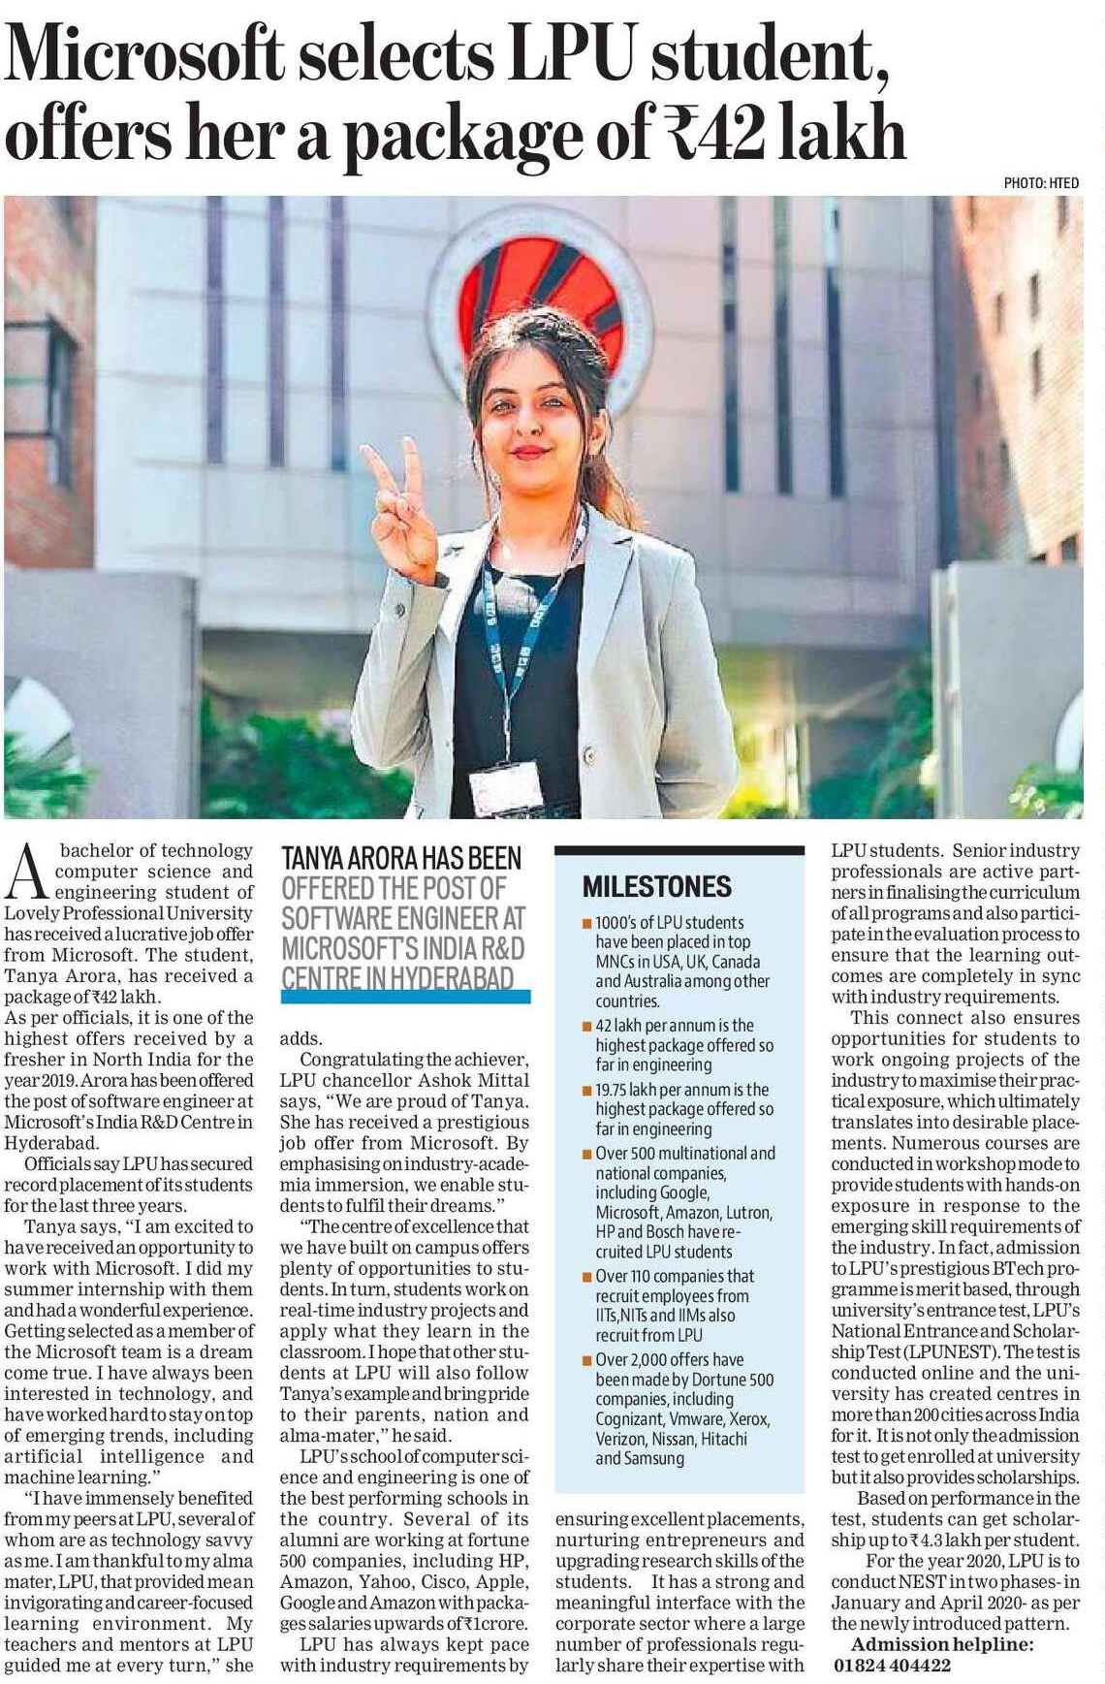

Hindustan Times 18 Dec. 2019