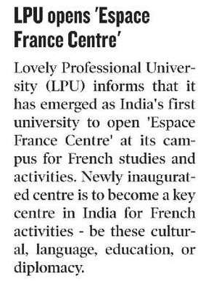

Hindustan Times 19 Dec. 2019