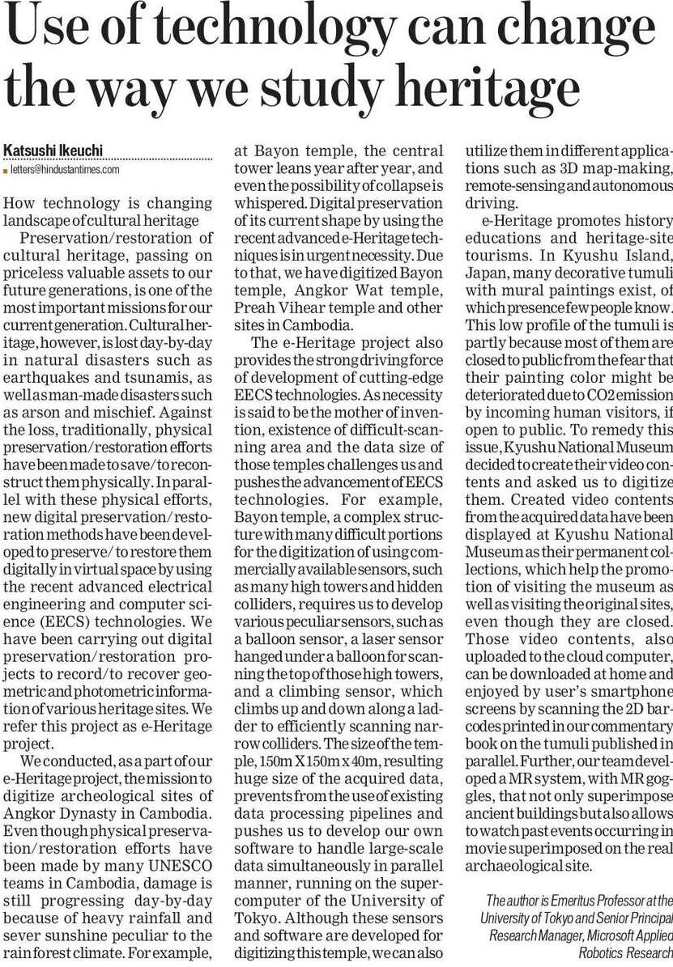

Hindustan Times 25 Dec. 2019