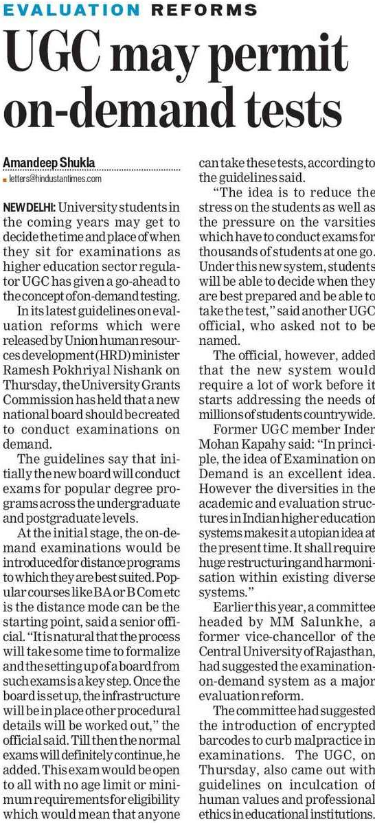

Hindustan Times 27 Dec. 2019