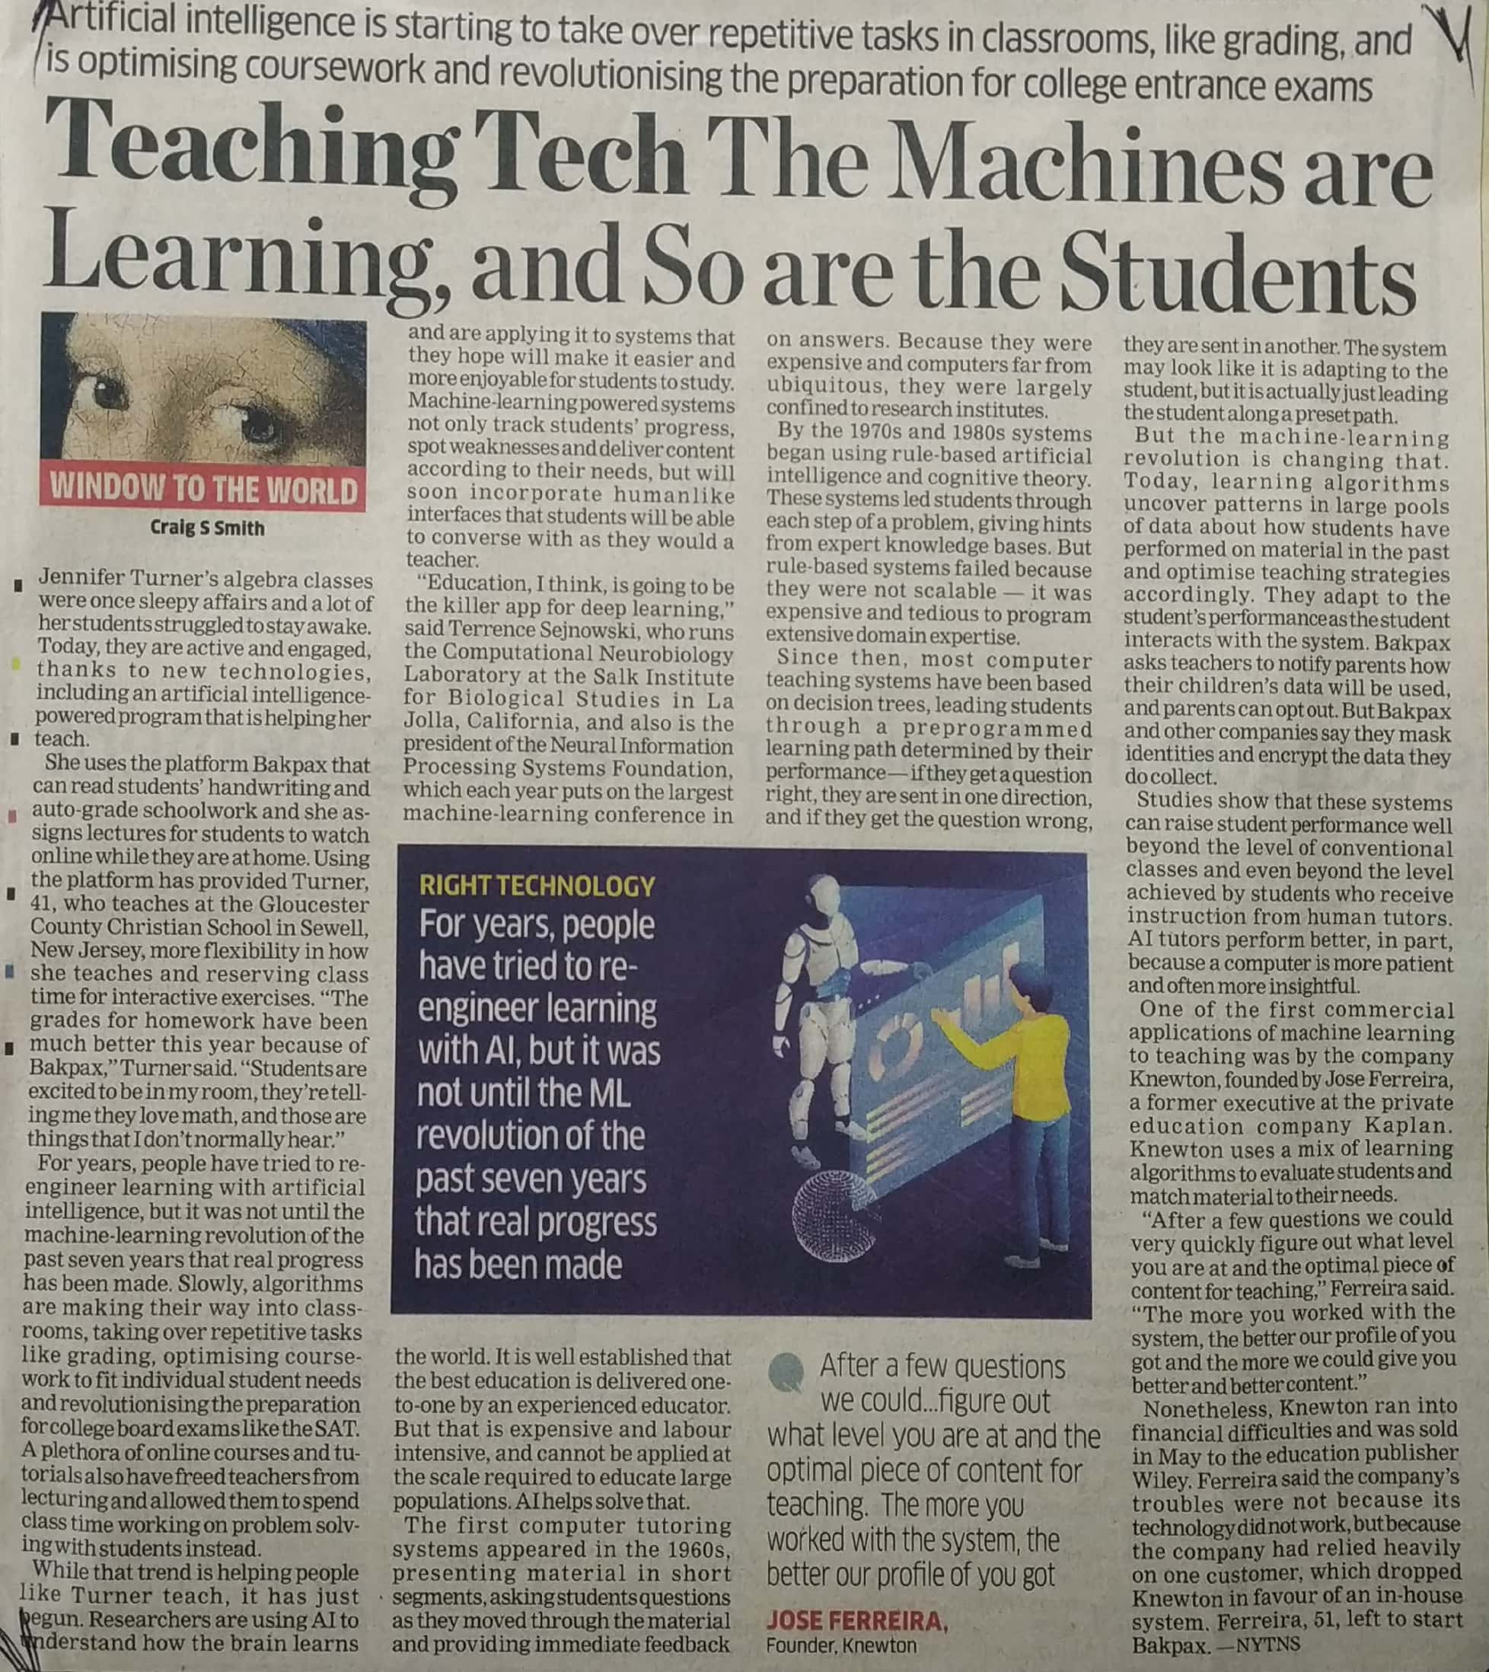

The Economics Times 21 Dec. 2019