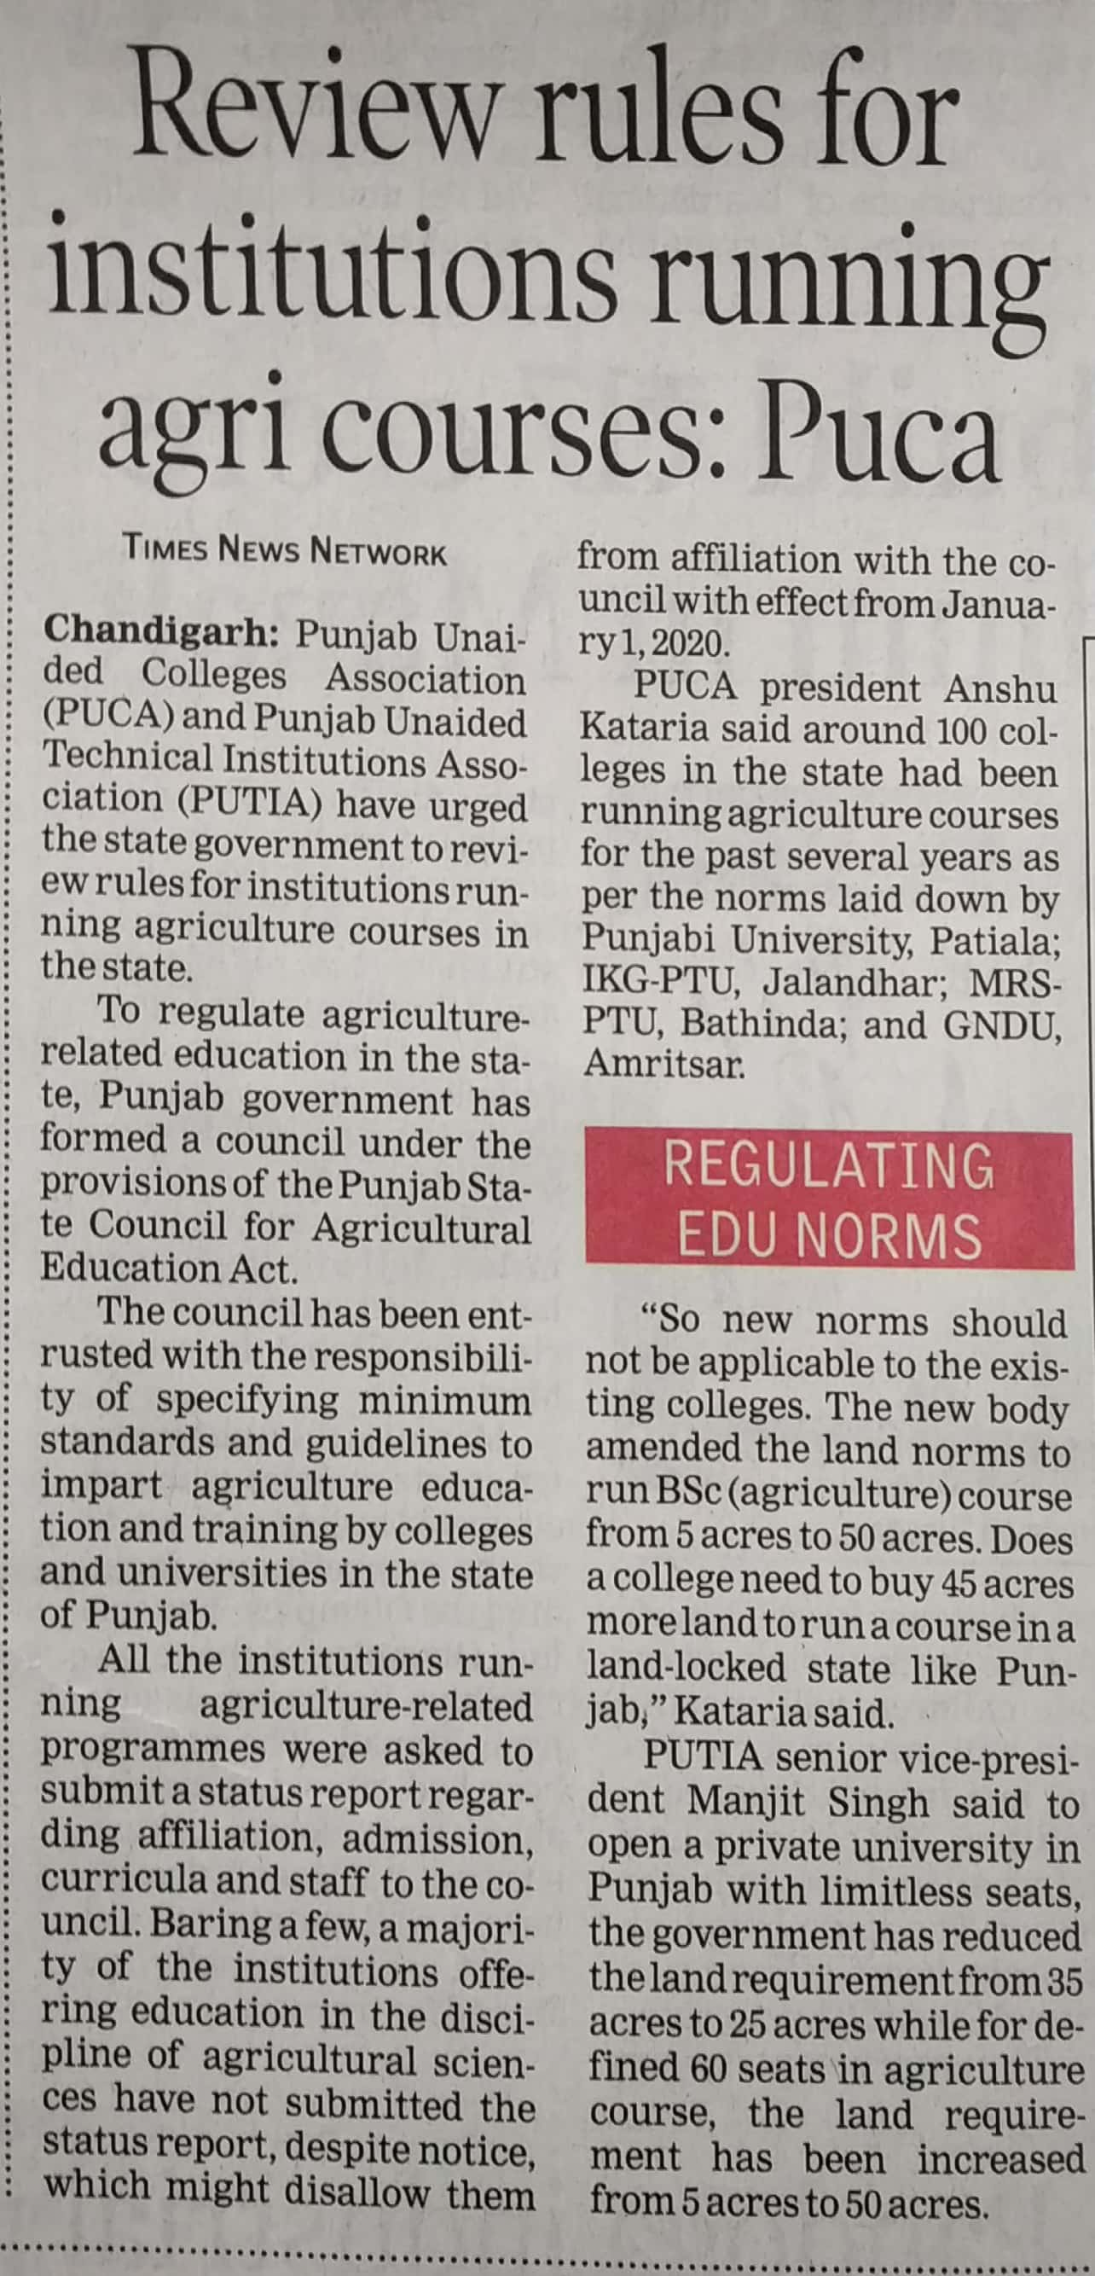

Times of India 25 Dec. 2019