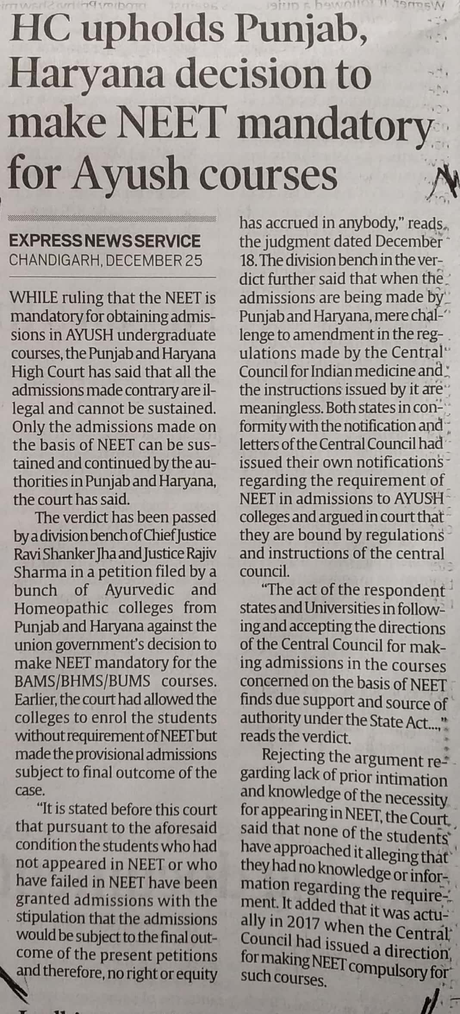

Indian Express 26 Dec. 2019