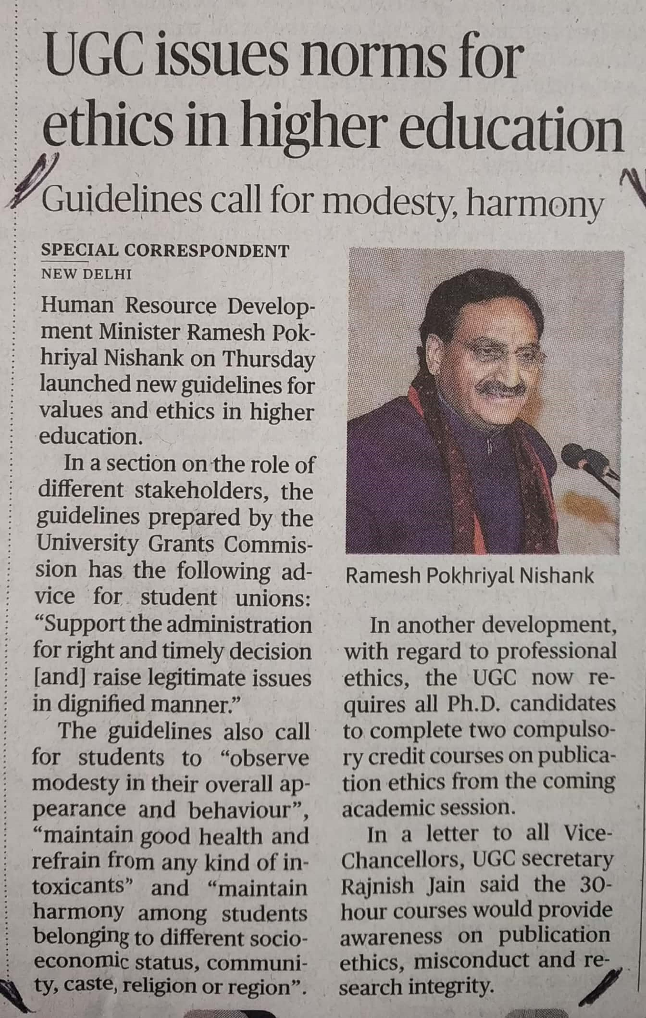

The Hindu 27 Dec. 2019