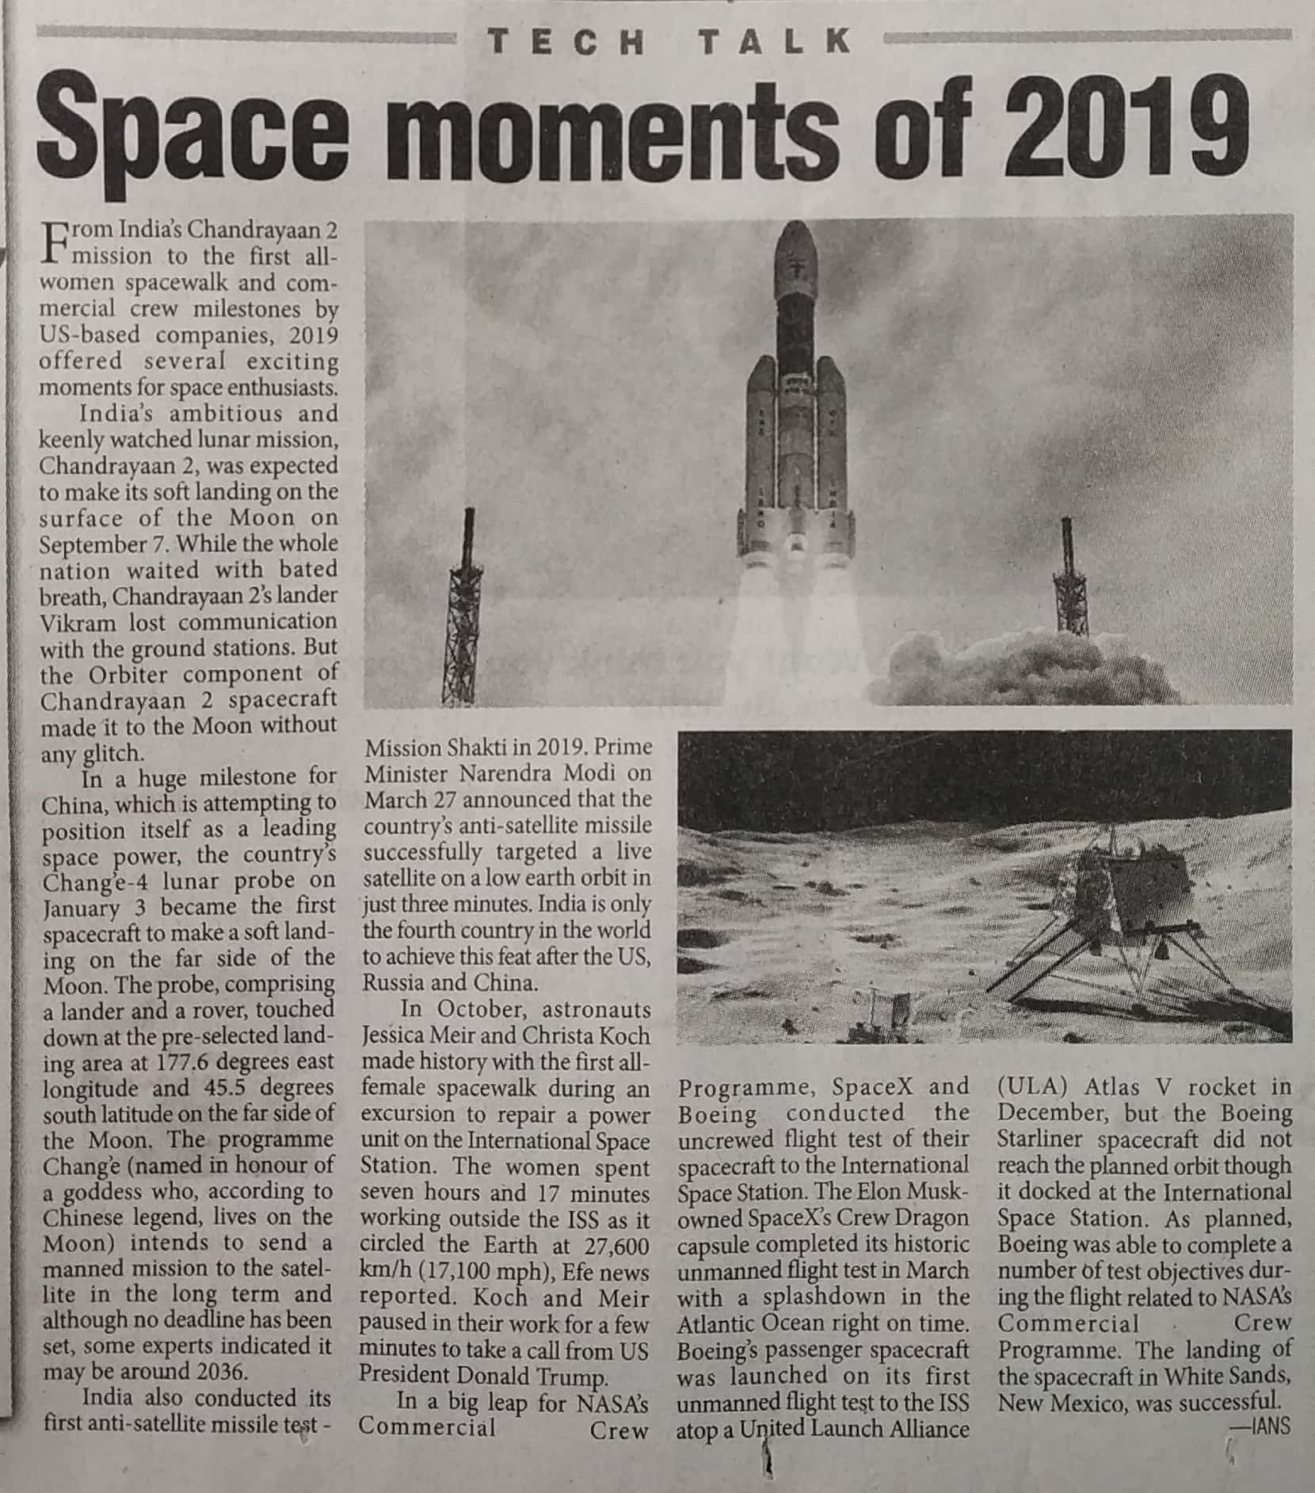

The Pioneer 30 Dec. 2019