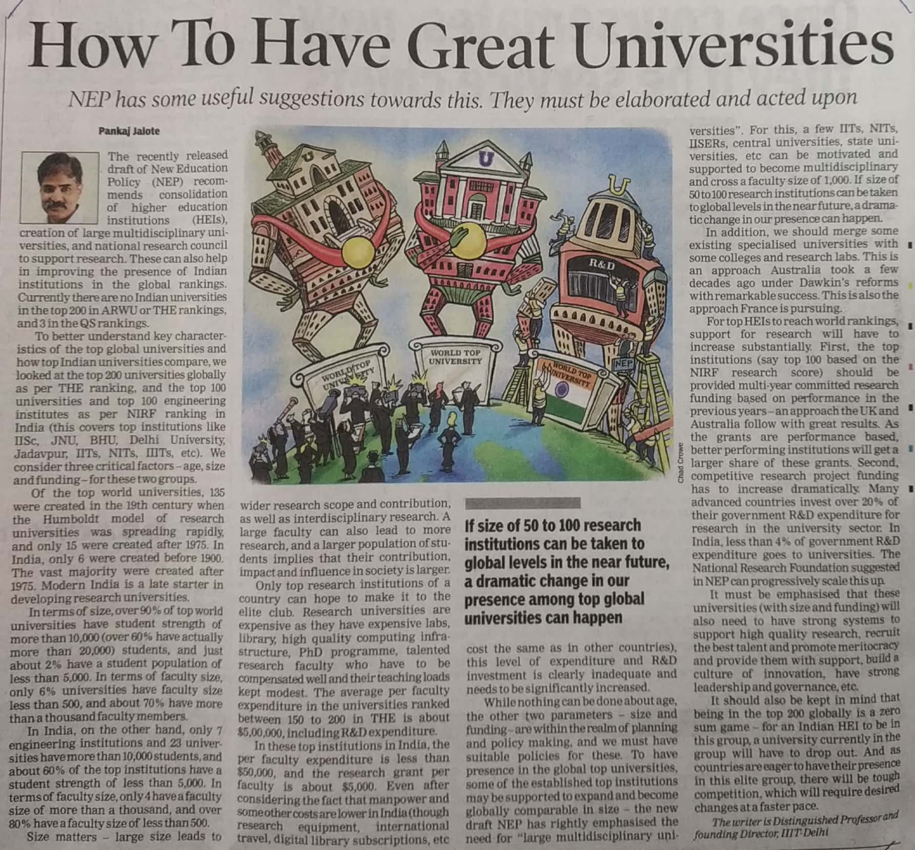

Times of India 19 Dec. 2019