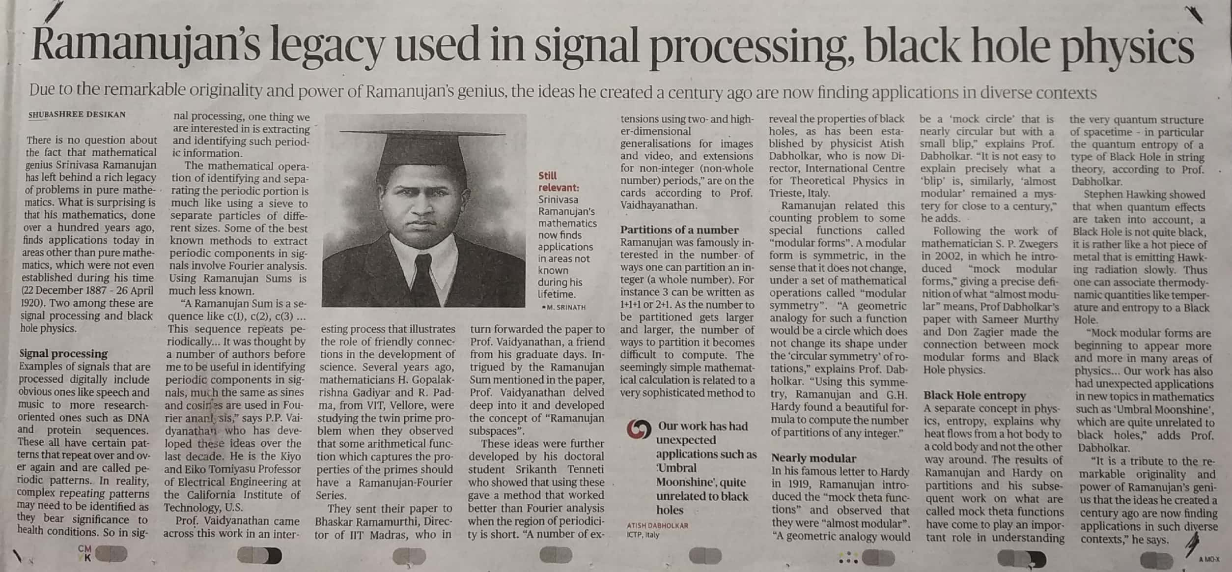

The Hindu 22 Dec. 2019