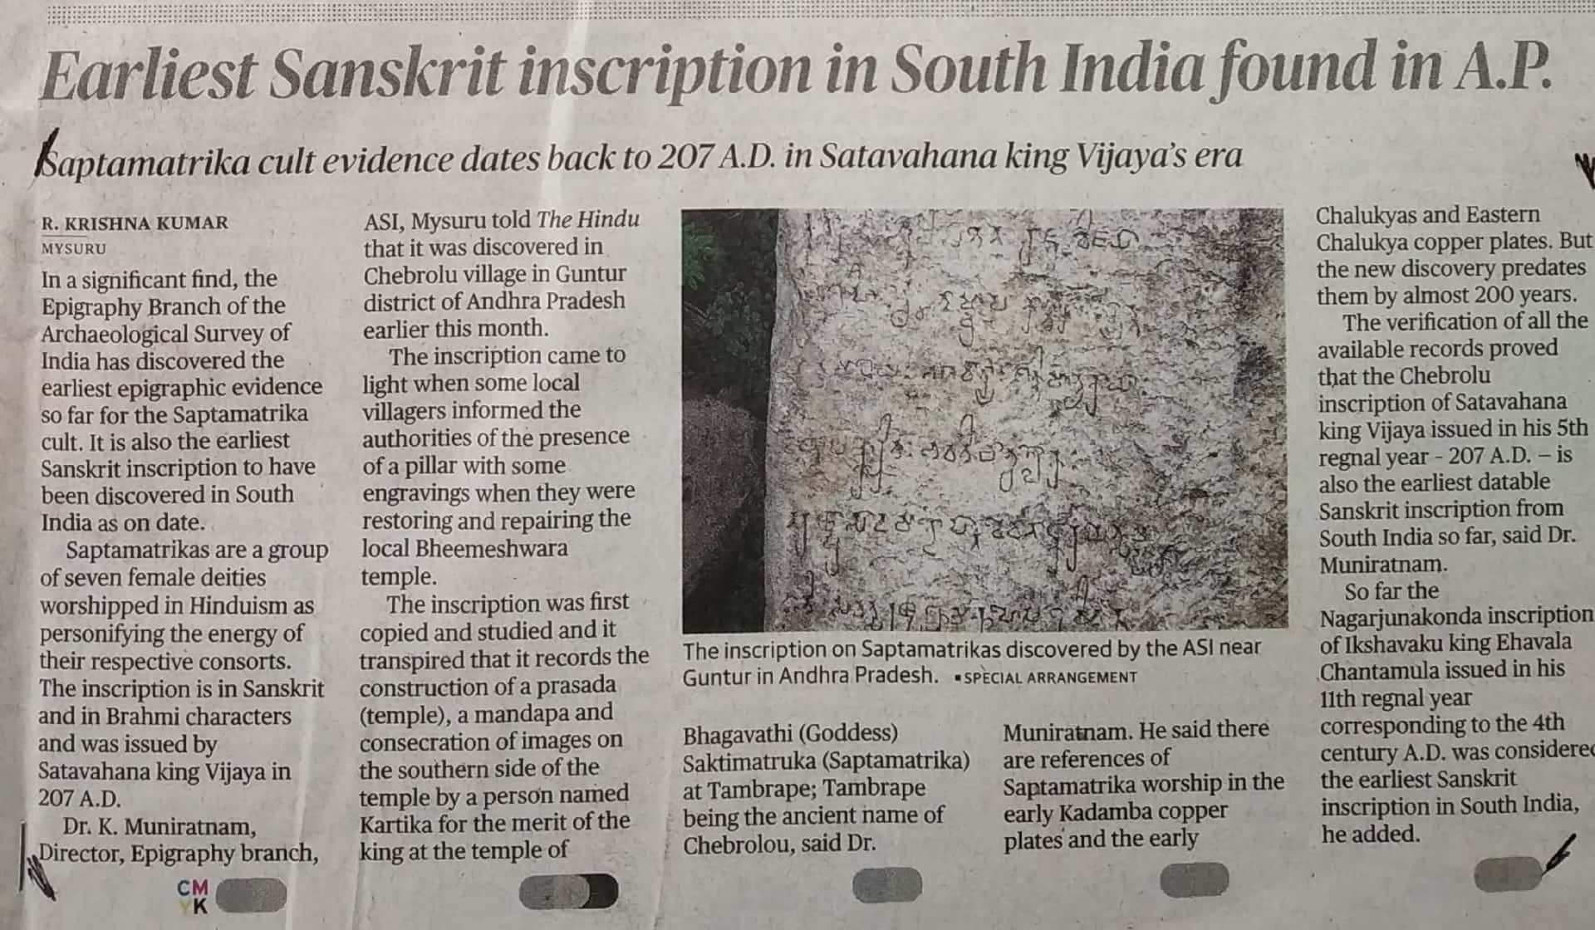

The Hindu 26 Dec. 2019