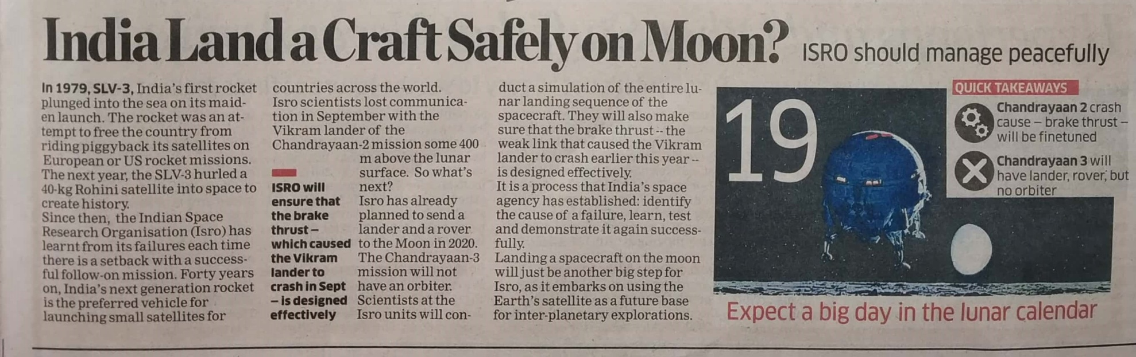

The Economics Times 30 Dec. 2019