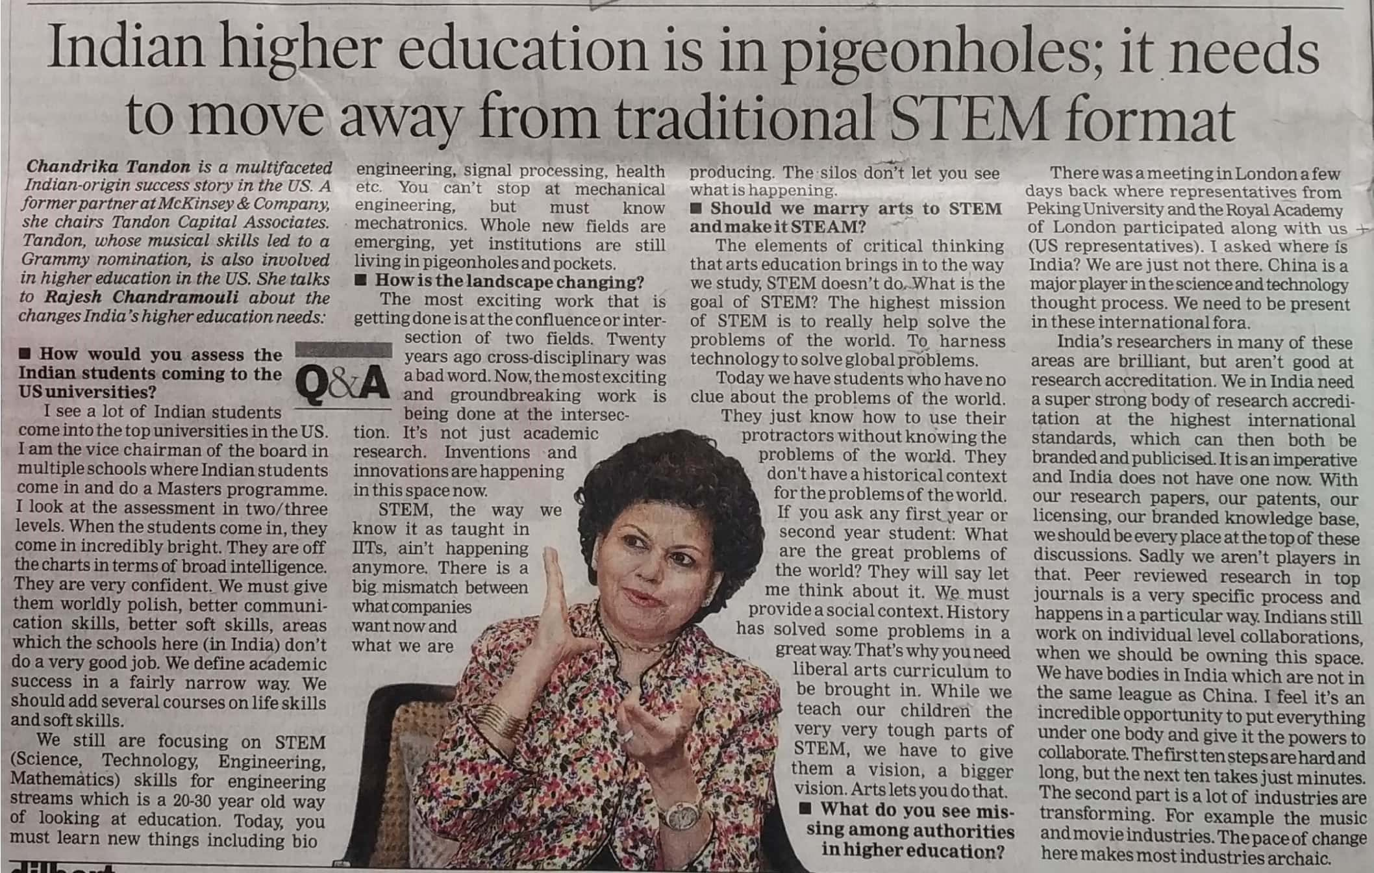

Times of India 30 Dec. 2019