EVALUATION OF DIFFERENT PADDY STRAW MANAGEMENT TECHNOLOGIES FOR THEIR ECOLOGICAL STABILITY AND ECONOMIC FEASIBILITY IN RICE-WHEAT SYSTEM
Thesis Submitted for the Award of the Degree of
DOCTOR OF PHILOSOPHY
in

AGRONOMY
By
Amrik Singh

Registration Number: 41700101

Supervised By | Co-Supervised by
Dr. Chandra Mohan Mehta (18376)  Professor  Department of Agronomy  School of Agriculture  Lovely Professional University, Phagwara | Dr. Vandna Chhabra (21027)  Associate Professor  Department of Agronomy  School of Agriculture  Lovely Professional University, Phagwara


LOVELY PROFESSIONAL UNIVERSITY, PUNJAB
2025
DECLARATION
I hereby declare that the dissertation entitled, “Evaluation of different paddy straw management technologies for ecological stability their economic feasibility in rice- wheat system” is an authentic record of my work carried out at Lovely Professional University as requirement of the degree of PhD in the discipline of Agronomy under the guidance Dr. Chandra Mohan and no part of this research work has been submitted for any other degree or diploma.

Student Name: Amrik Singh
Registration No. 41700101
Ph.D Agronomy

CERTIFICATE I
This is certify that the dissertation entitled, “Evaluation of different paddy straw management technologies for ecological stability their economic feasibility in rice- wheat system” submitted for the degree of Ph.D in the subject of Agronomy of the School of Agriculture, Lovely Professional University Punjab, is a bonafide research work carried out by Mr. Amrik Singh under my supervision and that no part of this Dissertation has been submitted for any other degree.
The Assistance and help received during the course of investigation have been fully acknowledged

Major Advisor Co-Advisor

CERTIFICATE -II
This is to certify that the work reported in the Ph. D. thesis entitled “Evaluation of different paddy straw management technologies for their ecological stability and economic feasibility in rice-wheat system” submitted by Mr. Amrik Singh (Registration No.- 41700101) to the Lovely Professional University, Phagwara submitted in fulfillment of the requirement for the award of degree of Doctor of Philosophy (Ph.D.) in the discipline of Agriculture (Agronomy) has been approved by the Advisory Committee after oral examination of the student in collaboration with an external examiner.

--------------------------------------- ------------------------------------
Dr. Chandra Mohan Mehta
Major Advisor External Examiner
Professor
Lovely Professional University, Phagwara
Punjab

---------------------------------------- -----------------------------------
Dr. Vandna Chhabra
Co-Advisor
Associate Professor
Lovely Professional University, Phagwara, Punjab
Dr. Sandeep Menon
Head of Department (Agronomy)
Lovely Professional University, Phagwara, Punjab

----------------------------------------
Dr. Ramesh Kumar Sadawarti
Dean, School of Agriculture

ABSTRACT

The study examines the economics of different paddy straw management methods in rice-wheat systems in Gurdaspur, Punjab during the Rabi seasons (2019-20 and 2020-21). The experiment was carried out with 2 wheat varieties, HD 3086 (V1) and PBW 550 (V2), using varied treatment combinations of crop residue management approaches, tillage and seed drilling methods. The texture of the experimental soil was sandy loam with pH 7.25, EC 0.13 mho/cm, O.C 0.47%, available N (410.5 kg ha⁻¹), P (23.17 kg/ha) and K (88.9 kg/ha). Based on the pooled data, the PAU (Punjab Agricultural University) cutter cum spreader + incorporation with Mould Board plough + Use of Seed drill (M4) treatment produced the highest plant height (95.87 cm). Treatment PAU cutter cum spreader + PAU happy seeder with press wheel (M2) (437.70 /m²) had the highest density of tillers per square meter, significantly outperforming other treatments. A significant interaction was observed between paddy residue management methods and varieties in terms of the number of tillers. Maximum spike length (12.13 cm) was obtained with Stubble Shaver + Burning + Zero Tillage Drill (M2), whereas maximum number of spikelets’ per spike (18.33) was noted in method (M2). The treatment method (M2) turned out to be the most efficient in terms of yield (50.50 q/ha) and benefit cost ratio (1.54).
Key Words: Dates of sowing, Grain yield, Nitrogen, Residue, Paddy, Wheat

ACKNOWLEDGEMENT
“Journey of thousand miles starts with one step” became the guiding force for me. It was only his blessing and grace that I have been able to make another achievement in my life. I bow my head to merciful and compassionate “Almighty God” for eternal love and blessings.
Indeed the words are inadequate, to convey the depth of my feelings of gratitude to my Major advisor, Dr Chander Mohan, Associate Dean, School of Agriculture, Lovely Professional University Phagwara (Punjab) and Dr Vandna Chhabra, Associate Professor (Agronomy), Lovely Professional University Phagwara (Punjab) without whose kind inspiration, keen interest and sustained encouragement, this dissertation could not have been started, much less finished. Their valuable guidance, constructive criticism, meticulous attention to details, untiring and ever willing help during the entire period of the study have been of immense help to me in planning and execution of the study.
A special thanks to my family members. Words cannot express how grateful I am to my wife, Sisters, Brothers for all the sacrifices that they’ve made on my behalf. Their prayer for me was what sustained me thus far. My most cordial thanks goes to my wife Narinder Kaur and gracious Son (Amrinder Singh and Harmanjot Singh) for their sacrifice, inspiration and constant encouragement. They were true and great supporters during my good and bad times. I would also like to thank to my official colleagues (Mrs Mandeep Kaur ADO, Mr Gurdit Singh AEO, Mr Subhash Chander AEO, Mr Sudesh Kumar ASI, Mr Anshuman ASI, MrNirpjit ASI, Miss Manjit Kaur ASI, Mrs Sakshi and other Field workers for supporting me during study.
Dr Sukhdev Singh, Agriculture Commissioner (Govt of India), Dr Balwinder Singh Sidhu Agriculture Commissioner Punjab, deserve deep appreciation for their incessant love, support and encouragement which brought the present task to completion.
I am thankful to the esteemed Dr. Ramesh Kumar (HOS, School of Agriculture) for his proper guidance and encouragement during the entire course of present studies.
I would also like to give special thanks to Dr. G.S. Khalsa Director, Department of Agriculture and Farmers Welfare Punjab for great help offered to me. I would also like to give great thanks to Mr Kuldip Singh of Magrala and Palwinder Singh of Sahari Villages for providing their field and labour to organize trials for study.
I appreciate with thanks the help rendered to me during the period of my study by all those whose names could not be mentioned specially.
Finally, I expressed my sincere faith in Waheguru, who made all the circumstances favorable and peaceful for me. I owe it all too Almighty God for granting me the wisdom, health and strength to undertake this research task and enabling me to its completion.

Place: Gurdaspur
Date:
Amrik Singh

TABLE OF CONTENTS
Chapter No. | PARTICULARS | Page No.
1.0 | Introduction | 1-5
1.1 | Availability of crop residues | 2
1.2 | Crop residues as source of plant nutrients | 2-3
1.3 | Management options for crop residues | 3-4
1.4 | Objectives of proposed work | 5
2.0 | Review of literature | 6-17
2.1 | Economically viable technology for paddy straw management | 6-8
2.2 | Impact of different PSM technologies on soil health | 8-9
2.3 | Effect on soil health | 9-14
2.4 | Impact of different PSM technologies on quality of grain and yield attribute of rice-wheat produce | 14-17
3.0 | Material and methodology | 18-32
3.1 | Weather situation during experiment | 19-20
3.2 | Design and layout | 20
3.3 | Treatments details | 21
3.4 | Treatment combinations | 21-22
3.5 | Layout of experimental plot | 22
3.6 | Experimental details of field experiment | 23-31
3.6.1 | Stubble shaver + Burning + Zero tillage drill (M1) | 23
3.6.2 | PAU cutter cum spreader + PAU happy seeder with press wheel (M2) | 24
3.6.3 | PAU cutter cum spreader + use of waste decomposer + PAU happy seeder with press wheel (M3) | 24
3.6.4 | Preparation of decomposer solution. | 24-25
3.6.5 | PAU cutter cum spreader+ incorporation with mouldboard plough+ use of seed drill (M4) | 25
3.6.6 | Super straw management system+ chopper+ incorporation +Use of seed drill (M5) | 25-26
3.6.7 | Straw removal (manual) +Zero tillage drill (M6) | 26-27
3.6.8 | Straw removal (manual) + thorough tillage + use of conventional seed drill (M7) | 27
3.7 | Growth and yield contributing parameters | 27-28
3.7.1 | Tillers m⁻² | 28
3.7.2 | Length of spikes (cm) | 28-29
3.7.3 | Number of grains per spikes | 29
3.7.4 | Test weight (g) | 29
3.7.5 | Grain yield (q ha⁻¹) | 29
3.7.6 | Biological yield (q ha⁻¹) | 29
3.7.7 | Harvest index (%) | 29-30
3.8 | Soil properties and soil sampling | 31-33
3.8.1 | Physical Property: Soil Texture | 31
3.8.2 | Soil chemical properties | 31
3.9 | Economics | 32
3.9.1 | Cultivation cost (Rs ha⁻¹) | 32
3.9.2 | Gross return (Rs ha⁻¹) | 32
3.9.3 | Net returns (Rs ha⁻¹) | 32
3.9.4 | B:C ratio | 32
3.9.5 | Statistical analysis | 32
4.0 | Chapter IV: Results and discussion | 33-66
4.1 | Growth parameters | 34-.37
4.1.1 | Plant height (cm) | 34-35
4.1.2 | Number of tillers/m² | 36-37
4.2 | Yield and yield attributes | 37-50
4.2.1 | Spike length(cm) | 37-39
4.2.2 | Number of spikelets per spike | 39-41
4.2.3 | Number of grains per spike | 41-43
4.2.4 | Test weight (g) | 43-45
4.2.5 | Grain yield (q ha⁻¹) | 45-47
4.2.6 | Biological yield (q ha⁻¹) | 47-49
4.3 | Economics: Cost benefit ratio | 49-51
4.4 | Impact of paddy straw management (PSM) techniques on soil chemical properties | 51-66
4.4.1 | Soil pH and EC | 51-52
4.4.2 | Organic carbon | 52-53
4.4.3 | Soil nutrients | 53-62
4.5 | Dehydrogenize activity in wheat soil as influenced by paddy straw management techniques | 62-63
4.6 | Effects of paddy straw management techniques on Bulk density of soil | 64-65
4.7 | Effects of paddy straw management techniques on infiltration rate of soil | 65-66
5.0 | Summary and Conclusion | 67-68
6.0 | References | 79-86

CHAPTER-I
INTRODUCTION
The development of the rice - wheat cropping system (RWCS) in India involved the inception of rice into traditional wheat-growing regions. With the advent of green revolution rice-wheat production system, expanded to cover a vast 29 lakh hectares in Punjab, often referred as the 'Food Basket of the Country'. However, over the past four decades, several challenges have emerged in the region, posing a risk to the sustainability of system. Insufficient soil organic matter, excessive soil depletion through mining, and the burning of crop residues are significant contributors to the decreasing productivity of rice-wheat. According to a study by Hira et al., (2004), Punjab's groundwater level is decreasing by 0.6 meters annually. In addition to the water shortage, agricultural practices including the excessive and unbalanced use of fertilizers and pesticides have reduced soil fertility and lowered the quality of the groundwater. Also contributing to global warming is residue burning, which caused pollution and reduces soil fertility. One such technique that may address difficulties with labour, water, soil health, etc. is direct seeding with zero-till drill technology (Jat et al., 2013; Malik et al., 2005; Jat et al., 2009; Gupta and Sayre, 2007; Gathala et al., 2011). The ‘Happy Seeder’ is also capable of direct drilling in fields while surface retention of residue is well maintained. The crop residue lying on the surface of soil lowers losses by evaporation process, upholds soil moisture and temperature of the soil (Jat et al., 2009). It also aids in mitigating the impacts of terminal heat (Gupta et al., 2007).
The farmers turn to burning rice straw since there isn't enough time between paddy harvest and wheat planting. It is just two to three weeks to do labor-intensive tasks like cleaning residues/straw of paddy out of the fields. Due to sufficient availability of wheat straw, dry fodder need of cattle is mostly fulfilled. Small and marginal farmers cannot bear the heavy costs of cutting, processing, collecting and transporting paddy residue. Moreover, more percentage of silica hampers its decomposition or incorporation or retention in the soil for the succeeding crop. Soil with rice straw incorporation process is not easy because it needs additional tillage before wheat sowing so’ cost of cultivation is increased. Moreover, possibility of diseases or insect pest’s infestation multiplied by putting residue back into the soil. More labour requirement is also one of the causes towards straw burning by the farmers (Government of Punjab, 2014). Punjab is contributed nearly 1/3 of the total ‘Central Pool of Food Grains’ (Government of Punjab, 2017). Though the state was successful in meeting the demand but caused environmental pollution issues also (Ramesh et al., 2016). Therefore, the key challenge is to augment the crop yield and while efficiently managing the tricky issue of agricultural residue. In addition, there is terrible need of water, energy, and capable labour management system for sustainable agricultural system (Jat et al., 2011; Gathala et al., 2011). The sustainability index significantly improves because of residue retention (Alvarez and Steinbach 2009; Jat et al. 2011; Jat, 2013). Rice-wheat systems can be more profitable and sustainable by embracing conservation agriculture principles and improving crop management practices.
1.1 Availability of crop residues
Production of agricultural residue in Punjab increased with the expansion of yields i.e. over 37 million tons annually. Crop residue output varies greatly, and its utilization is influenced by the crops cultivated there, the intensity of cropping, and the region's productivity. On-farm burning is typically done with spare crop waste. Rice residue of height almost 20-25 cm left after harvesting by using combine harvesters in the field for smooth and speeding up sowing of next crop. Farmers face challenges in disposal of paddy straw containing 40%-N, 35%-P, K-85% and 50% S (Singh et al., 2014) as well as cellulose, lignin and silica. Nitrogen Use Efficiency (NUE) for cereals affected by soil temperature, soil moisture, rate of nitrogen application and crop cultivation practices as well as crop species is approximately 33% (Raun and Johnson, 1999).
1.2 Crop residues as supplier of nutrients
Crop residues are crucial for the steadiness of agriculture- based ecosystems because these supply nutrients to the soil and source of organic matter supplied.At physiological maturity, the vegetative part of the rice still contains nutrients (N, P, K and S).The amount of nutrients in crop residues varies depending on the season, crop variety, crop management, and soil conditions. Despite chemical fertilizer’s predominant role in crop production, crop residues continue to play a significant part in the cycling of nutrients. As a result of continuous crop residue removal and burning, nutrient losses can occur, resulting in a deterioration of soil quality and decrease in productivity, as well as higher nutrient costs in the short term. Modern agricultural practices encompass a range of sustainable techniques aimed at enhancing soil health and nutrient management. One such practice involves returning crop residues to the soil, a process that serves multiple beneficial purposes. Firstly, it enriches the soil with carbon, thereby improving its organic matter content. Additionally, these crop residues serve as a valuable source of nutrients, comprising both essential macronutrients and micronutrients. Research by Baldock (2007) indicated that residues having C/N ratio exceeding 40 decompose more slowly than those with lower ratios. An optimal C/N ratio between 35 and 40 has been suggested (Shi, 2013). In cases, where residues have a high C/N ratio, microbial nitrogen immobilization may occur (Singh et al., 2005). Understanding the nutrient composition of different plant residues and their role in sustaining plant nutrition is of paramount importance. To address this need, the objective of this study was to develop a simple model capable of estimating the influx of nutrients into the soil following crop harvest, taking into account both root systems and post-harvest residues. This model utilizes readily available data, such as the primary crop's yield and its associated nutrient potential coefficient.
1.3 Management options for crop residue
Recently, the sustainability of predominant cropping system is questionable due to crop residue. Rice cultivation, an input-intensive system adds a huge amount of methane to atmosphere (Bhatt et al., 2016). In Punjab, most of the wheat and rice are harvested using combines, leaving behind residues on the field. Rice straw is not appropriate for animal feeding owing to higher silica amount (12-16%). Because of the short turnaround between harvesting of rice and sowing of wheat and the lack of adequate recycling technologies, managing rice straw is a far bigger issue than managing wheat straw. Crop residues, once harvested, can also find valuable applications in ethanol (biofuel) and paper production. The farmers are hesitant to invest in employing a chopper to clean the field as this practice adds to costs and necessitates another procedure. Farmers in Punjab have found that burning is the least expensive and easiest way to get rid of vast amounts of rice residues so that wheat can be planted immediately followed by rice. According to Yadvinder Singh et al., (2010a), now, the farmers burn about4/5th of the entire amount of paddy straw produced annually during 3–4 weeks in October–November. Crop residue burning has a significant negative influence on air quality (particulates, greenhouse gases), human and animal health and other environmental factors. About 686 MT of crop leftovers are produced in India each year, 368 MT of which come from grains. According to estimates by Hiloidhari et al., (2014), India has a surplus of 234 MT (34% of total) crop leftovers that are available for various management strategies. Emissions from the crop residues transform radiation balance, which brunt the microphysics of clouds along with chemistry of atmosphere near the earth, which may likely influence the biochemical cycles (McNeill et al.,2017). Regardless of the Punjab’s district magistrates' enforcement of the law's prohibition, burning of crop residues by the farmers has not subsided. Crop residues are removed for a variety of off-farm uses (apart from composting and using them as animal feed), potentially have noteworthy impacts on nutrient availability but it will also have long-term damaging penalties on soil and water quality.
Nitrogen deficiency can be observed in the crop which has been grown immediately after residue incorporation causing microbe immobilization of N fertilizer for small time span. By giving enough time (10–20 days) pertaining to the incorporation of rice straw and the sowing of the wheat crop, it is possible to successfully manage rice straw in situ and prevent N deficit (Yadvinder-Singh et al., 2004b). Less population of farmers choose residue inclusion as a burning alternative. Additionally, Yadvinder- Thuy et al., (2008) reported a 2–3-week delay in sowing when rice residue is added before wheat planting. Prasad et al., (1999) investigated that residues of duo (rice and wheat) could be securely included deprived of having a negative impact on the rice or wheat crops that are immediately cultivated after the residues are incorporated. By keeping in view, the importance of paddy residue management, the following objective is proposed for the study:

1.4 Objectives of the proposed work: -
- To find economically viable technology for in-situ paddy straw management
- To evaluate the impact of different PSM (Paddy Straw Management) technologies on soil health
- To evaluate the impact of different PSM technologies on quality and yield attribute of rice-wheat produce.

CHAPTER-II
REVIEW OF LITERATURE
For sustainability of agriculture and environmental, various tools and techniques being used for in-situ as well as ex-situ paddy straw management (PSMs) technologies in Punjab. To obtain a clear and in-depth understanding of the problem under study, the relevant literature related to a different aspect of the research problem was examined under three subheads:
- Economically viable technology for paddy straw management.
- Impact of different PSM technologies on Soil Health
- Impact of different PSM technologies on quality and yield attribute of rice-wheat produce.
2.1 Economically viable technology for paddy straw management.
The tillage system may not have a significant impact on yield; however, a significant impact was reported in energy requirement and cost production (Sharma et al., 1984). Adoption of no-tillage saves time, energy, and cost over the conventional practice.
One such technique that may have dealt with labour, water, soil health, etc. concerns is direct sowing with zero-till drill technology (Gupta and Sayre, 2007; Jat et al., 2009, 2013; Malik et al., 2005; Gathala et al., 2011a). No till system of paddy straw management provides various advantages, which includes timely sowing of wheat, soil moisture conservation, suppression of weeds, saving of irrigation water, enhancement in soil characteristics (Singh et al., 2005).
Among the various tools and techniques used in the past for economical production of paddy along with environmental safety, ‘Happy Seeder’ was found to be the most lucrative for managing straw of paddy before sowing wheat. This helped to save water and tractor use moreover reduced particulate matter. However, some of the constraints like timely hiring of the happy seeder, slow decomposition and rodent attack were faced by the farmers (Singh et al., 2019). Heil et al., 2018 elaborated that using happy seeder is the most cost- effective strategy. Early maturing varieties viz,PR121, PR126, and PR127 maybe also one of the best options to stop residue burning. The wheat is sown into the bare soil by a happy seeder which chops and lifts rice straw before spreading the straw over the wheat as mulch. Roy and Kaur, 2016revealed that happy seeder proved better in terms of economics than other ways of paddy straw management. An experimental comparison of no-tillage and traditional tillage techniques was conducted in the Haryana area of Kaithal during Rabi 1998. The results indicated that the wheat sowing through no-tillage seed fertilizer drill produced higher yield. A net saving of Rs. 2140 ha⁻¹ was observed with the adoption of no-till sowing of the wheat crop over the conventional method of sowing (Dixit et al., 2003). About 6% higher yield in Haryana and 3% in Punjab observed by use of zero-till-seed-cum-fertilizer drill in wheat as compared to conventional technique. Mehta and Singh, 2005reported lesser cost of tillage operations by 2000-5000 Rs.ha⁻¹.
According to the experimental findings, wheat yields in zero-till fields outperformed those in conventionally tilled plots. 3000 Rs. ha⁻¹ were redeemed and diesel use to the tune of about 47 liters ha⁻¹ with the consequent reduction in CO₂ emission on this account (Yadvinder-Singh et al., 2009).Results of a study deduced that zero and minimum tillage saves human energy, reduces production cost by at least Rs 2,000ha⁻¹ (Considering a minimum of 10 labor days per spading), conserves, soil, nutrients, and moisture (Ghosh et al., 2011). Zero tillage led to twenty eight percent (28%) hike in plant-available soil water as compared to conventional tillage at sowing revealed by Singh et al., 2012.
A study by Singh et al., 2011 claimed that wheat yield when sown by happy seeder was 0.12 t/ha higher compared to conventional sowing. Further, a similar trend was observed in on-farm trials with a 3% higher yield in zero tillage wheat-happy seeder technology. A study claimed that zero tillage wheat-happy seeder technology could improve soil physical properties and regulate canopy and soil surface temperature over conventional technology thus, also enhancing the yield of wheat Gathala et al., (2013). The results of a study revealed that happy seeder technology could save about 23 US dollars per hectare in field preparation costs compared to conventionally till. The study also noted that farmers save a lot of time because the Happy Seeder may be used as soon as the rice is harvested in the field. Further, fewer amounts of fertilizers and herbicides are required in wheat crop so saved money and time observed by Gupta (2012). Zero tillage can only be used continually to its full capacity, and at least 30% of the soil surface should still be covered in crop residue from previous seasons. According to Chakraborty et al., (2008), an increase in wheat grain yield was observed with the use of rice straw mulch, crop water use was also reduced by 3-11%, along with enhanced water productivity by one fourth than no mulch. Mulch made of rice residue may be able to inhibit growth of unwanted plants (Rahman et al. 2005; Sidhu et al., 2007), which would mitigate any potential detrimental effects of increasing weeds. Mulching can reduce the need for herbicides and the competition between weeds for nutrients and water, as well as restrict weed development through allelopathic effects or shadowing. Mulching would emerge as a desirable residue management strategy for the reduction of insect-pest incidence. It was suggested by Yadvinder-Singh et al., (2005) that 20 to 40 kg N ha⁻¹ should be applied for period of limited years after the inclusion of crop residue.
2.2 Impact of different PSM technologies on soil health
Since R-W are intensive users of nutrients, enormous nutrient removal from the soil is one of the main factors contributing to the system's poor soil health. The amount of nutrient removal by rice and wheat is in excess when compared to the quantity which is added through fertilizers.
Residues retention rallies the soil's physical, chemical, and biological qualities (such as the sequestration of soil organic carbon, microbial biomass carbon and species residing in soil. It also increases the rate at which water percolates into the ground and the amount of water that plants can use (Beri et al., 1992, 1995, Singh et al., 2008, Singh et al., 2005). Among the residues, rice straw is readily available in wetland rice fields and easily incorporated into the soil. As the main source of soil organic matter, cereal residues are also an excellent source of plant nutrients and are crucial for stable agriculture. Small levels of nitrogen released from the integrated residue make it unlikely that there will be a considerable reduction in Nitrogen fertilizer usage. Additionally, crops in most tests with integrated residue get enough N, P, and K fertilizers.
Most likely, the contributions of the residue's macronutrients were unrelated to the elevation in crop production included rice stubble. After several years of residue integration, the rise in quickly mineralized organic soil N and the accumulation of soil organic matter raise the possibility of lowering nitrogen fertilizer rates for the better production in succeeding crop (Thuy et al., 2008; Yadvinder Singh et al., 2009). One should use the proper tillage technique, keeping in mind the significance of residue retention and integration into soil. Residue inclusion with conventional tillage (CT) is one of the environmentally friendly alternative methods of residue disposal since it can increase soil organic matter, enhance health of soil and halt soil degradation (Aulakh et al., 2001).
2.3 Effect on soil physical health
Practices for managing residues have effect on the moisture content, hydraulic conductivity, porosity, temperature and aggregate formation in soil. The soil surface evaporation rate is reduced along with the duration of first stage drying by increasing the quantity of rice residues on soil. Therefore, aside from during prolonged droughts, soils covered in residue often have higher soil moisture contents than bare soil. More water was preserved by residue mulch treatments in Queensland, Australia, compared to residue burning or residue integration (Freebairn et al., 1986). However, in some investigations, researchers were unable to detect a substantial difference in soil water content between conventional tillage and no tillage (Hill et al., 1985; Nuttall et al.,1986).
Retaining/incorporating agricultural residue into the soil lowers bulk density and compaction of soil (Bellakkiet al., 1998). The bulk density in the 0–5 cm layer of sandy loam decreased to 0.98 from 1.20 g cm-3 after being applied annually for three years @160 quintal per hectare of rice straw. Lower infiltration is caused by the breaking aggregates and conception of soil surface because of raindrop impact, which also increases hardness and reduces pore percentage. This matter is resolved via retaining crop residue on soil surface. As compared to no residue treatment, incorporating agricultural residues decreased BD (bulk density) and increased water holding capacity and soil fertility.
Bulk density, a measure of soil compaction that considers pore space, is the ratio of soil mass to soil volume. Bulk density and soil porosity are inversely correlated, and this has an impact on water infiltration. According to Kharub et al., (2004), soil texture, organic matter concentration, residue management, and tillage intensity all enhance the bulk density. Bulk density is decreased when crop residues is incorporated in the soil surface as it gets accumulated in the soil.
Among the total production of crop residue, paddy straw alone constitutes 46.6% of total residue which increases problems with labor and time subsequently leading towards a mechanized R-W cropping system. After harvesting, most of the paddy straw was burnt, leading to environmental pollution, and reducing the availability of important mineral nutrients in the soil. Despite all these, there are few options for utilizing paddy straw. Inoculation with microbes that causes cellulolytic decomposition might be another approach to in-situ burning (Kumar et al., 2008) to make the paddy straw composting process economically viable in short span of time which serves as a nutrient source in organic farming reducing the use of chemical fertilizers. Most studied cellulolytic organisms include fungal species Trichoderma, Humicola, Penicillium, and Aspergillus. Mousavi et al., 2012 concluded in a study that incorporation of rice straw can delay the crack formation so helped to conserve water. Because porosity rises as bulk density decreases, the two are inversely correlated. Soil porosity increases along with crop residue. These findings imply that greater crop residue may enhance the physical characteristics of the soil. As a result of having more macro pores than un-mulched soils, mulched soils frequently drain more quickly. Karlen et al., (1994) found no variations in total porosity among soils mulched with maize stover. Maurya (1986) reported that no-tillage plots along with crop residue had higher carbon content and porosity than the tilled plots. Sandhu and Bhumla (1967) reported that the addition of paddy husk has significantly improved aggregates (>0.25 mm in diameter), non-capillary porosity, hydraulic conductivity, volume weight, and other physical properties of soil over control and maintained this effect for more than six months. In a study, it was concluded that the application of soil amendments resulted in a significant difference (p=0.05) among the treatments with an increase in total porosity up to 5.08 in paddy straw applied plots (Palangappa,1997).
SOM serves as both a water absorber and a source of plant nutrients (Lal, 2004). According to Govaerts et al., (2009), agricultural residue retention is essential for preserving SOC levels. The impact is influenced by soil type, weather, and management factors. Decomposition occurs when living organisms return their waste to the soil. Numerous studies have demonstrated that one of the most crucial elements influencing soil structure development and soil OC enhancement is the assimilation of waste into the soil (Gangwar et al., 2006; Aulakh et al., 2001; and Wagner et al., 2007). Soil productivity can be increased by increasing the quantity and quality of soil organic carbon (SOC) (Lal, 2004). Yadvinder-Singh et al., (2004) found that after incorporating rice residue into the soil for 7 years prior to planting wheat, the organic carbon content increased from 0.41 to 0.59 g kg-1 soil. When compared to silt loams with lower starting organic carbon concentration, sandy loams have a higher percent rise in organic carbon content (Yadvinder-Singh et al., 2009). When compared to conventionally tilled soils, the SOC content in the top few centimeters is often higher when reduced and no-tillage practices are used. Due to the delayed degradation of organic matter, Alberto et al., (2015) demonstrated the cumulative effect of continual straw incorporation in low lying soils under rice cultivation. Gangwar et al., (2006) found that adding 5 t ha-1 of rice straw to the soil had a positive impact on soil organic carbon and infiltration compared to removing or burning the rice straw. According to study findings, adding straw to treatments considerably boosted organic carbon levels by 0.7–23.4%, thereby reducing the amount of organic carbon that was lost owing to heavy cropping in the agro-ecosystem (Mandal et al.,2004). Of course, the amount, type, and duration of residue addition will all have an impact on SOM growth. Sometimes, the number of residues added is substantially correlated with SOM content but the type of residue used is only moderately correlated (Rasmussen et al., 1991).
When it comes to the presence of nutrients like N, P, S and soil microbial biomass (SMB positive correlations exist between the phyto-biomass in the soil and the population of soil flora and fauna. Researchers Beri et al., (1992) and Sindu et al. ,(1995) found that soil treated with agricultural residues had 1.5–11 times as many fungi and 5–10 times more aerobic bacteria than soil that had been burned or removed. As soil residues were retained on the soil surface in both rainfed and irrigated long-term trials, soil microbial biomass (C and N) decreased in zero-till treatments (Verhulst et al., 2011). The crop residues have also been shown to facilitate Azotobacter chrococcum and Azomonasagilis, symbiotic bacteria, in increasing nitrogen fixation in soil. According to Skidmore et al., (1986), aggregation was unaffected by residue management practices (removal, incorporation, and burning).
Raison,1979 studied that numerous studies have shown that prolonged fire permanently reduced the soil's microbial community, significantly reducing the number of bacteria participating in nitrification. The recovery process from those activities can take several months to five years. Rice wheat systems in north India have exhibited a negative balance at low N levels during 10 years of study.
Samui et al., 2020 and Mondal et al., 2020 reported that crop residue mulching enhanced soil microbial activity in the top layer. Comparable findings were observed by Chatterjee et al., 2018 and they found that applying wheat crop residue greatly enhanced the amount of soil microbial biomass carbon (MBC). Incorporation of cluster bean residues was reported to enhance the microbial biomass and dehydrogenase activity (DHA) of soil as compared to the control treatment by Smitha et al., 2019.
Soil nutrients are good gages of the soil quality (Dong et al., 2012) thereby contributing greatly to the soil fertility. Frequent incorporation of organic materials (crop residues) significantly affected the soil properties (Dolan et al., 2006; Roldán et al., 2003). Power et al., 1998 showed enhanced availability of nutrients with residue inception compared to fertilizers alone.
Chatterjee et al., 2018 studied improvement in cation exchange capacity (CEC), pH, electrical conductivity, and the transformation of several main and secondary plant nutrients. A positive relationship exists between the application of crop residue and the soil carbon pool. It has been suggested that applying 10 tons ha⁻¹ of wheat residue mulching together with 75 kg ha⁻¹Nraised carbon pool of maize production system. Recycling of potash in soil can be enhanced (15%) with residue incorporation observed by Singh et al., 2019.The amount of crop residues integrated into the soil has a significant impact on the pH of the soil, which determines soil fertility. By applying straw over a lengthy period, you can boost the availability of macro and micronutrients while also increasing the organic matter and nitrogen levels in your soil. Eleven years study conducted by Beri et al.,1995 concluded that crop residues created in rice-wheat system enhanced phosphorous and potassium content in soil. According to Gupta et al., (2007), adding crop waste to burn straw reduces the amount of inorganic and organic P sorption and enhances P release. Recycled residue can recover between 50 and 80 percent of the micronutrients (Zn, Fe, Cu, and Mn) ingested by wheat and rice crops. The number of micronutrients like zinc and iron that are available in rice is influenced by crop residue (Singh et al., 2005 and Gupta et al., 2007). The breakdown of residues is influenced by residue properties as well as aspects of soil and crop management. N can be immobilized for 4-6 weeks at the right temperature and moisture level. Several studies found that burning residue causes a decrease in microbial biomass. Incorporation of residue results in an increase in microbial activity than residue removal or burning.
For soil microbes and plants, crop residues constitute a source of organic C, lower run-off and erosion significantly and land preparation costs (Lal, 1989). Each year, India produces 500–550 million tons of crop wastes (MoA, 2012). For maintaining the carbon to nitrogen ratio in soil, different nitrogen levels and crop residues rates are practically possible techniques as the ratio is the key factor in determining the effects of residue incorporation on nutrient availability in soil. The soil's ability to store and recycle organic matter and nutrients for the physical stabilization of aggregates is demonstrated by the biomass of soil microbes.
In a rice-wheat scheme, Beri et al., (1992) found five to ten time’s higher bacteria and fungi in soil applied with crop left over than soil where residues either burnt or removed. Soil residue incorporation has encouraging effects on soil health. The pH of soil significantly decreased by retaining residue of maize (Bai et al., 2011), mainly due to higher microbial growth caused an enhancement in wheat growth, especially in the alkaline type of soils. High crop production depends on availability of adequate soil organic matter and nutrients those are reliable measures of soil fertility (Karami, et al. 2012). An increased availability of nutrients was reported by long-standing incorporation of rice straw in tropical regions (Ponnamperuma, 1984; Verma and Bhagat, 1992) related condensed nitrogen need with higher yields. Additionally, rich in potash, rice residues release 70% of their potassium content in just 10 days after being added to the soil (Yadvinder-Singh et al., 2010a). Crop residue boosted the soil's hydraulic conductivity and infiltration rate primarily by altering the soil's structure, macropore content, and aggregate stability (Mando et al., 1996).
2.4 Impact of different Paddy Straw Management technologies on quality of grains and yield attribute of rice-wheat produce
During harvest times, a lot of crop residue is produced each year, including sugarcane leaves and tops, woody stalks, and cereal straws. Large amounts of residues are also produced during the milling process used to process farm products. These leftovers are used as industrial fuel, personal cooking fuel, animal fodder, and thatching for rural dwellings (Niveta et al., 2014). Crop residue retention on the soil's surface significantly minimizes run-off and soil erosion, and it can also cut down on soil evaporation and land preparation expenditures. The Indo-Gangetic Plain has harvested more than 75% of its rice area mechanically since the introduction of combine harvesters. Rice straw can be disposed of most effectively by burning from the farmers' point of view. It serves as an efficient pest management approach in addition to being a cost-effective one (John, 2013). Singh et al., (2012) concluded that burning rice straw produces gaseous emissions of 70, 7, 0.66, and 2.09% of CO₂, CO, CH₄, and N₂O, respectively. They also noted that air pollution from burning stubble has a negative influence on both human and animal health, both medically and through tragic traffic accidents caused by decreased visibility.
Crop residues' lingo cellulose linkages have been weakened and broken down by physical, chemical, and biological processes to increase their nutritional value (Kamla et al., 2015). Biswas et al., (2006) have reported that crude protein content with urea molasses mineral mixture treatment of paddy straw can be increased from 3.2% in the untreated straw to 6.4% processing of paddy straw with urea, improved the dry matter intake, digestibility and utilization of nutrients and nutritive value. By adding Phosphorus to the rice straw compost using a locally available source of low-grade rock phosphate, 1.5% N, 2.3% P₂ O₅, and 2.5% K₂O can be added to the compost to make it more valuable(Behera, 2018). Yadvinder Singh et al., (2005) found that bovine feed and other uses, including livestock bedding, house thatching, and fuel, were once served by the collection of wheat and rice straws. Two of the four most popular fungus, Volvariella volvacea and Agaricus bisporus, may be grown on good substrates made of wheat and rice straws. Hay and horse dung are typically combined with straw while cultivating Agaricus, which allows for very high substrate conversion efficiency (Salar and Aneja,2007). Sidhu and Beri (2005) indicated in-situ incorporation of residue as the best substitute existing to rice residue burning. The results of six years’ trials emphasized that rice residue incorporation from 10-40 days before sowing. Rice produced more grain and straw when wheat straw was added or burned compared to when the straw was removed (Maskina et al., 1987). Standing wheat stubble reduced spring wheat grain and straw yields by less than 5%, but it reduced winter wheat grain production by 13% and straw yield by 15%, according to Rasmussen et al., (1980) in Oregon, USA.
Singh et al., (1996) reported a considerably increased wheat yield by paddy residue incorporation 21 days before sowing. 14-29% increased organic carbon in the soil was observed. On the contrary, when the paddy residue was amalgamated instantaneously before sowing the wheat, grain yield was reduced due to the arrest of nitrogen which adversely caused nitrogen deficiency. With maize residues retention enhanced wheat yield was noticed than removal (Lao et al., 2003; Liu et al., 2007; Ma et al., 2003; Zhang et al., 2009; Zhang et al., 2010). Badarinath et al., (2006) studied crop management in the IGP and demonstrated improved crop yield by residue incorporation. Yadvinder-Singh et al., (2005) suggested the application of more N @ 20-40 kg per hectare in the form of urea broadcasted for the initial years after residue incorporation on soils. Afterward recommended dose of fertilizers may help to realize higher productivity in the (R-W) rice-wheat system.
Plant height and the number of tillers increased because of residue being incorporated into the soil (Meelu et al., 1994). They further added that with rising levels of nutrients there was reduced mortality in tillers, improved photosynthetic source, appropriate food, better cell growth. Kumar et al., (1995) revealed increased yields of grain +straw with every augmentation of nitrogen at Karnal along with higher N uptake. In Rice -Wheat cropping system, the application of crop residues + FYM produced more grain yield compared to 100% NPK alone suggested by Prasad and Sinha (1995). However, the peak yield of grain and straw was with 100% crop residue incorporation along with 10 kg Zn/ha in rice-wheat cropping pattern highlighted by Kumari et al., (2018) in Bihar. Choudhary (2015) reported enhanced weed management, elevated yield productivity with higher net returns after combining zero tillage, early planting, and full residue in wheat crop. Results during 1983 to 1991, from field experiments conducted at different locations in India, were compiled and it was indicated that recommended NPK and N through the wheat straw in the ratio of 50:50 in rice, if followed by a full dose of NPK in wheat balanced the productivity of rice wheat system (Katyal et al., 1998).
In a study conducted in U.P. (Misra et al., 1996), rice and wheat productivities were amplified by integration with straws at starting over incorporation without nitrogen and residue burning methods which were also supported by Sarkar (1997). He observed that where succeeding crops were cultivated on the residues of the preceding crops, application of nitrogen @20 kg per hectare was essential at sub-humid climatic conditions. However, significant wheat yield increase over recommended fertilizer management practices by incorporation of rice straw was recommended by Varma and Mathur (1990) along with cellulolytic microbes and rock phosphate application before sowing wheat.
Thakur and Pandya (1997) reported significantly increased grain yield and N uptake in wheat by mixing urea with rice straw and soil than urea alone. The grain yield acquired by applying 80Kg N/ha wheat residue incorporation was significantly higher compared to control (Paikaray et al., 2001). They went on to say that improved nutrient accessibility may have had a role in the utilization of 40 kg less nitrogen per hectare when crop residue was incorporated. The lowest grain yield was attained might be due to the soil N imbalance by residue incorporation without nitrogen application. The highest crop growth and yield were achieved with the application of higher nitrogen doses.
Different opinions were given by many scientists regarding the relationship between residue usage methods and grain yield of crops. Beri et al., (1995) revealed a fall in yields of rice and wheat by incorporation of residue instantly prior sowing of the next crop as compared to straw removal in a long-term study. From different experiments, it was revealed that with the incorporation of wheat and rice residues soil health improved, however, no yield increase was reported (Sidhu and Beri, 1989 and Beri et al., 1992). Verma and Bhagat (1992) reported that less wheat yield was attained under residue incorporation one month before sowing wheat crop compared to the rice residue burnt or removed. While studies by Kundu et al., (1994) showed that before planting rice, incorporation of wheat straw has a slight impact on the following wheat yield.
Release of nitrogen @ 6-9 Kg/ha for varied straw decomposition techniques of rice in wheat crop proved by Yadvinder-Singh et al., (2004) proposed further to such meager amount of N evolved from residue, almost non- significant savings of nitrogen is expected. Application of rice residue for the short term (1-3 years) typically showed a minor effect on wheat yields (Yadvinder et al., 2005; Singh et al., 2008) but in the 4th year, the impact was noted concerning residues incorporation (Gupta et al., 2007).
Negligible contribution of nutrients from the residue of crops as mostly is supplied by applying fertilizers causing an increase in yields was justified from the experiments of Singh et al., 2008). Analogous consequences were also revealed by Bahrani et al., (2002) and Singh et al., (2004) with an indication of that due to N immobilization, grain yield was lesser in the treatments with residue incorporation before sowing the next crop, than the plots where residues were removed or burnt.
Crop production was not significantly affected by the varied residue management options. While in trials, less tillage drastically lowered grain output when compared to conventional/common tillage techniques (Hiel et al., 2018) after conducting experiments with four residue management practices on three crops.
CHAPTER-III
MATERIALS AND METHODOLOGY

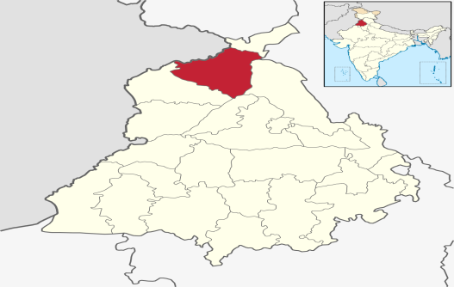
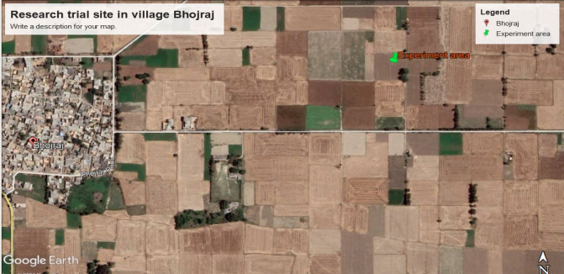
A research experiment was carried out in farmer’s field, village Bhojraj, district Gurdaspur, Punjab (31.9 ºN, 75.23 ºE and 265mAbove Mean Sea Level) during Rabi season (2019-20 and 2020-21) after harvesting of paddy crop. The owner of the field (Palwinder Singh S/o Chanan Singh) has 10ha of land and adopting wheat-rice
Figure 1: Location of experiment site in village Bhojraj District Gurdaspur.
cropping system. He is not burning any residue of his crops but incorporating it in soil. He is also using happy seeder to sow wheat after harvesting paddy. After harvesting paddy soil samples were collected from selected plots at depth of 6 inches from different sites of field and after mixing them all, composite samples were prepared. After proper labeling all soil samples, these were sent to Soil Testing Laboratory of Punjab Agricultural University, Ludhiana and Soil testing Laboratory of Regional Research Station Punjab Agricultural University, Gurdaspur for analyzing chemical and physical properties of the soil.
S.No. | Property | Value | Method employed
Chemical properties
1 | Electrical Conductivity (dSm⁻¹) | 0.18 | Systronics Electrical conductivity meter
2 | pH (1:25 soil water suspension) | 7.3 | Glass electrode pH meter
3 | Amount of organic carbon (%) | 0.52 | Walkley and Black’s technique
4 | Nitrogen (kg ha⁻¹) | 258.7 | Alkaline KMnO₄ process
5 | Phosphorus (kg ha⁻¹) | 10.96 | 0.5 M Sodium Hydrogen Carbonate
6 | Potassium (kg ha⁻¹) | 41.57 | 1N Neutral C2H7NO2
7 | Sulphur (Kg ha⁻¹) | 39.78 | Turbid metric method of Chesnin and Yien (1950)
8 | Zinc (mg/kg of soil) | 1.76 | DTPA,Lindsey  and Norwell, 1978
10 | Iron (mg/kg of soil) | 45.53 | DTPA,Lindsey  and Norwell, 1978
11 | Manganese (mg/kg of soil) | 5.23 | DTPA,Lindsey  and Norwell, 1978
12 | Copper (mg/kg of soil) | 3.78 | DTPA,Lindsey  and Norwell, 1978
3.1 Weather situation during experiment
Weekly average of weather variables recorded from meteorological observatory situated at Regional Research Station PAU Gurdaspur. The climatic conditions prevailed during the crop seasons in the years of experimentation (2019-2020 and 2020-21) are depicted through Fig. 1&2. The varying temperature conditions were observed during the crop seasons viz. 2019-20 and 2020-21. The mean maximum temperature of the study site was 24.7ºC and minimum temperature was 19.6ºC for the year 2019-20. However, these values were 26.3 º C and 12.6 º C in 2020-21. Total rainfall received in 2019-20and 2020-21 was 475.3 mm and 211.4 mm respectively. Though the amount of rainfall was almost double during 1st year (2019-20) than 2nd year (2020-21). Almost 8 months of crop season (2019-20) every month got the rainfall and highest amount was during March i.e.112.8 mm followed by Dec (90.0 mm). However, in year 2020-21, October month didn’t receive any rainfall, where the highest amount was during May i.e.65.3 mm followed by April (62.9 mm). 13 weeks out of 21 received rainfall with maximum amount (89 mm) during 50th SMW followed by second highest 56 mm in 13th SMW in 2019-20.
Average relative humidity (R.H) during morning remained 85.12% and during evening it remain 64.3% during crop season 2019-20 and during 2020-21 average relative humidity during morning remain 83.25% (Fig 2) and during evening it remain 50.12%.
2019 | TMAX (°C) | TMIN (°C) | RH.M (%) | RH.E (%) | RF (mm)
Oct | 29.9 | 17.1 | 90 | 57 | 6.2
Nov | 24.5 | 13.0 | 91 | 68 | 58.6
Dec | 15.9 | 7.4 | 93 | 76 | 90
Jan 20 | 15.6 | 6.4 | 93 | 74 | 70.0
Feb | 21.1 | 7.6 | 90 | 63 | 30.8
Mar | 24.1 | 12.4 | 85 | 92 | 112.8
Apr | 30.3 | 16.2 | 76 | 47 | 42.2
May | 35.9 | 19.6 | 63 | 38 | 64.7
Mean | 24.66 | 19.6 | 85.12 | 64.37 | 59.41

2020 | TMAX (°C) | TMIN (°C) | RH.M (%) | RH.E (%) | RF (mm)
Oct | 32.5 | 16.2 | 89 | 37 | 0
Nov | 24.9 | 10.4 | 90 | 45 | 27.9
Dec | 18.6 | 7.4 | 93 | 65 | 15.8
Jan 21 | 17.1 | 7.8 | 91 | 68 | 22.7
Feb | 23.0 | 10.0 | 85 | 58 | 3.7
Mar | 24.5 | 13.1 | 80 | 51 | 13.1
Apr | 33.2 | 16.0 | 70 | 40 | 62.9
May | 36.5 | 19.5 | 68 | 37 | 65.3
Mean | 26.29 | 12.55 | 83.25 | 50.12 | 26.42

3.2 Design and layout
The field experiment was laid out in strip plot design with having 14 treatments which replicated thrice.

3.3 Treatments details
- Design: Strip plot design
- Treatments: 14 (7 Methods and 2 Varieties)
- Replications: 3
- Plot Size: 50 m²
- Total Plots: 42
- Gross area: 2500 m²
- V1: HD 3086
- V2: PBW 550 (UNNAT)
3.4 Treatment combinations
T1 | M1V1 | Stubble Shaver+ Burning + Zero Tillage Drill (M1)
T2 | M2V1 | PAU cutter cum spreader +PAU happy Seeder with press wheel (M2)
T3 | M3V1 | PAU cutter cum spreader +straw decomposer+ PAU happy Seeder with press wheel (M3)
T4 | M4V1 | PAU cutter cum spreader +incorporation with MouldBoard plough + Use of Seed drill (M4)
T5 | M5V1 | Super Straw management system +Chopper +incorporation + Use of conventional Seed Drill (M5)
T6 | M6V1 | Straw removal (Manual) +Zero Tillage Drill (M6)
T7 | M7V1 | Straw removal (Manual) +thorough tillage + Use of conventional Seed Drill (M7)
T8 | M1V2 | Stubble Shaver+Burning + Zero Tillage Drill (M1)
T9 | M2V2 | PAU cutter cum spreader +PAU happy Seeder with press wheel (M2)
T10 | M3V2 | PAU cutter cum spreader +straw decomposer+ PAU happy Seeder with press wheel (M3)
T11 | M4V2 | PAU cutter cum spreader +incorporation with MouldBoard plough + Use of Seed drill (M4)
T12 | M5V2 | Super Straw management system +Chopper +incorporation + Use of conventional Seed Drill (M5)
T13 | M6V2 | Straw removal (Manual) +Zero Tillage Drill (M6)
T14 | M7V2 | Straw removal (Manual) +thorough tillage + Use of conventional Seed Drill (M7)

3.5 Layout of experimental plot

3.6 Experimental details of field experiment
For the field experiment during Rabi Season 2019-20 and 2020-21, PAU recommended two varieties were selected for sowing of wheat crop i.e. HD 3086 and PBW 550 Unnat. Selected wheat varieties were sown on 27th October 2019 with seven treatments as follows:
3.6.1 Stubble shaver + Burning+Zero Tillage Drill: Paddy was harvested then whole paddy straw was turned into small pieces with stubble shaver and burnt in the field. Sowing of wheat was done with zero tillage drill by using 100 kg seed/ha in case of HD 3086 and 112.5 kg/ha of PBW 550 Unnat during the years 2018-19 and 2019-20 at depth of 4-6 cm at row-row distance of 20 cm. Irrigation was given two weeks before harvesting of paddy to ensure proper moisture at the time of wheat sowing. 1st Irrigation was given after 25 days of sowing. 2nd dose of urea broadcasted after 2nd irrigation and 3rd dose at 45 days after sowing.
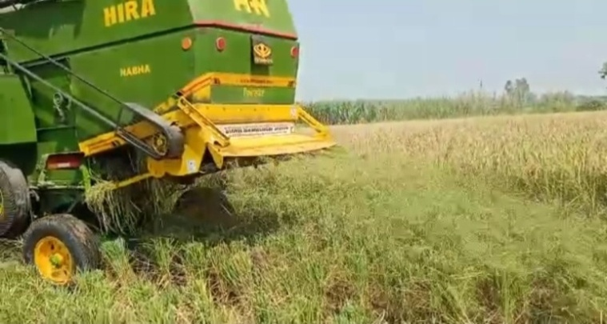
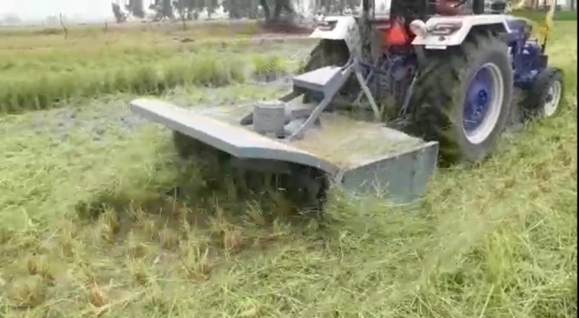
After harvesting of paddy whole paddy straw was turned into small pieces with stubble shaver and burnt in the field. Sowing of wheat was done with zero till drill by using 100 kg seed/ha in case of HD 3086 and 112.5 kg/ha of PBW 550 Unnat during the years 2018-19 and 2019-20 at depth of 4-6 cm at row-row distance of 20 cm. Irrigation was given two weeks before harvesting of paddy to ensure proper moisture at the time of wheat sowing. 3.6.2 PAU cutter cum spreader +PAU happy Seeder with press wheel
After harvesting of paddy crop whole paddy straw was disperse in the field by using PAU cutter cum spreader and wheat was sown with PAU happy seeder with press wheel without straw removal and burning. No weedicide was applied to control weeds because paddy straws in the field suppress the weed’s seeds to germinate.

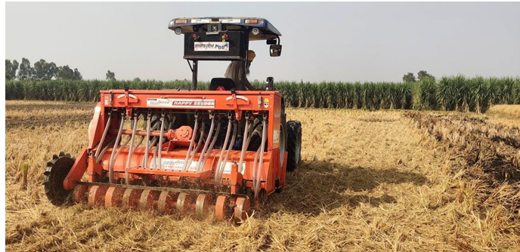
Plate 2: Sowing of wheat with PAU Happy Seeder with press wheel
3.6.3 PAU cutter cum spreader+ use of waste decomposer +PAU happy seeder with press wheel:
After harvesting of paddy crop wheat was sown with PAU happy seeder with press wheel without straw removal and burning. ICAR PUSA waste decomposer was sprayed after preparation in jaggery on paddy straw. The decomposers are in the form of capsule made by extracting fungi strains that helps the paddy straw to decompose at a much faster rate than usual.
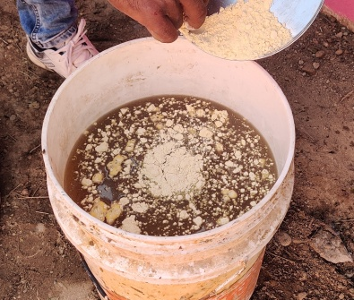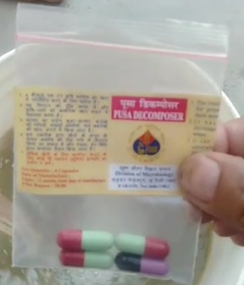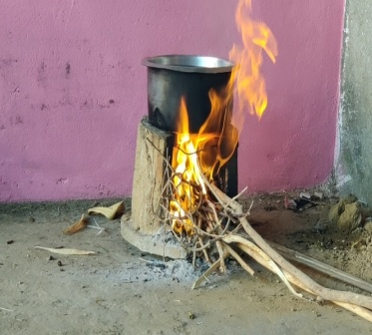
Plate 3: Preparation of Decomposer Solution
3.6.4 Preparation of decomposer solution
50 g jiggery was dissolved in 5 liters of water and boiled vigoursely and all dirt particles removed with sieve and the solution was put in a tub and tilted the solution till slightly warm.50grams floor added as a source of protein for bacteria and mixed thoroughly. Total of four capsules were broken apart and mixed in solution. The solution has been covered with piece of cloth and kept in warm place. Decomposer solution should be sprayed on paddy straw.
3.6.5 PAU cutter cum spreader + incorporation with Mould Board Plough +Use of seed drill
After harvesting of paddy crop with combine harvester, whole paddy straw cut into small pieces with PAU cutter cum spreader and chopped straw was incorporated into soil with the help of Mould Board Plough. After incorporation, field was prepared with rotavator. After planking, sowing of wheat was done with seed drill.
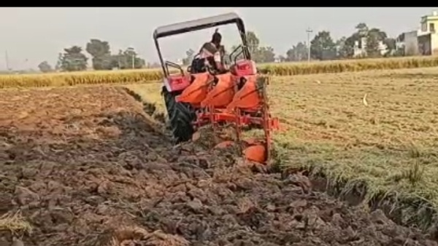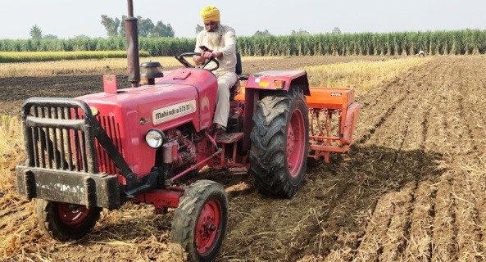
Plate 4: Incorporation with Mould Board Plough + Use of seed drill
3.6.6 Super Straw Management system + Chopper + incorporation +Use of seed drill
After harvesting of paddy crop with combine harvester using super straw management (SMS) system, whole paddy straw was chopped into small pieces with Chopper. Whole chopped straw incorporated into soil with mould board plough. After incorporation, field was prepared with rotavator. After planking, sowing of wheat was done with seed drill.
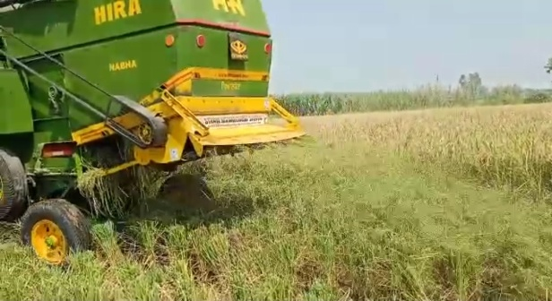 | 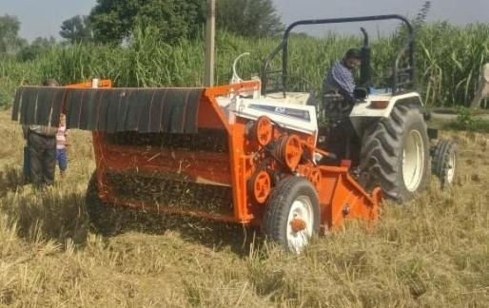
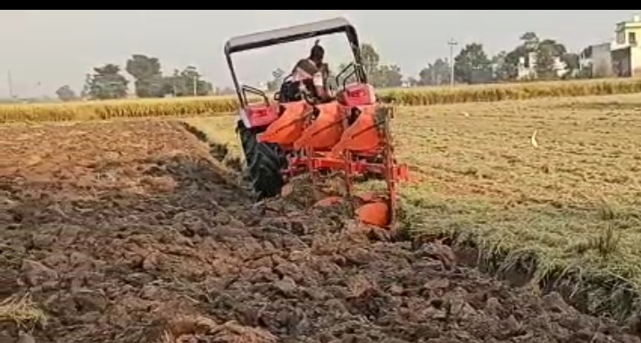 | 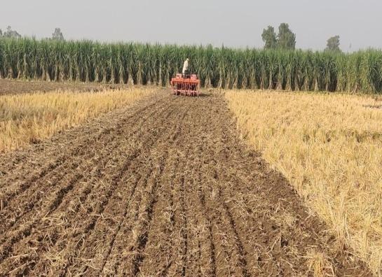
Plate 5: Super Straw management system + Chopper + incorporation +Use of seed drill
3.6.7 Straw removal (Manual) +Zero Tillage Drill:
After harvesting of paddy crop whole straw was removed manually from the field and then sowing of wheat was done by using Zero till drill.
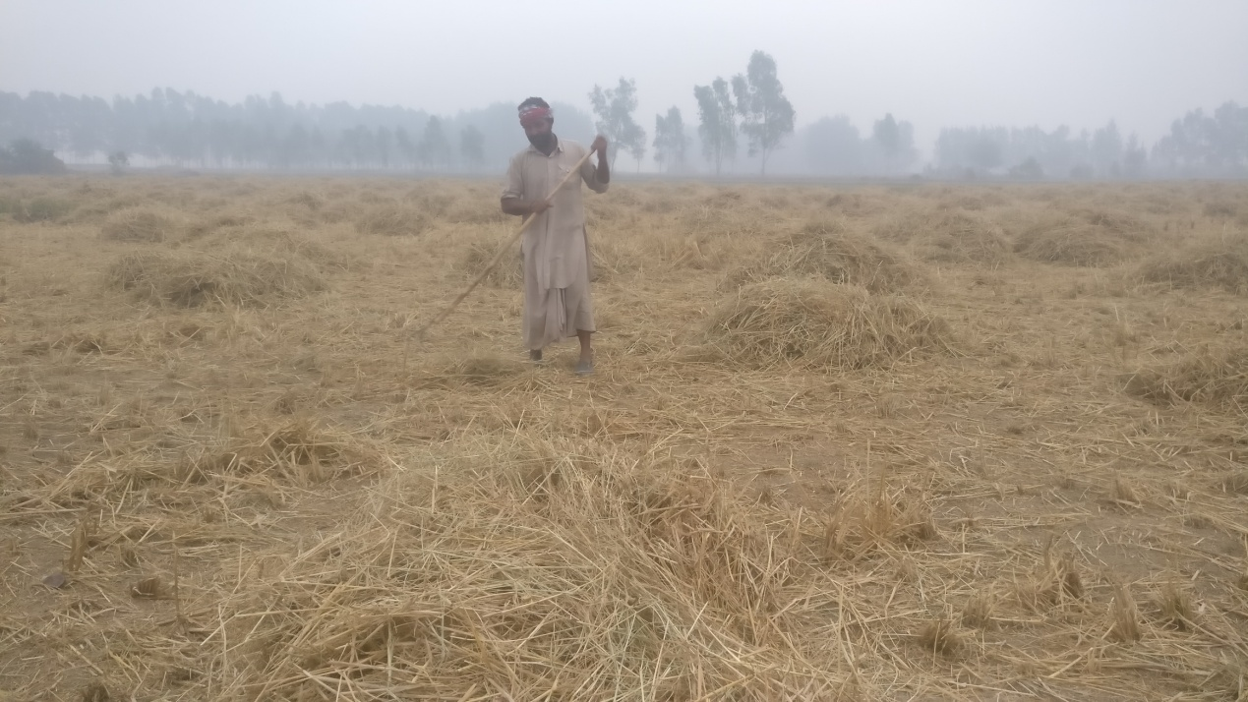 | 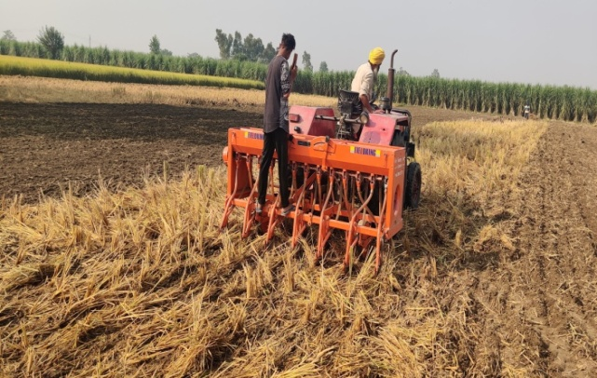
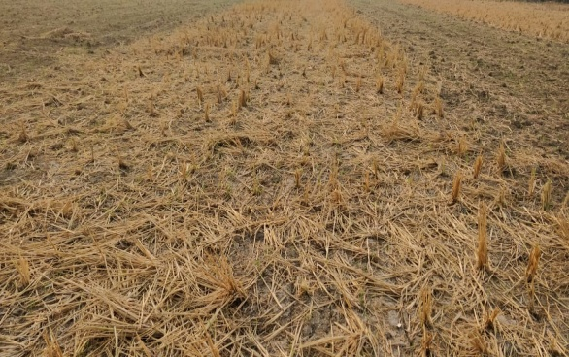 | 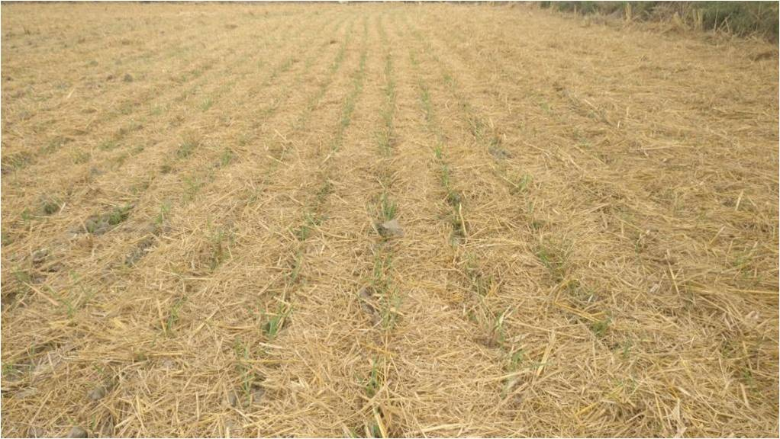
Plate 6: Straw removal (Manual) +Zero Tillage Drill
3.6.8 Straw removal (Manual) +thorough tillage + Use of conventional seed drill
After harvesting of paddy crop whole paddy straw removed from field manually and field was prepared using disc harrow and planking was done to sow wheat crop with seed drill.
3.7 Growth and yield contributing parameters
3.7.1 Plant Height:
Plant height of wheat crop was measured by selecting 10 plants from all the treatment at time of harvest commencing from ground level (base) to the top of spike and expressed in centimeters.
3.7.2 Number of Tillers m⁻²
For assessment of number of tillers, one m⁻²plots was selected randomly from all treatments and recorded at the time of harvest.
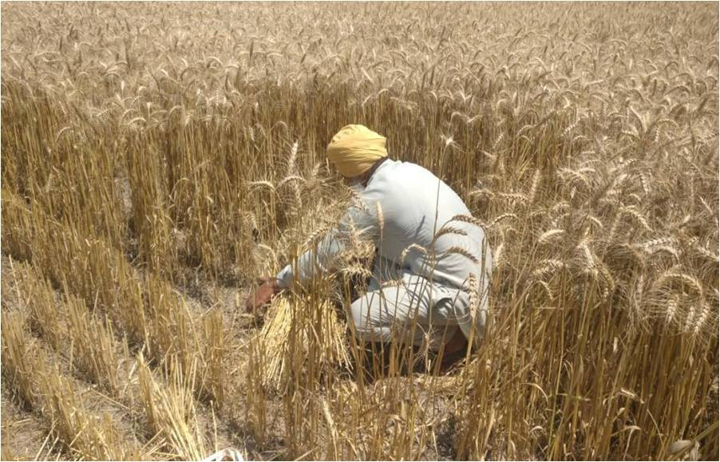
Plate 7: Recording Number of Tillers m⁻²
3.7.3 Length of Spikes (cm)
10 ears were randomly selected from each plot, measured from tip of the last spikelet to the base of the first spikelet with meter scale and average length was recorded in Centimeters.
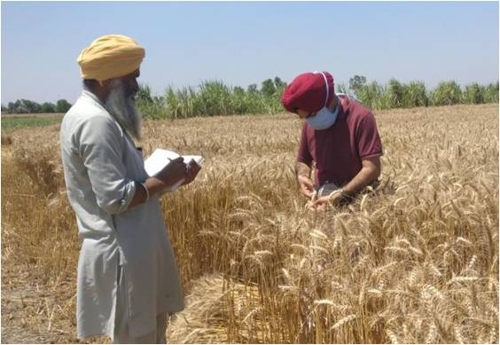
Plate 8: Recording length of spike
3.7.4. Number of grains per spike:
Number of grains per spike was recorded from 10 spikes selected randomly from each plot and threshed manually and carefully averaged for grains per spike count.

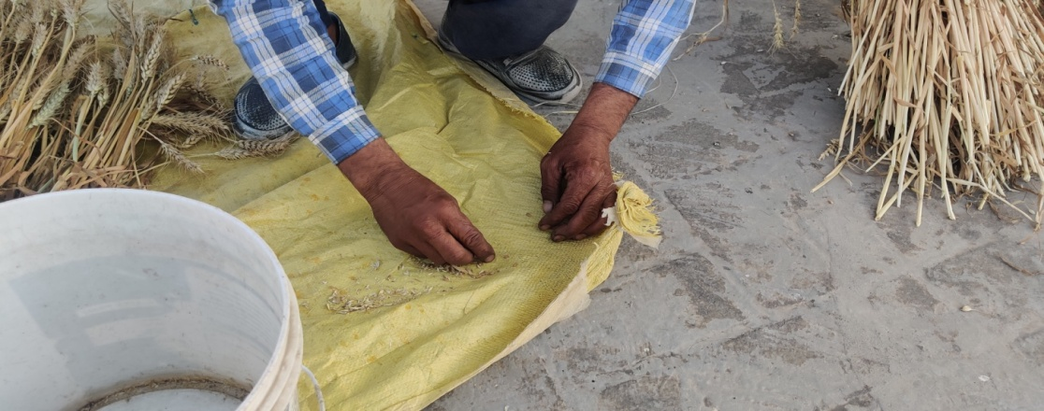
Plate 9: Recording Number of grains per spike
3.7.5. Test weight of grains (g)
From the harvest of each plot, one thousand grins were taken and their weight was recorded in grams (g).
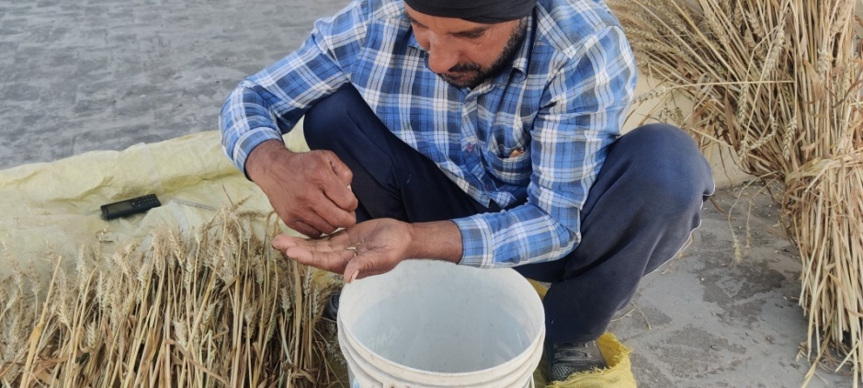
Plate 10: Recording Test weight of grains (g)
3.7.6 Biological yield (q ha⁻¹)
The plots were harvested and dried under sunshine for four days. After drying the bundle weight was noted down and expressed as the biological yield of the plot was recorded both years and expressed in quintal per hectare (q ha⁻¹).

3.7.7 Grain yield (q ha⁻¹)
The crop was harvested as per treatment at physiological maturity phase. Each plot’s bundles were separately threshed and the grains were collected in individual bags for each plot. The grains were cleaned and weighed in quintal per hectare (q ha⁻¹).
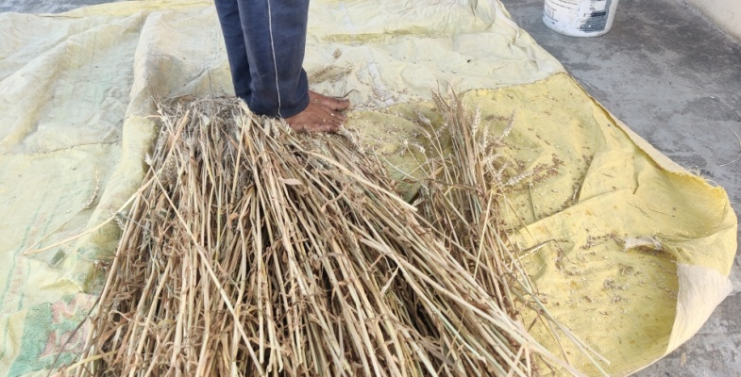
Plate 11: Recording Test weight of grains (g)
3.7.8 Harvest index (%)
The harvest index was defined as the ratio of grains to biological yield (dry matter), which expressed as a percentage and calculated using the following formulas:
Harvest Index (%) = (Grain yield/Biomass) x100
3.8 Soil properties and soil sampling
After removing remaining wheat straw from field with straw reaper, samples of soil were collected from 5 different sites in each treatment plot, mixed them thoroughly and then took one composite sample from each treatment for analysis.

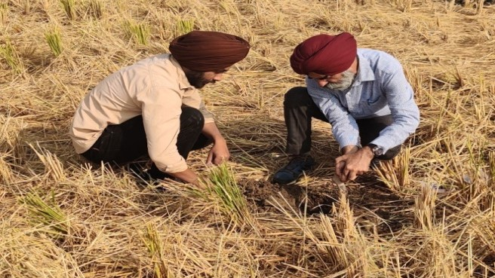
Plate 11: Soil sampling after harvest of wheat crop
3.8.1 Physical Property of Soil: Soil Texture
Infiltration was measured by a single ring infiltrometer of 15 cm diameter. Infiltrometres were filled with water, and the amount of water falling into the rings was time-stamped until the rate of water intake became consistent.
  - Bulk density and porosity were measured by established methods. Porosity is calculated as the ratio between the pore volume of a medium and its total volume and it is expressed as:
      - Volume of Voids / Total Volume x 100.
  - Water content in soil was determined by oven drying method. The percent moisture on dry weight basis was calculated by standard thermo-gravimetric method (Dastane, 1967).

  - 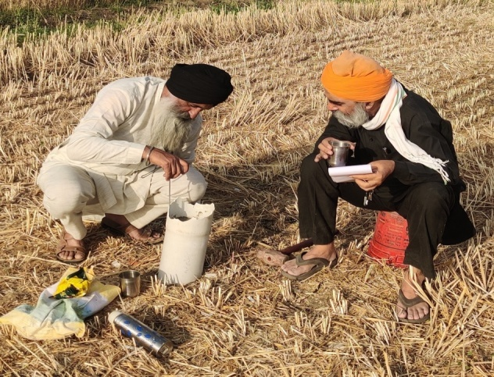
Plate 11: Soil sampling after harvest of wheat crop
  - 3.8.2 Soil chemical properties
  - The pH, electrical conductivity, organic carbon, available N, P and K of soil was analyzed by standard methods devised by Walkley and Black, 1934; Subbiah and Asija (1956); (Olsen et al., 1954) and Helmke and Sparks (1996). Determination of available micronutrients in soil using Atomic Absorption Spectrophotometer was done.

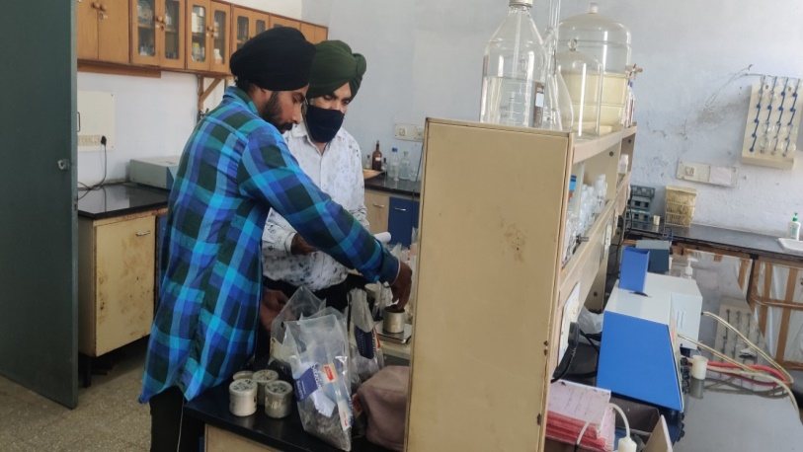 | 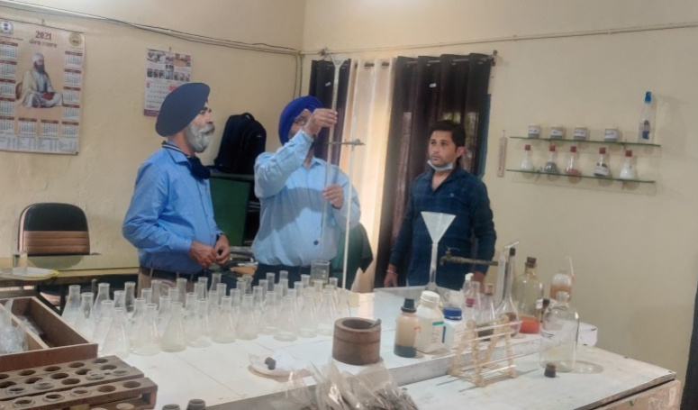
3.9 Economics
  - 3.9.1 Cultivation cost (Rs ha⁻¹)
  - Cost of cultivation was calculated by using the different agronomic practices and the inputs in a particular treatment.
  - 3.9.2 Gross return (Rs ha⁻¹)
  - To work out the gross return, the market price was multiplied to grain yield and straw yield respectively.
  - 3.9.3 Net returns (Rs ha⁻¹)
  - Net returns= Gross return- Cost of cultivation
  - 3.9.4 B:C ratio
  - It was calculated on the basis of additional cost incurred on applying different inputs and an additional output (GY) obtained due to the application of these additional inputs.
  - = $\frac{\text{Net returns }({\text{Rs ha}}^{\text{-1}})}{\text{Total cost of cultivation }({\text{Rs ha}}^{\text{-1}})}$
  - 3.9.5 Statistical analysis
  - Analysis of variance was done by Fischer’s method by using OP Stat software
  - developed by HAU, Hisar and interpretation of the results was done. The level of the significance was p=0.05 and C.D. was calculated.

CHAPTER-IV
RESULTS AND DISCUSSION

Results of the experiment are presented and discussed herein under this chapter.
4.1Growth parameters
4.1.1 Plant height (cm)
The height of plant is an imperative agronomic trait of wheat that directly affects its yield. It is a crucial physiological factor in the crop's growth and development. While there was a significant difference among the different methods of residue management, there were no apparent differences found between the varieties. In the year 2019-20, maximum plant height (94.99 cm) was observed in the treatment PAU cutter cum spreader + incorporation with Mould Board plough + Use of Seed drill i.e., M4 which was statistically at par with M5: Super Straw management system +Chopper + incorporation +Use of conventional Seed Drill (94.98 cm). Minimum plant height was observed in M1: Stubble Shaver + Burning + Zero Tillage Drill (86.18 cm). In the year 2020-21, maximum height was also observed in M4: PAU cutter cum spreader + incorporation with Mould Board plough+ Use of Seed drill (96.76 cm) and was at par with M3:PAU cutter cum spreader + straw decomposer + PAU happy Seeder with press wheel and M5: Super Straw management system + Chopper + incorporation ₊Use of conventional Seed Drill (94.98 cm) and the minimum height was observed in the treatment M1: Stubble Shaver + Burning + Zero Tillage Drill (87.57 cm). As a result, a general rise in plant height was seen in 2020–21 compared to 2019–20. Among the pooled data similar results were found to be obtained where maximum plant height was observed in M4: PAU cutter cum spreader + incorporation with Mould Board plough+ Use of Seed drill (95.87 cm).
A non-significant difference was seen for both varieties in the years 2019–20 and 2020–21. In the year 2019-20, maximum plant height was observed in variety V1: HD 3086 (92.60 cm) when compared to V2: PBW 550 Unnat (92.27 cm). Whereas, in year 2020-21 variety V2: PBW 550 Unnat (92.98 cm) obtained the maximum height as compared to V1: HD 3086 (92.82 cm). In the pooled data, V1: HD 3086(92.73 cm) obtained the maximum plant height. It was found that cultivars and paddy residue management methods did not significantly interact, and vice versa (Table 1).Similar findings were made by Kaushal et al., in 2012, who found that planting techniques had no effect on the height of wheat plants.
Table 1: Plant height (cm) in wheat crop
Treatments | Treatment details | Plant height (cm)
Methods |  | 2019-20 | 2020-21 | Pooled
M1 | Stubble Shaver + Burning + Zero Tillage Drill | 86.18 | 87.57 | 86.87
M2 | PAU cutter cum spreader + PAU Happy Seeder with press wheel | 92.84 | 95.77 | 95.38
M3 | PAU cutter cum spreader + straw decomposer +PAU happy Seeder with press wheel | 93.47 | 94.98 | 94.23
M4 | PAU cutter cum spreader + incorporation with Mould Board plough + Use of Seed drill | 94.99 | 96.76 | 95.87
M5 | Super Straw management system +Chopper + incorporation ₊ Use of conventional Seed Drill | 94.98 | 94.98 | 93.91
M6 | Straw removal (Manual) + Zero Tillage Drill | 92.97 | 90.01 | 91.49
M7 | Straw removal (Manual) + thorough tillage + Use of conventional drill | 91.60 | 90.23 | 90.92
 | CD at 5% | 1.14 | 1.99 | 1.12
Varieties
V1 | HD 3086 | 92.60 | 92.82 | 92.71
V2 | PBW 550 Unnat | 92.27 | 92.98 | 92.63
 | CD | NS | NS | NS
 | MXV | NS | NS | NS
 | VXM | NS | NS | NS

4.1.2 Number of tillers/m²
The actual plant stand maintained during the crop period is indicated by a periodic tiller count. The potential of a wheat crop to tiller is a sign of its potential to maximize crop yield. The perusal of data showed that different methods significantly affected the number of tillers during both the years, whereas among the varieties no significant difference was observed. In the year 2019-20, maximum no of tillers per square meter (446.94) was observed in the treatment M3: PAU cutter cum spreader + straw decomposer + PAU Happy Seeder with press wheel and was at par with M2: PAU cutter cum spreader + PAU happy Seeder with press wheel (434.50) and the least count was observed in M6: Straw removal (Manual) + Zero Tillage Drill (360.63). Maximum number of tillers was observed in treatment M2 (440.89) and was significantly higher than any other treatments. The lowest tiller count was observed in M6: Straw removal (Manual) + Zero Tillage Drill (350.66) in the year 2020-21. In pooled data, highest tiller count was observed in M2: PAU cutter cum spreader + PAU Happy Seeder with press wheel (437.70) and minimum was found in M6: Straw removal (Manual) + Zero Tillage Drill (355.65) and these results were like the results in the year 2020-21. In both years and across the pooled data, there was no significant difference between the varieties. There was a significant interaction between the methods of paddy residue management and varieties, as well as the other way around(Table 2) (Fig 1).The variety V1: HD 3086 and V2: PBW 550 Unnat showed same results on the pooled data for number of tillers /m² by the adoption of M3: PAU cutter cum spreader + straw decomposer+ PAU happy Seeder with press wheel, M5: Super Straw management system +Chopper + incorporation ₊ Use of conventional Seed Drill and M7: Straw removal (Manual) + thorough tillage+ Use of conventional drill (Fig 1).
This is likely due to the decomposition of paddy straw which helps in a continuous supply of macro and micronutrients in required quantities throughout the growth stages of wheat (Dhillon, 2016). Use of M2: PAU cutter cum spreader + PAU Happy Seeder with press wheel facilitates the timely crop sowing which helps in retaining the soil moisture and facilitates timely operations of crop cultivation. Optimum sowing time is an important factor that decides the growth and yield attributes. Early and timely sowing is one of the most significant conventional techniques for enhancing grain output (Ma et al., 2018) by improving the growth and yield contributing parameters. According to Tiwari et al., 2019 in contrast to the conventional approach (113.3), happy seeder seeded wheat was shown to have the maximum number of tillers per meter row length (117.2). During 2014-15 and 2015-16, wheat sown using a Happy Seeder and a zero till drill obtained approximately the same number of productive tillers (213 and 282) compared to wheat sown conventionally (216 and 293) (Iqbal et al., 2017).
Table 2: No. of tillers /m² in wheat for different treatments
Treatments | Treatment details | Number of tillers /m²
Methods |  | 2019-20 | 2020-21 | Pooled
M1 | Stubble Shaver + Burning + Zero Tillage Drill | 375.53 | 362.66 | 369.10
M2 | PAU cutter cum spreader + PAU Happy Seeder with press wheel | 434.50 | 440.89 | 437.70
M3 | PAU cutter cum spreader + straw decomposer + PAU happy Seeder with press wheel | 446.94 | 407.83 | 427.39
M4 | PAU cutter cum spreader + incorporation with Mould Board plough + Use of Seed drill | 387.33 | 385.48 | 386.41
M5 | Super Straw management system +Chopper + incorporation ₊ Use of conventional Seed Drill | 401.28 | 351.50 | 376.39
M6 | Straw removal (Manual) + Zero Tillage Drill | 360.63 | 350.66 | 355.65
M7 | Straw removal (Manual) + thorough tillage + Use of conventional drill | 377.92 | 374.66 | 376.29
 | CD at 5% | 14.44 | 19.94 | 14.76
Varieties
V1 | HD 3086 | 402.82 | 369.53 | 386.18
V2 | PBW 550 Unnat | 392.64 | 394.38 | 393.51
 | CD at 5% | NS | NS | NS
 | MXV | 22.33 | 40.40 | 21.32
 | VXM | 41.92 | 65.07 | 36.67
Fig.1. Interaction between methods and varieties w.r.t pooled tillers /m²
4.2 Yield and yield attributes
4.2.1 Spike length (cm)
The spike length serves as a gauge that ultimately affects grains. Year wise (2019-20 and 2020-21) analysis of variance revealed a significant difference among the treatments. In the year 2019-20, spike length (12.91) was found to be maximum in the M2: PAU cutter cum spreader + PAU Happy Seeder with press wheel and was followed by M7:Straw removal (Manual) + thorough tillage+ Use of conventional drill (12.49), M6: Straw removal (Manual) + Zero Tillage Drill (12.36) and M4: PAU cutter cum spreader + incorporation with Mould Board plough + Use of Seed drill(12.26). Minimum spike length (10.88) was observed in the treatment M1: Stubble Shaver + Burning + Zero Tillage Drill. Similarly in the year 2020-21, maximum spike length was observed in the M2: PAU cutter cum spreader + PAU happy seeder with press wheel (11.34). Minimum length was observed in the treatment M1: Stubble Shaver + Burning + Zero Tillage Drill (9.73). Similar trends were observed in the pooled data in the table 3.
In the year 2019-20, a significant difference was observed in the varieties and higher spike length was observed in the V2: PBW 550 Unnat i.e., 12.68 than 11.64 cm for V1: HD 3086, whereas no significant difference was observed among varieties both in the year 2020-21 and pooled data. Interaction of methods of paddy residue management and varieties and vice versa was found to be non-significant.
There were similar results recorded by Tiwari et al., 2019 in which the spike length with happy seeder was found to be 11.8 cm whereas for conventional method it was found to be 11.6 cm. However, the difference in spike length was non-significant among the different methods of planting (Kaushal et al., 2012). Similar research findings were given by Usman et al., (2014) revealing spike length was increased with residue retention when compared with conventional methods of planting.
Table 3: Spike length(cm) in wheat crop
Treatments | Treatment details | Spike length (cm)
Methods |  | 2019-20 | 2020-21 | Pooled
M1 | Stubble Shaver + Burning + Zero Tillage Drill | 10.88 | 9.73 | 10.31
M2 | PAU cutter cum spreader + PAU Happy Seeder with press wheel | 12.91 | 11.34 | 12.13
M3 | PAU cutter cum spreader + straw decomposer +PAU happy Seeder with press wheel | 12.06 | 10.57 | 11.32
M4 | PAU cutter cum spreader + incorporation with Mould Board plough + Use of Seed drill | 12.26 | 8.92 | 10.59
M5 | Super Straw management system +Chopper + incorporation ₊ Use of conventional Seed Drill | 12.13 | 8.58 | 10.36
M6 | Straw removal (Manual) + Zero Tillage Drill | 12.36 | 8.56 | 10.47
M7 | Straw removal (Manual) + thorough tillage + Use of conventional drill | 12.49 | 8.18 | 10.34
 | CD at 5% | 0.90 | 0.53 | 0.63
Varieties
V1 | HD 3086 | 11.64 | 9.32 | 10.48
V2 | PBW 550 Unnat | 12.68 | 9.50 | 11.09
 | CD at 5% | 0.97 | NS | NS
 | MXV | NS | NS | NS
 | VXM | NS | NS | NS

4.2.2 Number of spikelets per spike
The number of spikelets per spike varied significantly across the two research years, as shown by the analysis of variance. The number of spikelets per spike varied from 17.57 to 14.67 in 2019-20, with M2: PAU cutter cum spreader + PAU happy Seeder with press wheel exhibiting the maximum number and M6: Straw removal (Manual) + Zero Tillage Drill exhibiting the minimum number. Additionally, it was significantly higher in treatment M2: PAU cutter cum spreader + PAU happy Seeder with press wheel (19.09) in the year 2020-21 than it was in the rest of the treatments. The lowest was recorded in M6: Straw removal (Manual) + Zero Tillage Drill (14.63). Based on the pooled data, different methods of paddy residue management significantly affected the number of spikelets per spike. The results were like the results of the second year i.e., 2020-21 (Table 4) (Fig2). Variety HD 3086 (V1) and PBW 550Unnat (V2) showed same trend in the year 2020-21 on number of spikelet per spike in M1: Stubble Shaver + Burning + Zero Tillage Drill, M2: PAU cutter cum spreader + PAU happy Seeder with press wheel and M5: Super Straw management system +Chopper + incorporation ₊ Use of conventional Seed Drill.
Both the years and the pooled data showed no significant effects in varieties contrary to as given by Liu et al., 2010. Albeit, the results of the year 2019-20, and pooled results, the interaction effect between the methods of paddy residue management and varieties was non-significant. As for the year 2020-21 it was found to be significant.

Table 4: Spikelets per spike in wheat
Treatments | Treatment details | Spikelets per spike
Methods |  | 2019-20 | 2020-21 | Pooled
M1 | Stubble Shaver + Burning + Zero Tillage Drill | 15.58 | 15.90 | 15.74
M2 | PAU cutter cum spreader + PAU Happy Seeder with press wheel | 17.57 | 19.09 | 18.33
M3 | PAU cutter cum spreader + straw decomposer +PAU happy Seeder with press wheel | 17.20 | 16.80 | 17.00
M4 | PAU cutter cum spreader + incorporation with Mould Board plough + Use of Seed drill | 16.40 | 15.09 | 15.75
M5 | Super Straw management system +Chopper + incorporation ₊ Use of conventional Seed Drill | 16.00 | 15.81 | 15.91
M6 | Straw removal (Manual) + Zero Tillage Drill | 14.67 | 14.63 | 14.65
M7 | Straw removal (Manual) + thorough tillage + Use of conventional drill | 14.87 | 15.10 | 14.99
 | CD at 5% | 0.84 | 1.06 | 0.59
Varieties
V1 | HD 3086 | 16.25 | 15.93 | 16.09
V2 | PBW 550 Unnat | 15.83 | 16.19 | 16.01
 | CD at 5% | NS | NS | NS
 | MXV | NS | 1.38 | NS
 | VXM | NS | 1.44 | NS

Fig.2. Interaction between methods and varieties w.r.t the year 2021-22 on thenumber of spikelets per spike
4.2.3 Grain count per spike
Number of grains per spike serves as a reliable criterion to assess the crop yield. Data analysis revealed that various methods of paddy residue management affected the number of grains per spike in both years significantly. Number of grains per spike varied from 38.46 to 43.61 during 2019-20 and from 36.02 to 46.12 during 2020-21 with the highest grains per spike was recorded in M2: PAU cutter cum spreader + PAU Happy Seeder with press wheel were 43.61 and 46.12 and lowest in M7: Straw removal (Manual) + thorough tillage + Use of conventional drill as 38.46 and 36.02. Pooled data also showed the trends like both years i.e., 2019-20 and 2020-21.
With respect to varieties no significant difference was observed for both the years as well as pooled data. Significant interaction was found between paddy residue management methods and varieties and vice versa (Table 5). Variety HD 3086 (V1) and PBW 550 Unnat (V2) showed same results on the pooled data of number of grains per spike at M1: Stubble Shaver + Burning + Zero Tillage Drill, M2: PAU cutter cum spreader + PAU Happy Seeder with press wheel, M4: PAU cutter cum spreader + incorporation with Mould Board plough+ Use of Seed drill and M5: Super Straw management system +Chopper + incorporation ₊ Use of conventional Seed Drill (Fig 3).
Similar findings were observed by Rafiq et al., 2017 that wheat crop sown with Happy Seeder and Turbo Seeder recorded a greater number of grains per spike compared with ZT (Zero Tillage) drill sown in residue burning burned field along with various nitrogen fertilization.
Table 5. Grain count in each spike
Treatments | Treatment details | Number of grains per spike
Methods |  | 2019-20 | 2020-21 | Pooled
M1 | Stubble Shaver + Burning + Zero Tillage Drill | 39.38 | 39.66 | 39.52
M2 | PAU cutter cum spreader + PAU Happy Seeder with press wheel | 43.61 | 46.12 | 44.87
M3 | PAU cutter cum spreader + straw decomposer + PAU happy Seeder with press wheel | 43.39 | 43.43 | 43.41
M4 | PAU cutter cum spreader + incorporation with Mould Board plough + Use of Seed drill | 41.37 | 39.21 | 40.29
M5 | Super Straw management system +Chopper + incorporation ₊ Use of conventional Seed Drill | 42.39 | 37.36 | 39.88
M6 | Straw removal (Manual) + Zero Tillage Drill | 39.57 | 39.39 | 39.48
M7 | Straw removal (Manual) + thorough tillage + Use of conventional drill | 38.46 | 36.02 | 37.24
 | CD at 5% | 1.51 | 3.34 | 1.55
Varieties
V1 | HD 3086 | 41.23 | 39.26 | 40.26
V2 | PBW 550 Unnat | 41.11 | 41.05 | 41.08
 | CD at 5% | NS | NS | NS
 | MXV | 2.70 | 3.81 | 2.20
 | VXM | 3.57 | 3.40 | 2.80
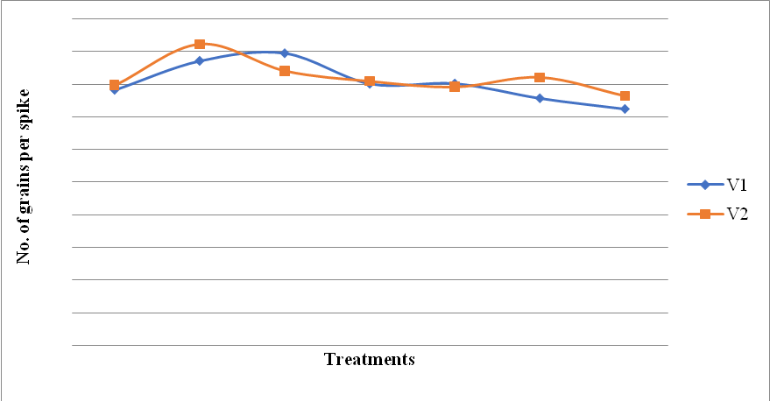
Fig.3. Interaction between methods and varieties w.r.t the pooled data onnumber of grains per spike
4.2.4 Test weight (g)
A significant difference among the treatments was observed in both the year whereas no significant difference was observed with respect to the varieties. The test weights were between 38.50 g to 45.62 g. The treatments M2: PAU cutter cum spreader + PAU happy Seeder with press wheel (45.62 g) gave the highest test weight in comparison to the other treatments. However, the lowest of the test weight was observed in treatmentM1: Stubble Shaver + Burning + Zero Tillage Drill (38.50 g). Similar, trends were observed for the year 2020-21 in which the maximum test weight was observed in M3: PAU cutter cum spreader + straw decomposer+ PAU happy Seeder with press wheel (44.66 g) which was at par withM2:PAU cutter cum spreader + PAU happy Seeder with press wheel (43.33 g) and the lowest of the test weight was observed in the treatment M1: Stubble Shaver + Burning + Zero Tillage Drill (34.16 g). By comparing the test weight results for the two years, it was determined that the greatest test weight was recorded in 2019–20 rather than 2020–21. The pooled data also revealed the same trends as those shown in the table 6.
In terms of varieties, there was no significant difference between the two varieties from 2019–20 to 2020–21andamong the pooled data. In the year 2019-20, PBW 550 Unnat (V2) variety showed maximum test weight (42.48 g) when compared with HD 3086 (V1) (40.95 g). Similar trends were also observed in the second year, where maximum test weight was observed in PBW 550 Unnat (V2) (39.33 g) when compared with HD 3086 (V1) (39.23 g). However, it was shown that there was significant interaction between paddy residue management techniques and variety, and vice versa. The results obtained w.r.t. pooled data by varieties HD 3086 (V1) and PBW 550 Unnat (V2) showed same results on the test weight (g) by adoption of M1: Stubble Shaver + Burning + Zero Tillage Drill, M2: PAU cutter cum spreader + PAU Happy Seeder with press wheel,M3: PAU cutter cum spreader + straw decomposer+ PAU happy Seeder with press wheel,M4:PAU cutter cum spreader + incorporation with Mould Board plough + Use of Seed drill and M6: Straw removal (Manual) + Zero Tillage Drill (Fig 4).
The findings are consistent with those of Shahzad et al., (2007), who discovered that earlier seeding resulted in improved grain growth and accumulation of photosynthates due to a longer growing time.
Table 6: Test weight (g) in wheat for different treatments
Treatments | Treatment details | Test weight (g)
Methods |  | 2019-20 | 2020-21 | Pooled
M1 | Stubble Shaver + Burning + Zero Tillage Drill | 38.50 | 34.16 | 36.33
M2 | PAU cutter cum spreader + PAU Happy Seeder with press wheel | 45.62 | 43.33 | 44.47
M3 | PAU cutter cum spreader + straw decomposer +PAU happy Seeder with press wheel | 44.00 | 44.66 | 44.34
M4 | PAU cutter cum spreader + incorporation with Mould Board plough + Use of Seed drill | 42.94 | 39.50 | 41.22
M5 | Super Straw management system +Chopper + incorporation ₊ Use of conventional Seed Drill | 40.43 | 35.00 | 37.71
M6 | Straw removal (Manual) + Zero Tillage Drill | 39.46 | 38.66 | 39.16
M7 | Straw removal (Manual) + thorough tillage + Use of conventional drill | 41.05 | 39.66 | 40.36
 | CD at 5% | 1.59 | 3.34 | 1.73
Varieties
V1 | HD 3086 | 40.95 | 39.23 | 40.09
V2 | PBW 550 Unnat | 42.48 | 39.33 | 40.91
 | CD at 5% | NS | NS | NS
 | MXV | 2.06 | 4.25 | 2.26
 | VXM | 3.22 | 3.56 | 2.07

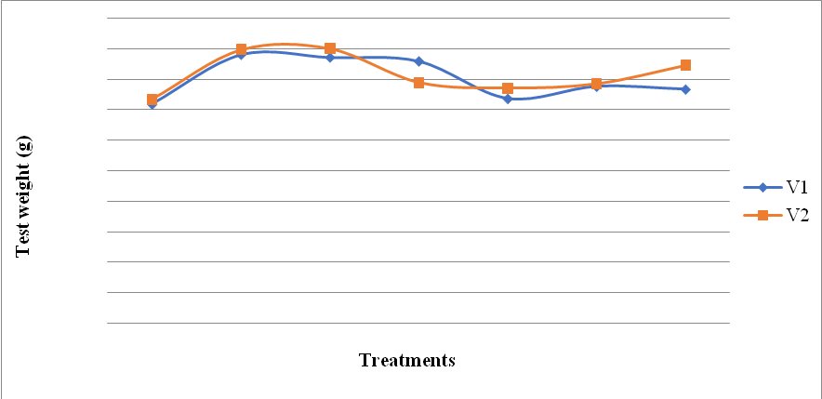
Fig.4: Interaction between methods and varieties w.r.t pooled data in test weight (g)
4.2.5 Grain yield (q/ha)
Analysis of variance revealed the significant difference among the treatments and varieties with respect to grain yield of wheat crop during first year of experimentation i.e., 2019-20. Grain yield ranged from 42.0 to 52.2 q/ha during 2019-20. The treatments M2: PAU cutter cum spreader + PAU happy Seeder with press wheel (52.16 q/ha) and M3: PAU cutter cum spreader + straw decomposer+ PAU Happy Seeder with press wheel (48.83 q/ha) were statistically at par and had given maximum grain yield in comparison to the other treatments. However, lowest grain yield was observed under M6: Straw removal (Manual) + Zero Tillage Drill (42.00 q/ha) and M7: Straw removal (Manual) + thorough tillage+ Use of conventional drill (42.83 q/ha) even lesser than M1: Stubble Shaver + Burning + Zero Tillage Drill (44.83 q/ha). During 2020-21 of study, similar trend of grain yield was observed though lowest yield of wheat was for M7: Straw removal (Manual) + thorough tillage + Use of conventional drill (42.16 q/ha) treatment and statistically at par with M5: Super Straw management system +Chopper + incorporation + Use of conventional Seed Drill (43.66 q/ha) and M6: Straw removal (Manual) + Zero Tillage Drill (43.33 q/ha). By comparing 2019-20 and 2020-21’s grain yield of wheat, the first year of study recorded higher grain yield compared to second year (42.2-48.8 q/ha) may be due to favorable weather conditions. Pooled data showed the same trend as presented in Table 7.
As far as varieties are concerned, V2: PBW 550 Unnat (47.90 q/ha) get the better of in grain yield as compared to V1: HD 3086 (44.76 q/ha) for both years and overall, also. During 2019-20, V2: PBW 550 Unnat showed statistically higher grain yield (7%) more than V1: HD 3086 variety. During the second year of study, non-significant difference was found between both varieties and similar trends were also found for pooled grain yield. However, interaction of methods of paddy residue management and varieties and vice-versa were non-significant.
The retention of residue with the use of a PAU cutter cum spreader functions as a fuel for the soil food web and so has a significant impact on nutrient cycling for sustaining soil quality and production (Sharma &Dhaliwal 2021). Combined use of PAU cutter cum spreader + PAU happy Seeder with press wheel i.e., M2 also provides additional advantages like reduction in weed growth, conservation of optimum moisture, and maintaining optimum crop stand by ensuring uniform germination which ultimately helps in improving the final yield.

Table 7: Grain yield (q/ha) in wheat
Treatments | Treatment details | Grain yield (q/ha)
Methods |  | 2019-20 | 2020-21 | Pooled
M1 | Stubble Shaver + Burning + Zero Tillage Drill | 44.83 | 44.66 | 44.75
M2 | PAU cutter cum spreader + PAU Happy Seeder with press wheel | 52.16 | 48.83 | 50.50
M3 | PAU cutter cum spreader + straw decomposer +PAU happy Seeder with press wheel | 48.83 | 47.50 | 48.16
M4 | PAU cutter cum spreader + incorporation with Mould Board plough + Use of Seed drill | 48.00 | 44.83 | 46.41
M5 | Super Straw management system +Chopper + incorporation ₊ Use of conventional Seed Drill | 45.66 | 43.66 | 44.66
M6 | Straw removal (Manual) + Zero Tillage Drill | 42.00 | 43.33 | 42.66
M7 | Straw removal (Manual) + thorough tillage + Use of conventional drill | 42.83 | 42.16 | 42.50
 | CD at 5% | 3.68 | 2.42 | 2.58
Varieties
V1 | HD 3086 | 44.76 | 44.81 | 44.78
V2 | PBW 550 Unnat | 47.90 | 45.19 | 46.54
 | CD at 5% | 1.22 | NS | NS
 | MXV | NS | NS | NS
 | VXM | NS | NS | NS
4.2.6 Biological yield (q/ha)
The result of vegetative growth and reproductive yield is biological yield. It's possible that the major impact residue management techniques had on these features was what caused the increased biological yield in each treatment.
During the first year of study (2019-20), residue management methods have a significant influence on the biological yield. Significantly higher biological yield was obtained with M2: PAU cutter cum spreader + PAU happy Seeder with press wheel (124.50 q/ha) which was found to be statistically at par with M3 and M5 i.e., PAU cutter cum spreader + straw decomposer+ PAU happy Seeder with press wheel (116.05 q/ha) and Super Straw management system +Chopper + incorporation + Use of conventional Seed Drill (114.14 q/ha) respectively. The minimum was observed in M1: Stubble Shaver + Burning + Zero Tillage Drill (96.83q/ha). However, during the second year of study significantly higher biological yield was obtained with M3:PAU cutter cum spreader + straw decomposer + PAU happy Seeder with press wheel (136.33 q/ha) and lowest in M1: Stubble Shaver + Burning +Zero Tillage Drill (83.25 q/ha). Among the pooled data highest biological yield (126.13 q/ha) was recorded with M3: PAU cutter cum spreader + straw decomposer + PAU happy Seeder with press wheel which was statistically at par with M2: PAU cutter cum spreader + PAU happy Seeder with press wheel (120.09 q/ha) (Table 8).
Biological yield by both the varieties were found to be non-significant in both the years and for the pooled data. Similarly, the interaction between methods and varieties and vice versa was found to be non-significant.
Table 8: Biological yield (q/ha) in wheat
Treatments | Treatment details | Biological yield (q/ha)
Methods |  | 2019-20 | 2020-21 | Pooled
M1 | Stubble Shaver + Burning + Zero Tillage Drill | 96.83 | 83.25 | 90.04
M2 | PAU cutter cum spreader + PAU Happy Seeder with press wheel | 124.50 | 115.68 | 120.09
M3 | PAU cutter cum spreader + straw decomposer +PAU happy Seeder with press wheel | 116.05 | 136.33 | 126.13
M4 | PAU cutter cum spreader + incorporation with Mould Board plough + Use of Seed drill | 110.12 | 108.40 | 109.26
M5 | Super Straw management system +Chopper + incorporation ₊ Use of conventional Seed Drill | 114.14 | 105.00 | 109.97
M6 | Straw removal (Manual) + Zero Tillage Drill | 103.05 | 100.91 | 101.98
M7 | Straw removal (Manual) + thorough tillage + Use of conventional drill | 108.00 | 104.81 | 106.40
 | CD at 5% | 11.09 | 12.25 | 8.38
Varieties
V1 | HD 3086 | 109.91 | 106.58 | 108.24
V2 | PBW 550 Unnat | 110.85 | 108.96 | 109.91
 | CD at 5% | NS | NS | NS
 | MXV | NS | NS | NS
 | VXM | NS | NS | NS
4.3 Economics: Cost benefit ratio
The economic analysis of all treatments with wheat sowing by various paddy straw management techniques was carried out after harvesting of rice with combine harvester. Here the practices were carried out that are mostly followed by farmers in Punjab. In economics calculations, for the Seed, hiring cost of machinery used for sowing, Seed treatment, weedicide, straw management machinery, fertilizer, fungicide, labour cost and harvesting cost of machinery included as variable cost.
Between the treatments the highest gross return was obtained by adoption of M2: PAU cutter cum spreader + PAU happy Seeder with press wheel (Rs. 115194/-) followed by M3: PAU cutter cum spreader + straw decomposer+ PAU happy Seeder with press wheel (Rs. 113415/-) followed by M4: PAU cutter cum spreader + incorporation with Mould Board plough+ Use of Seed drill (Rs 106184/-) and M1: Stubble Shaver + Burning + Zero Tillage Drill (Rs. 99269/-) (Table 17). Gross returns amongst this sowing technology were superior due to the mulching which ultimately conserves the moisture during grain filling stage. Though, the benefit-cost ratio was also upper with M2: PAU cutter cum spreader + PAU happy Seeder with press wheel (1:54) as compared to M3: PAU cutter cum spreader + straw decomposer+ PAU happy Seeder with press wheel (1:46), M1: Stubble Shaver + Burning + Zero Tillage Drill (1.23) and M6: Straw removal (Manual) + Zero Tillage Drill (1.03) (Table 17).
In a study by Dhillon (2016), Rs 4,24, 366 and Rs. 1989/ha was saved on Urea, DAP and Potash fertilizers in wheat sown with Happy seeder technology amounting to Rs. 2,779/ha. Additionally, the physical properties will be improved over a more extended period as compared to the conventional method. According to Iqbal et al., 2017, Happy Seeder ZT provided the highest net income when compared to conventional methods with a B:C ratio of 1.51. Sharma et al., (2008) noted the same outcomes. Additionally, Sidhu et al., (2007) noticed less cost when sowing was done with happy seeder than half as much as using a traditional method. CT can help rain-fed agriculture boost crop output, maximise the B:C ratio, maximise earnings, decrease environmental difficulties, and increase sustainability, according to Li and Kahloon et al., during the years 2004/2005 and 2012 respectively.
These findings agreed with those of Iqbal et al., (2017) and Dhillon (2016).As compared to conventional techniques, the Happy Seeder minimizes the cost of field preparation without compromising the mean wheat yields (Gupta, 2012).

Table 9: Wheat yield and B:C ratio
Treatments | Grain yield  (q/ha) | Gross returns (Rs) | Net returns (Rs) | B:C
Stubble Shaver+Burning + Zero Tillage Drill | 44.75 | 99269 | 54769 | 1.23
PAU cutter cum spreader + PAU happy Seeder with press wheel | 50.50 | 115194 | 69944 | 1.54
PAU cutter cum spreader + straw decomposer+ PAU happy Seeder with press wheel | 48.16 | 113415 | 67352 | 1.46
PAU cutter cum spreader + incorporation with Mould Board plough + Use of Seed drill | 46.14 | 106184 | 52372 | 0.97
Super Straw management system +Chopper + incorporation ₊ Use of conventional Seed Drill | 44.66 | 103302 | 50739 | 0.96
Straw removal (Manual) + Zero Tillage Drill | 42.66 | 98046 | 49733 | 1.03
Straw removal (Manual) + thorough tillage + Use of conventional drill | 42.50 | 100121 | 47308 | 0.86
CD at 5% | 2.58 |  |  | 0.11

4.4 Impact of paddy straw management (PSM) techniques on soil chemical properties
4.4.1 Soil pH and EC
The availability of nutrients is influenced by soil pH, which is a key component in regulating soil fertility. Crop residue can alter soil pH, which could impact how quickly it decomposes. In both the cropping seasons of 2019–20 and 2020–21, it was discovered that there was no significant difference between the effects of rice residue management approaches on soil pH and EC. In the year 2019-20, the maximum soil pH was found in treatment M1: PAU cutter cum spreader + Burning (7.35) which was followed by M7: Straw removal (Manual) + thorough tillage + Use of conventional drill(7.31),M3: PAU cutter cum spreader + straw decomposer + PAU happy Seeder with press wheel (7.30),M5: Super Straw management system +Chopper + incorporation + Use of conventional Seed Drill (7.30), M2: Super Straw management system +Chopper + incorporation ₊ Use of conventional Seed Drill (7.28) and M4 : PAU cutter cum spreader + incorporation with Mould Board plough + Use of Seed drill (7.25) and M6: Straw removal(Manual) + Zero Tillage Drill. However, in the year 2020-21 it was observed that the maximum pH was observed in treatment M2: PAU cutter cum spreader + PAU happy Seeder with press wheel (7.45), and was followed by M1: Stubble Shaver+ Burning + Zero Tillage Drill (7.37),which was followed with M5: Super Straw management system +Chopper + incorporation ₊ Use of conventional Seed Drill also similar with M7 Straw removal (Manual) + thorough tillage + Use of conventional drill. The minimum of soil pH was observed in the treatment M4: PAU cutter cum spreader + incorporation with Mould Board plough + Use of Seed drill i.e., 7.22 respectively.
The maximum soil EC for both the years was found to be maximum in treatment M1: Stubble Shaver+ Burning + Zero Tillage Drill (0.19 and 0.19 mho/cm) (Table 10). In comparison to control plots, Clark et al., 2007 found that an increase in soil EC in lucerne and wheat crop residue amended soil.
Limousine and Tessier (2007) also noted that no-till management of conservation agriculture decreased soil pH in the upper 5 cm layer compared to conventional, perhaps because of an accumulation of organic acids generated by residue decomposition. In a two-year trial, Virk et al., 2017 found that sowing using a happy seeder, straw chopper + zero till sowing and conventional sowing had no discernible impact on soil pH or EC. But with the use of a straw chopper and minimal tillage seeding, a minor pH reduction was noticed. According to Wang et al., (2017), soil pH decreased in residue-amended soil compared to a control treatment.
4.4.2 Organic carbon (%)
Soil organic carbon is an index of soil quality and sustainability of agriculture as it provides the reservoir of soil nutrients. A slight increase in organic carbon content was observed from 2019-20 and 2020-21 in all the treatments. In the year 2019-20, maximum OC was observed in the treatment M4: PAU cutter cum spreader + incorporation with Mould Board plough + Use of Seed drill (0.51 %), and was similar in M5: Super Straw management system +Chopper + incorporation (M5) ₊ Use of conventional Seed Drill (0.50%) followed by M2: PAU cutter cum spreader + PAU happy Seeder with press wheel and M3: PAU cutter cum spreader + straw decomposer(M3)+ PAU happy Seeder with press wheal (0.49 %), minimum OC was recorded in M1, Stubble Shaver+Burning + Zero Tillage Drill (0.48), M6 and M7 M2: PAU cutter cum spreader + PAU happy Seeder with press wheel (0.52%), M5: Super Straw management system +Chopper + incorporation ₊ Use of conventional Seed Drill (0.50 %), M1: Stubble Shaver+Burning + Zero Tillage Drill (0.48%) and M7 (0.44 %). In the year 2020-21, the maximum OC was 0.53% which was found in both M4: PAU cutter cum spreader + incorporation with Mould Board plough+ Use of Seed drill and M5: Super Straw management system +Chopper + incorporation + Use of conventional Seed Drill. The lowest organic carbon percentage was observed in treatmentM6: Straw removal (Manual)+ Zero Tillage Drill M1: Stubble Shaver+Burning + Zero Tillage Drill which was 0.49%. The largest organic carbon build-up was found in rice straw that had been cut and combined with animal dung, followed by straw mulch and animal manure, and the lowest was found in rice straw that had been burned and removed, according to Verma and Bhagat (1992). According to Naresh et al., (2016) the use of rice straw mulches could improve the quantitative and qualitative characteristics of soil aggregates and soil organic carbon (SOC), as well as increase wheat production. Further, in comparison to conventional tillage methods, Mondal et al., (2020) reported that adopting reduced tillage and reduced tillage with 30% as residue increased the soils organic carbon content. They also concluded that crop residue retention and reduced tillage could significantly enhance the soil's health and organic carbon content.
4.4.3 Soil nutrients
Soil nitrogen was ranged from 403 kg/ha to 448 kg/ha in M7 and M5 respectively during first year of trial, however in the subsequent year, available N ranged from 428 to 480.2 kg/ha in M7 and M4 respectively.
Table 10. Impact of paddy straw management techniques on soil nitrogen pooled (2019-20 and 2020-21)
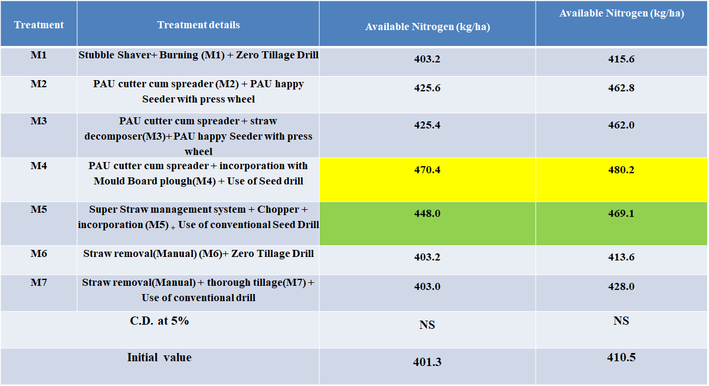
It was noted that the soil's available P in the 2019–20 ranged from 23.25 to 24 kg/ha. The treatment M4: Super Straw management system +Chopper + incorporation ₊ Use of conventional Seed Drill (24 kg/ha) and M5, Super Straw management system +Chopper + incorporation ₊ Use of conventional Seed Drill followed by M1: Stubble Shaver+Burning + Zero Tillage Drill (23.87 kg/ha) M7: Straw removal (Manual) + thorough tillage+ Use of conventional drill (23.5 kg/ha),M2:PAU cutter cum spreader (M2) + PAU happy Seeder with press wheel (23.25 kg/ha), M3: PAU cutter cum spreader + straw decomposer+ PAU happy Seeder with press wheel (23.25 kg/ha), M6: Straw removal (Manual) + Zero Tillage Drill (23.25 kg/ha), In 2020–21, treatment M7 Straw removal (Manual) + thorough tillage+ Use of conventional drill (29.72 kg/ha) likewise was the highest available P, followed by M6: Straw removal (Manual) + Zero Tillage Drill (29.42 kg/ha),M2 PAU cutter cum spreader (M2) + PAU happy Seeder with press wheel (28.70 kg/ha),M1: Stubble Shaver+ Burning (M1) + Zero Tillage Drill (28.17 kg/ha),M3: PAU cutter cum spreader + straw decomposer+ PAU happy Seeder with press wheel (27.87 kg/ha), M5: Super Straw management system +Chopper + incorporation ₊ Use of conventional Seed Drill (25.97 kg/ha), M4: PAU cutter cum spreader + incorporation with Mould Board plough+ Use of Seed drill (21.77 kg/ha), while treatment M4 had the lowest available P .As a result, an increase in available P was seen in all the treatments from 2019–20 to 2020–21 except M4 (Table 11).
As far as available potassium is concerned, in the year 2019–20, it was observed that the treatment M1: Stubble Shaver+ Burning (M1) + Zero Tillage Drill (90.42 kg/ha). and M6: Straw removal (Manual) + Zero Tillage Drill showed the similar values followed by M7 (89.75 kg/ha) had the highest available K, followed by M2: PAU cutter cum spreader + PAU happy Seeder with press wheel (89.1 kg/ha), M3:PAU cutter cum spreader + straw decomposer+ PAU happy Seeder with press wheel (88.9 kg/ha), M4: PAU cutter cum spreader + incorporation with Mould Board plough + Use of Seed drill (88.75 kg/ha), M5: Super Straw management system +Chopper + incorporation ₊ Use of conventional Seed Drill (88.32 kg/ha), While the available K in 2020–21 ranged from 89.75 to 90.97 kg/ha. The treatment M2 has the highest quantity (90.97 kg/ha), whereas M5: Super Straw management system +Chopper + incorporation ₊ Use of conventional Seed Drill (88.32 kg/ha)
The results showed that the available S (kg/ha) results for the two years, 2019–20 and 2020–21, were similar. For both years, the maximum was seen in the M4: PAU cutter cum spreader + incorporation with Mould Board plough + Use of Seed drill (39.2 and 45.87).
From 2019–20 to 2020–21, there was a rise in the level of micronutrients in the soil. The treatment M3: PAU cutter cum spreader + straw decomposer+ PAU happy Seeder with press wheel had the highest concentration of Zn (mg/kg soil) during both years (1.62 and 2.51). The maximum amount of Fe (mg/kg soil) was observed to be maximum in both treatment M4 and M5 for 2019-20 (40.2) and M7: Straw removal (Manual) + thorough tillage+ Use of conventional drill 2020-21 (56.57). However, in M2: PAU cutter cum spreader + PAU happy Seeder with press wheel the minimum quantity was seen for both years (35.16 and 37.75). For Mn (mg/kg soil) in 2019–20, the highest quantity was seen in treatment M4 and M5 (5.20), while the lowest amount was shown in M7: Straw removal (Manual) + thorough tillage+ Use of conventional drill (4.55). The highest value was discovered in M3: PAU cutter cum spreader + straw decomposer +PAU happy Seeder with press wheel (5.80) and the lowest value was found in M5 (4.75) in 2020–2021. As a result, it was determined that an increase in nutrient uptake was noticed in the year 2020-21 relative to 2019-20 (Table 11 & Fig 5).
According to Dwivedi and Thakur (2000), adding rice straw to silt-clay soil conditions enhanced the uptake of Das et al., (2001) also disclosed similar results. According to Kharia et al., (2017), happy seeder seeded wheat with crop residue retained as surface mulch significantly increased macronutrient and micronutrient uptake compared to conventional tillage without rice straw.
Table 11: Impact of paddy straw management techniques on soil health data mean (2019-20 and 2020-21)
Treatments | pH |  | EC (mho/cm) |  | O.C (%) |  | P  (Kg/ha) |  | K  (Kg/ha) |  | S  (Kg/ha) |  | Zn  (mg/Kg soil) |  | Fe  (mg/Kg soil) |  | Mn  (mg/Kg soil)
Treatments | 19-20 | 20-21 | 19-20 | 20-21 | 19-20 | 20-21 | 19-20 | 20-21 | 19-20 | 20-21 | 19-20 | 20-21 | 19-20 | 20-21 | 19-20 | 20-21 | 19-20 | 20-21
M1 | 7.35 | 7.37 | 0.19 | 0.19 | 0.48 | 0.49 | 23.87 | 28.175 | 36.17 | 36.25 | 37.32 | 38.83 | 1.72 | 1.37 | 37.48 | 39.27 | 4.90 | 5.61
M2 | 7.28 | 7.45 | 0.14 | 0.16 | 0.49 | 0.52 | 23.25 | 28.7 | 35.64 | 36.39 | 38.35 | 41.39 | 1.62 | 2.24 | 35.16 | 37.75 | 4.90 | 5.62
M3 | 7.30 | 7.25 | 0.15 | 0.17 | 0.49 | 0.52 | 23.25 | 27.87 | 35.56 | 36.33 | 38.76 | 39.23 | 1.62 | 2.51 | 36.4 | 42.48 | 4.95 | 5.80
M4 | 7.25 | 7.22 | 0.15 | 0.17 | 0.51 | 0.53 | 24.0 | 21.77 | 35.50 | 35.90 | 39.2 | 45.87 | 1.69 | 1.65 | 40.2 | 47.30 | 5.20 | 5.09
M5 | 7.30 | 7.30 | 0.14 | 0.14 | 0.50 | 0.53 | 24.0 | 25.97 | 35.33 | 35.33 | 39.1 | 33.68 | 1.70 | 2.03 | 40.2 | 45.77 | 5.20 | 4.75
M6 | 7.25 | 7.28 | 0.13 | 0.14 | 0.48 | 0.49 | 23.25 | 29.42 | 36.17 | 36.13 | 38.9 | 37.63 | 1.62 | 1.27 | 36.5 | 49.58 | 4.60 | 4.79
M7 | 7.31 | 7.30 | 0.13 | 0.15 | 0.48 | 0.50 | 23.5 | 29.72 | 35.90 | 35.90 | 38.46 | 41.85 | 1.62 | 1.25 | 36.5 | 56.57 | 4.55 | 4.99
CD at 5% | NS | NS | NS | NS | 0.05 | 0.06 | NS | NS | 1.48 | NS | NS | NS | NS | NS | 9.87 | 11.15 | NS | NS
Initial value | 7.25 |  | 0.13 |  | 0.47 |  | 23.17 |  | 35.85 |  | 37.19 |  | 1.68 |  | 35.09 |  | 4.73

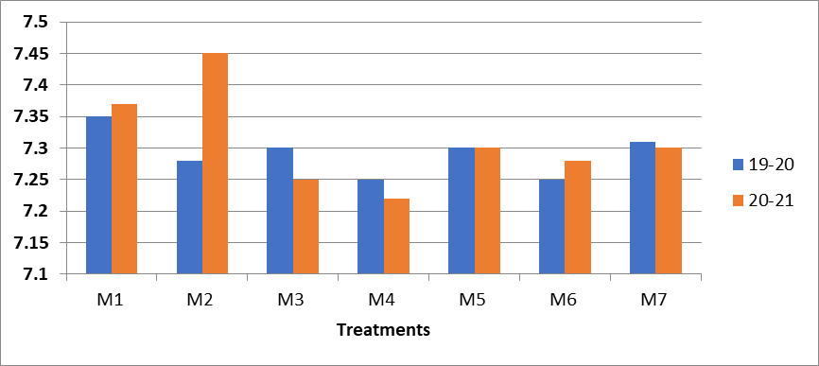
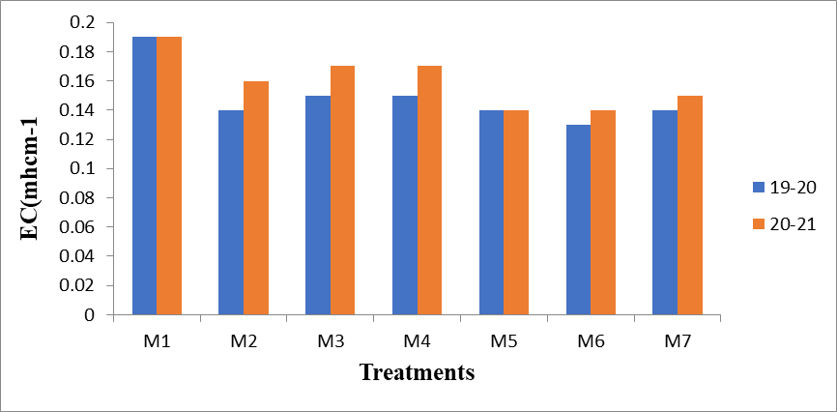

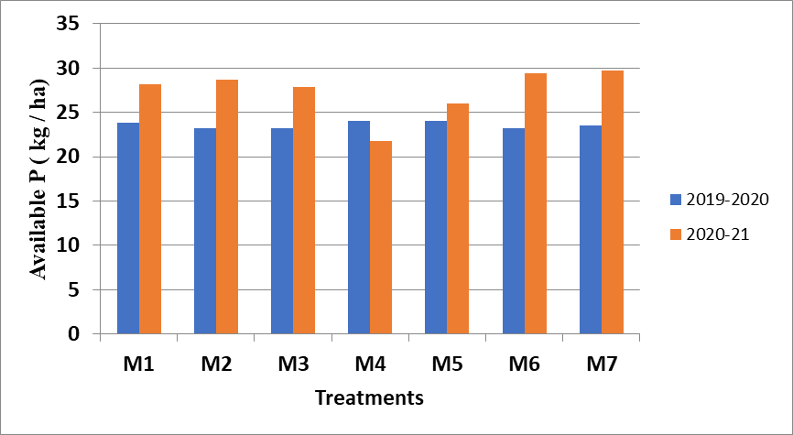
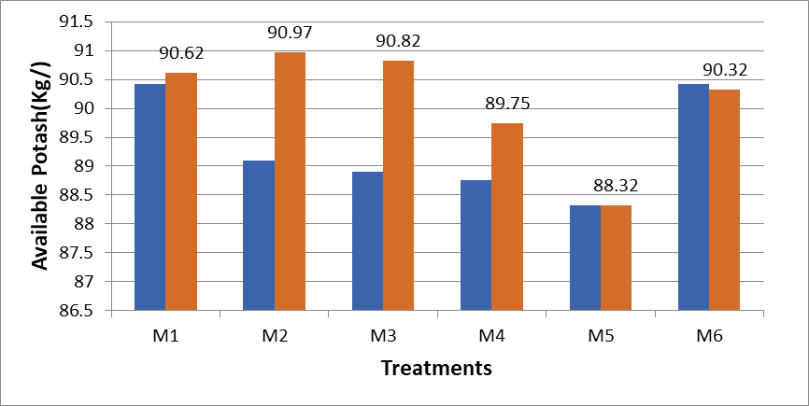

Fig 5. Impact of paddy straw management techniques on soil health
4.5. Dehydrogenize activity in wheat soil as influenced by paddy straw management techniques
Average dehydrogenize activity of two years (Fig 6) was found significantly higher (57.01 μg TPF g ⁻¹ h⁻¹) under PAU cutter cum spreader +straw decomposer+ PAU happy seeder with press wheel(M3) followed by M4 (55.47μg TPF g ⁻¹ h⁻¹) and Straw removal(manually) +thorough tillage + use of conventional drill M2 (53.21 μg TPF g ⁻¹ h⁻¹) as shown in Table 12. higher dehydrogenize activity in M3 may be due use of bio waste decomposer and mulching of paddy straw on soil which ultimately incorporate into soil after harvesting of wheat and before transplanting of paddy. It supported earlier research by Gaind et al., (2006). Incorporating rice straw enhanced the physical and biological characteristics of the soil (Singh et al., 2005; Bera et al., 2018; Saikia et al., 2019). A study also revealed that crop residue incorporation has been the essential component with key multi-functional roles in soil biological properties of soil (Smith et al., 2000; Bhaduri et al., 2017).

Table 12: Mean dehydrogenize activity (µg TPF g ⁻¹ h⁻¹) in wheat soil as influenced by paddy straw management techniques during 2019-20 and 2020-21
Treatments | Mean DHA  2019-20 | Mean DHA  2020-21
M1 | 40.65 | 43.47
M2 | 51.01 | 53.21
M3 | 52.98 | 57.01
M4 | 47.05 | 55.47
M5 | 45.98 | 48.82
M6 | 47.00 | 50.77
M7 | 48.76 | 51.53
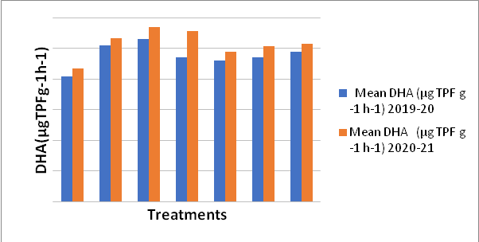
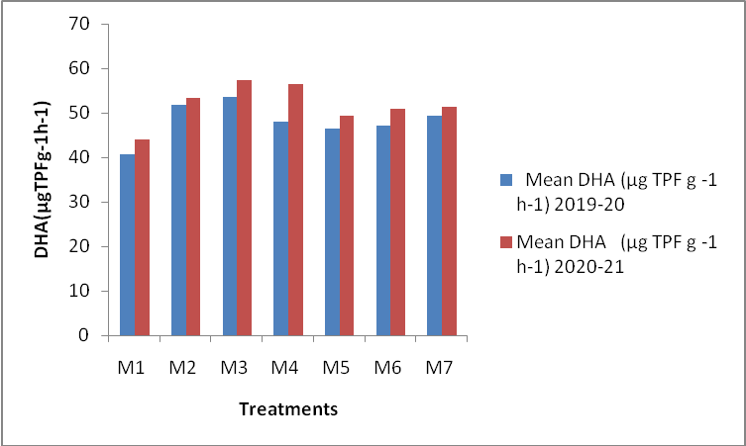
Fig 6: Impact of paddy straw management techniques on mean dehydrogenize activity in wheat soil during both the years (2019-20 and 2020-21).

Table 13. Effects of paddy straw management techniques on bulk density of soil (g/cm ³) w.r.t pooled data (2019-20 and 2020-21)
Treatments | Bulk density (g/cm³) after harvesting
M1 | 1.30
M2 | 1.30
M3 | 1.30
M4 | 1.25
M5 | 1.25
M6 | 1.28
M7 | 1.28
CD at 5% | NS
Initial value | 1.25

In M4: PAU cutter cum spreader + incorporation with Mould Board plough+ Use of Seed drill and M5: Super Straw management system +Chopper + incorporation + Use of conventional Seed Drill minimum bulk density was due to incorporation of paddy straw as compared to M1:Stubble Shaver +Burning + Zero Tillage Drill, M2: PAU cutter cum spreader + PAU happy Seeder with press wheel, M3: PAU cutter cum spreader + straw decomposer+ PAU happy Seeder with press wheel, M6: Straw removal (Manual) + Zero Tillage Drill and M7: Straw removal (Manual) + thorough tillage + Use of conventional drill (Table 13). Compared to rotavator and conventional tillage-sown wheat fields, happy seeder farms have lower bulk density, according to Singh (2013). The amount and duration of residue retention in conservation tillage, as well as the type of soil and weather conditions, all affect the bulk density. The initial few years of conservation tillage had higher bulk density, but after that, a decrease in bulk density was observed in conservation tillage compared to conventional tillage, indicating that the impact of conservation tillage on bulk density was not immediate and that it took some time to observe the decrease in bulk density compared to conventional tillage (He et al., 2009). Without a doubt, adding crop residue to conservation tillage, specifically in RWCS, helps reduce BD since the residue is lighter than mineral matter, its decomposition process is quicker, and the products encourage more soil aggregation (Abid and Lal, 2008).
4.7 Effects of paddy straw management techniques on infiltration rate of soil
Infiltration rate was measured after harvesting of paddy in 2019-20 and 2020-21. The data on infiltration rates at 5,15, 30,45,60,90 and 120 is presented in Table 14. Data in table indicated that there was an increase in infiltration rate in M4: PAU cutter cum spreader + incorporation with Mould Board plough+ Use of Seed drill and M5:Super Straw management system Chopper + incorporation + Use of conventional Seed Drill of soil due to incorporation of paddy straw as compared other treatments M1: Stubble Shaver+ Burning + Zero Tillage Drill,M2: PAU cutter cum spreader + PAU happy Seeder with press wheel,M3: PAU cutter cum spreader + straw decomposer + PAU happy Seeder with press wheel,M6: Straw removal (Manual) + Zero Tillage Drill and M7: Straw removal (Manual) + thorough tillage + Use of conventional drill similar results of improving the infiltration rate by 1.4 times due to addition of summer moong straw in maize-wheat crop sequence was reported by Sidhu and Sur (1993);Sharma et al.,(1987) also reported remarkable increment in the cumulative infiltration of soil as a result of residue incorporation and increase may be due to improved soil aggregation due to application of organic materials.

Table 14: Pooled Data (2019-20 and 2020-21) of Infiltration rate of soil affected with straw managements practices in rice-wheat cropping pattern.
Treatments | Infiltration rate (mm hr⁻¹)
Treatments | Cumulative Time (minutes)
Treatments | 5 | 10 | 15 | 20 | 30 | 60 | 90 | 120
M1: Stubble Shaver + Burning + Zero Tillage Drill | 4.55 | 1.75 | 0.6 | 0.35 | 0.25 | 0.25 | 0.15 | 0.16
M2: PAU cutter cum spreader + PAU Happy Seeder with press wheel | 4.45 | 1.75 | 0.6 | 0.35 | 0.25 | 0.25 | 0.15 | 0.1
M3: PAU cutter cum spreader + straw decomposer +PAU happy Seeder with press wheel | 4.55 | 1.75 | 0.7 | 0.45 | 0.25 | 0.2 | 0.1 | 0.1
M4: PAU cutter cum spreader + incorporation with Mould Board plough + Use of Seed drill | 6.15 | 3.05 | 3.1 | 2.1 | 1.35 | 1.6 | 1.2 | 1.3
M5: Super Straw management system +Chopper + incorporation ₊ Use of conventional Seed Drill | 6.2 | 3.1 | 3.3 | 1.95 | 1.25 | 1.7 | 1.2 | 1.2
M6: Straw removal (Manual) + Zero Tillage Drill | 4.6 | 1.8 | 0.7 | 0.55 | 0.45 | 0.4 | 0.25 | 0.2
M7: Straw removal (Manual) + thorough tillage + Use of conventional drill | 4.65 | 1.7 | 0.6 | 0.5 | 0.4 | 0.3 | 0.25 | 0.2

CHAPTER-V
SUMMARY AND CONCLUSIONS

Based on the experimental studies, the results are summarized as below:
- In the year 2019-20, maximum plant height (94.99 cm) was observed in the treatment PAU cutter cum spreader + incorporation with Mould Board plough + Use of Seed drill (M4). In the year 2020-21, maximum height was also observed in M4: PAU cutter cum spreader+ incorporation with Mould Board plough+ Use of Seed drills (96.76 cm) and was at par with M3. Among the pooled data similar results were found to be obtained where maximum plant height was observed in M4: PAU cutter cum spreader + incorporation with Mould Board plough+ Use of Seed drill (95.87 cm).
- In the year 2019-20, maximum no of tillers per square meter (446.94) was observed in the treatment M3: PAU cutter cum spreader + straw decomposer + PAU Happy Seeder with press wheel and was at par with M2: PAU cutter cum spreader + PAU happy Seeder with press wheel (434.50) and the least count was observed in M6: Straw removal (Manual) + Zero Tillage Drill (360.63). In pooled data, highest tiller count was observed in M2: PAU cutter cum spreader + PAU Happy Seeder with press wheel (437.70) and minimum was found in M6: Straw removal (Manual) + Zero Tillage Drill (355.65) and these results were like the results in the year 2020-21.
- In the year 2019-20, spike length (12.91) was found to be maximum in the M2: PAU cutter cum spreader + PAU Happy Seeder with press wheel and was followed by M7: Straw removal (Manual) + thorough tillage+ Use of conventional drill (12.49), M6: Straw removal (Manual) + Zero Tillage Drill(12.36) and M4: PAU cutter cum spreader + incorporation with Mould Board plough + Use of Seed drill(12.26). Similarly in the year 2020-21, maximum spike length was observed in the M2: PAU cutter cum spreader + PAU happy Seeder with press wheel (11.34). Minimum length was observed in the treatment M1: Stubble Shaver + Burning + Zero Tillage Drill (9.73). Similar trends were observed in the pooled data.
- The number of spikelets per spike varied from 17.57 to 14.67 in 2019-20, with M2: PAU cutter cum spreader + PAU happy Seeder with press wheel exhibiting the maximum number and M6: Straw removal (Manual) + Zero Tillage Drill exhibiting the minimum number. Additionally, it was significantly higher in treatment M2: PAU cutter cum spreader + PAU happy Seeder with press wheel (19.09) in the year 2020-21 than it was in the rest of the treatments. Variety HD 3086 (V1) and PBW 550Unnat (V2) showed same trend in the year 2020-21 on number of spikelets per spike with respect to varieties no significant difference was observed for both the years as well as pooled data. Significant interaction was found between paddy residue management methods and varieties and vice versa.
- A significant difference among the treatments was observed in both the year whereas no significant difference was observed with respect to the varieties. The test weights were between 38.50 g to 45.62 g. The treatments M2: PAU cutter cum spreader + PAU happy Seeder with press wheel (45.62 g) gave the highest test weight in comparison to the other treatments.
- Grain yield ranged from 42.0 to 52.2 q/ha during 2019-20. The treatmentsM2: PAU cutter cum spreader + PAU happy Seeder with press wheel (52.16 q/ha) and M3: PAU cutter cum spreader + straw decomposer+ PAU Happy Seeder with press wheel (48.83 q/ha) were statistically at par with each other and had given highest grain yield in comparison to the other treatments. By comparing 2019-20 and 2020-21’s grain yield of wheat, the first year of study recorded higher grain yield compared to second year (42.2-48.8 q/ha) may be due to favorable weather conditions. Pooled data showed the same trend. As far as varieties are concerned, V2: PBW 550 Unnat (47.90 q/ha) superseded in grain yield as compared to V1: HD 3086 (44.76 q/ha) for both years and overall, also. During 2019-20, V2: PBW 550 Unnat showed statistically higher grain yield (7%) more than V1: HD 3086 variety.
- Though, the benefit-cost ratio was also highest with M2: PAU cutter cum spreader + PAU happy Seeder with press wheel (1.54) as compared to M3: PAU cutter cum spreader + straw decomposer+ PAU happy Seeder with press wheel (1.46), M1: Stubble Shaver + Burning + Zero Tillage Drill (1.23) and M6: Straw removal (Manual) + Zero Tillage Drill (1.03).
- In both the cropping seasons of 2019–20 and 2020–21, it was discovered that there was no significant difference between the effects of rice residue management approaches on soil pH and EC. The maximum soil EC for both the years was in treatmentM1: Stubble Shaver+ Burning + Zero Tillage Drill (0.19 mho/cm).
- A slight increase in organic carbon content was observed from 2019-20 and 2020-21 in all the treatments. In the year 2019-20, maximum OC was observed in the treatment M4: PAU cutter cum spreader + incorporation with Mould Board plough +Use of Seed drill (0.51%), and was similar in M5: Super Straw management system +Chopper + incorporation (M5) ₊ Use of conventional Seed Drill (0.50%)
- It was noted that the soil's available P in the 2019–20 ranged from 23.25 to 24 kg/ha. An increase in available P was seen in all the treatments from 2019–20 to 2020–21 excluding M4. The results showed that the available S (kg/ha) results for the two years, 2019–20 and 2020–21, were similar. For both years, the maximum was seen in the M4: PAU cutter cum spreader + incorporation with Mould Board plough + Use of Seed drill (39.2 and 45.87). The treatment M3: PAU cutter cum spreader + straw decomposer+ PAU happy Seeder with press wheel had the highest concentration of Zn (mg/kg soil) during both years (1.62 and 2.51). The maximum amount of Fe (mg/kg soil) was observed to be maximum in both treatment M4 and M5 for 2019-20 (40.2) and M7: Straw removal (Manual) + thorough tillage+ Use of conventional drill 2020-21 (56.57). For Mn (mg/kg soil) in 2019–20, the highest quantity was seen in treatment M4 and M5 (5.20), while the lowest amount was shown in M7: Straw removal (Manual) + thorough tillage+ Use of conventional drill (4.55).
- Average dehydrogenize activity of two years (Fig 6) was found significantly higher (57.01 μg TPF g ⁻¹ h⁻¹) under PAU cutter cum spreader +straw decomposer+ PAU happy seeder with press wheel(M3) followed by M4 (55.47μg TPF g ⁻¹ h⁻¹⁾ and Straw removal(manually) +thorough tillage + use of conventional drill M2 (53.21 μg TPF g ⁻¹ h⁻¹⁾. Data in table indicated that there was an increase in infiltration rate in M4: PAU cutter cum spreader + incorporation with Mould Board plough+ Use of Seed drill and M5: Super Straw management system Chopper + incorporation + Use of conventional Seed Drill of soil due to incorporation of paddy straw as compared other treatments.
It is concluded therefore that Wheat sown with PAU cutter cum spreader (M2) + PAU happy seeder with press wheel method produced the maximum growth and yield with respect to number of tillers/m², number of spikelets per spike, number of grains per spike, test weight and grain yield. Both varieties showed similar effects when any of the methods of residue management was taken. Wheat sowing with PAU cutter cum spreader (M2) + PAU happy seeder with press wheel method was found to be economically viable. Soil health improved by incorporation of paddy straw through PAU cutter cum spreader + incorporation with Mould Board plough + Use of Seed drill.

REFERCENCES
Abid, M. and Lal, R. (2008). Tillage and drainage impact on soil quality: I. Aggregate stability, carbon and nitrogen pools. Soil and Tillage Research, 100(1-2), 89-98.
Alberto, M. C. R., Wassmann, R., Gummert, M., Buresh, R. J., Quilty, J. R., Correa Jr, T. Q.and Oca, G. M. (2015). Straw incorporated after mechanized harvesting of irrigated rice affects net emissions of CH4 and CO2 based on eddy covariance measurements. Field Crops Research, 184, 162-175.
Alvarez, R., & Steinbach, H. S. (2009). A review of the effects of tillage systems on some soil physical properties, water content, nitrate availability and crops yield in the Argentine Pampas. Soil and Tillage Research, 104(1), 1-15.
Aulakh, M. S., Khera, T. S., Doran, J. W., & Bronson, K. F. (2001). Managing crop residue with green manure, urea, and tillage in a rice–wheat rotation. Soil Science Society of America Journal, 65(3), 820-827.
Badarinath, K. V. S., Chand, T. K. and Prasad, V. K. (2006). Agriculture crop residue burning in the Indo-Gangetic Plains–a study using IRS-P6 AWiFS satellite data. Current Science, 1085-1089.
Bahrani, M. J., Kheradnam, M., Emam, Y., Ghadiri, H. and Assad, M. T. (2002). Effects of tillage methods on wheat yield and yield components in continuous wheat cropping. Experimental Agriculture, 38(4), 389-395.
Bai, H. P., Hu, X. Q., Zhu, J. T., Pan, Y. X., Liang, Y. P., Zhang, X. J.and Jiang, A. F. (2011). Effects of corn straw returning to field on wheat field soil nutrient. Science and Technology Information, 11, 37–38.
Baldock, J. A. (2007). Composition and cycling of organic carbon in soil. In Nutrient cycling in terrestrial ecosystems (pp. 1-35). Berlin, Heidelberg: Springer Berlin Heidelberg.
Behera, B. (2018). Recycling of crop residues for improved soil nutrient status and farm income, department of agronomy CA. OUAT, Bhubaneswar.
Bellakki, M. A., Badanur, V. P. and Setty, R. A. (1998). Effect of long-term integrated nutrient management on some important properties of a Vertisol. Journal of the Indian Society of Soil Science, 46(2), 176-180.
Bera, T., Sharma, S., Thind, H. S., Sidhu, H. S., & Jat, M. L. (2018). Changes in soil biochemical indicators at different wheat growth stages under conservation-based sustainable intensification of rice-wheat system. Journal of Integrative Agriculture, 17(8), 1871-1880.
Beri, V., Sidhu, B. S., Bahl, G. S. and Bhat, A. K. (1995). Nitrogen and phosphorus transformations as affected by crop residue management practices and their influence on crop yield. Soil Use and Management, 11(2), 51-54.
Beri, V., Sidu, B. S., Bhat, A. K., Bhujsinderpal Singh, B. S. and Singh, B. (1992). Nutrient balance and soil properties as affected by management of crop residues.
Bhaduri, D., Purakayastha, T. J., Patra, A. K., Singh, M., & Wilson, B. R. (2017). Biological indicators of soil quality in a long-term rice–wheat system on the Indo-Gangetic plain: combined effect of tillage–water–nutrient management. Environmental Earth Sciences, 76, 1-14.
Bhatt, R., Kukal, S. S., Busari, M. A., Arora, S. and Yadav, M. (2016). Sustainability issues on rice–wheat cropping system. International Soil and Water Conservation Research, 4(1), 64-74.
Bhumbla, D. R., & Sandhu, B. S. (1967).Effect of addition of different organic material and gypsum on soil structure. Journal of the Indian Society of Soil Science, 15, 141–148.
Biswas, B. K., Chand, B. K., Biswas, A. and Goswami, A. (2006). Studies on improvement of poor-quality paddy straw through urea-molasses-mineral mixture treatment on intake and milk production in cows.
Chakraborty, D., Nagarajan, S., Aggarwal, P., Gupta, V. K., Tomar, R. K., Garg, R. N. and Kalra, N. (2008). Effect of mulching on soil and plant water status, and the growth and yield of wheat (Triticum aestivum L.) in a semi-arid environment. Agricultural Water Management, 95(12), 1323-1334.
Chatterjee, S., Bandyopadhyay, K. K., Pradhan, S., Singh, R. and Datta, S. P. (2018). Effects of irrigation, crop residue mulch and nitrogen management in maize (Zea mays L.) on soil carbon pools in a sandy loam soil of Indo-gangetic plain region. Catena, 165, 207-216.
Choudhary, M. (2015). Effect of planting dates, tillage, and residue management on weed dynamics and crop productivity in wheat under the rice-wheat system (Doctoral dissertation, Sardar Vallabhbhai Patel University of Agriculture and Technology, Meerut, Uttar Pradesh).
Chesnin, L. and Yien, C. H. (1950). Turbid metric method for determination of sulphur. Proc. Soil Sci. Soc. America1950, 14, 149-151.
Clark, G. J., Dodgshun, N., Sale, P. W. G. and Tang, C. (2007). Changes in chemical and biological properties of a sodic clay subsoil with addition of organic amendments. Soil Biology and Biochemistry, 39(11), 2806-2817.
Das, T. K. and Yaduraju, N. T. (2011). Effects of missing-row sowing supplemented with row spacing and nitrogen on weed competition and growth and yield of wheat. Crop and Pasture Science, 62(1), 48-57.
Dastane, N.G. 1967. Practical manual for water use research.
Dendooven, L. (2009). Conservation agriculture and soil carbon sequestration: Between myth and farmer reality. Critical Reviews in Plant Sciences, 28(3), 97–122.
Dhillon, G. S. (2016). Comparative evaluation of happy seeder technology versus normal sowing in wheat (Triticum aestivum) in adopted village Killi Nihal Singh of Bathinda district of Punjab. Journal of Applied and Natural Science, 8(4), 2278.
Dixit, J., Gupta, R. S. R., Behl, V. P. and Yadav, R. L. (2003). No-tillage and conventional tillage system evaluation for production of wheat-an analysis. Indian Journal of Agricultural Research, 37(3), 199-203.
Dolan, M. S., Clapp, C. E., Allmaras, R. R., Baker, J. M. and Molina, J. A. E. (2006). Soil organic carbon and nitrogen in a Minnesota soil as related to tillage, residue and nitrogen management. Soil and Tillage Research, 89(2), 221-231.
Dong, W., Zhang, X., Wang, H., Dai, X., Sun, X., Qiu, W. and Yang, F. (2012).Effect of different fertilizer application on the soil fertility of paddy soils in the red soil region of southern China. PLOS ONE, 7(9), e44504.
Dwivedi, D. K. and Thakur, S. S. (2000). Production potential of wheat (Triticum aestivum) crop as influenced by residual organics, direct and residual fertility levels under rice (Oryza sativa)-wheat cropping system. Indian Journal of Agronomy, 45(4):641-647.
Freebairn, D. M., Ward, L. D., Clarke, A. L. and Smith, G. D. (1986). Research and development of reduced tillage systems for Vertisols in Queensland, Australia. Soil and Tillage Research, 8, 211-229.
Gaind, S., Pandey, A. K. and Lata (2006). Microbial biomass, P-nutrition, and enzymatic activities of wheat soil in response to phosphorus enriched organic and inorganic manures. Journal of Environmental Science and Health Part B, 41(2), 177-187.
Gangwar, K. S., Singh, K. K., Sharma, S. K. and Tomar, O. K. (2006). Alternative tillage and crop residue management in wheat after rice in sandy loam soils of Indo-Gangetic plains. Soil and Tillage Research, 88(1-2), 242-252.
Gathala, M. K., Kumar, V., Sharma, P. C., Saharawat, Y. S., Jat, H. S., Singh, M. and Ladha, J. K. (2013). Optimizing intensive cereal-based cropping systems addressing current and future drivers of agricultural change in the northwestern Indo-Gangetic Plains of India. Agriculture, Ecosystems & Environment, 177, 85-97.
Gathala, M. K., Ladha, J. K., Kumar, V., Saharawat, Y. S., Kumar, V., Sharma, P. K and Pathak, H. (2011a). Tillage and crop establishment affects sustainability of South Asian rice–wheat system. Agronomy Journal, 103(4), 961-971.
Gathala, M. K., Ladha, J. K., Saharawat, Y. S., Kumar, V., Kumar, V. and Sharma, P. K. (2011). Effect of tillage and crop establishment methods on physical properties of a medium‐textured soil under a seven‐year rice− wheat rotation. Soil Science Society of America Journal, 75(5), 1851-1862.
Gaur, A. C. and Sadasivam, K. V. (1993). Theory and practical considerations of composting organic wastes. Organics in soil health and crop production, 1-22.

Ghosh, P. K., Das, A., Munda, G. C., Patel, D. P.and Saha, R. (2011). Prospects and opportunities for conservation agriculture in rice based cropping systems of Northeast India. Conservation Agriculture News Letter (PACA), 18, 4-5.

Govaerts, B., Verhulst, N., Castellanos-Navarrete, A., Sayre, K. D., Dixon, J. and

Government of Punjab. (2014).Management and utilization of paddy straw in Punjab: Earn, don’t burn initiative (Draft White Paper). Department of Science, Technology and Environment.
Government of Punjab. (2017).Statistical abstract of Punjab 2017 (Publication No. 956). Economic and Statistical Organization, Chandigarh.
Gupta R (2012). The Happy Seeder: An Agricultural Solution to Air Pollution in South Asia, Policy Brief 61, South Asian Network for Development and Environmental Economic, Kathmandu, Nepal.
Gupta, R. K., Ladha, J. K., Singh, J., Singh, G. and Pathak, H. (2007). Yield and phosphorus transformations in a rice–wheat system with crop residue and phosphorus management. Soil Science Society of America Journal, 71(5), 1500-1507.
Gupta, R., & Sayre, K. (2007). Conservation agriculture in south Asia. Journal Of Agricultural Science-Cambridge-, 145(3), 207.
Helmke, P. A. and Sparks, D. (1996). Methods of soil analysis, part 3. Chemical methods, 1085-1121.
Hiel, M. P., Barbieux, S., Pierreux, J., Olivier, C., Lobet, G., Roisin, C. and Dumont, B. (2018). Impact of crop residue management on crop production and soil chemistry after seven years of crop rotation in temperate climate, loamy soils. PeerJ, 6, e4836.
Hill, R. L., Horton, R., & Cruse, R. M. (1985). Tillage effects on soil water retention and pore size distribution of two Mollisols. Soil Science Society of America Journal, 49(5), 1264-1270.

Hiloidhari, M., Das, D. and Baruah, D. C. (2014). Bioenergy potential from crop residue biomass in India. Renewable and sustainable energy reviews, 32, 504-512.
Hira, G. S., Jalota, S. K.and Arora, V. K. (2004). Efficient management of water resources for sustainable cropping in Punjab. Research Bulletin, Department of Soils, Punjab Agricultural University, Ludhiana, 20.
Iqbal, M. F., Hussain, M., Faisal, N., Iqbal, J., Rehman, A. U., Ahmad, M.andPadyar, J. A. (2017). Happy seeder zero tillage equipment for sowing of wheat in standing rice stubbles. International Journal of Advanced Research in Biological Sciences, 4(4), 101-105.
Jat, M. L., Gathala, M. K., Ladha, J. K., Saharawat, Y. S., Jat, A. S., Kumar, V.and Gupta, R. (2009). Evaluation of precision land leveling and double zero-till systems in the rice–wheat rotation: Water use, productivity, profitability and soil physical properties. Soil and Tillage Research, 105(1), 112-121.
Jat, M. L., Gathala, M. K., Saharawat, Y. S., Tetarwal, J. P. Gupta, R. (2013). Double no-till and permanent raised beds in maize–wheat rotation of north-western Indo-Gangetic plains of India: Effects on crop yields, water productivity, profitability and soil physical properties. Field Crops Research, 149, 291-299.
Jat, M. L., Saharawat, Y. S. and Gupta, R. (2011). Conservation agriculture in cereal systems of South Asia: Nutrient management perspectives. Karnataka Journal of Agricultural Sciences, 24(1).
John, A. (2013). Alternatives to open-field burning on paddy farms. OPTIONS Agricultural and Food Policy Studies Institute, Malaysia, 18, 1-5.
Kamla, M., Tokkas, J., Chander, Anand, R. and Kumari, N. (2015).Pretreated rice straw as an improved fodder for ruminants—An overview. Journal of Applied and Natural Science, 7(1), 514–520.
Karami, A., Homaee, M., Afzalinia, S., Ruhipour, H. and Basirat, S. (2012). Organic resource management: Impacts on soil aggregate stability and other soil physico-chemical properties. Agriculture, Ecosystems & Environment, 148, 22-28.
Karlen, D. L., Wollenhaupt, N. C., Erbach, D. C., Berry, E. C., Swan, J. B., Eash, N. S. and Jordahl, J. L. (1994). Crop residue effects on soil quality following 10-years of no-till corn. Soil and Tillage Research, 31(2-3), 149-167.
Katyal, V., Sharma, S. K.andGangwar, K. S. (1998). Stability analysis of rice (Oryza sativa)-Wheat (Triticum aestivum) cropping system in integrated nutrient management. The Indian Journal of Agricultural Sciences, 68(2).
Kaushal, M., Singh, A. and Kang, J. S. (2012). Effect of planting techniques and nitrogen levels on growth, yield and N recovery in wheat (Triticum aestivum L.). J. Res., Punjab Agriculture University, 49(1), 14-16.
Kayombo, Bond and Lal, G.P. (1986).Effects of soil compaction by rolling and soil structure and development of maize in no till and disc ploughingon a tropical alfisol. Soil Tillage Res., 7: 117-134.
Kharia, S., Thind, H. S., Sharma, S., Sidhu, H. S., Jat, M. L. and Singh, Y. (2017). Tillage and rice straw management affect soil enzyme activities and chemical properties after three years of conservation agriculture based rice-wheat system in north-western India.
Kharub, A. S., Sharma, R. K., Mongia, A. D., Chhokar, R. S., Tripathi, S. C. and Sharma, V. K. (2004). Effect of rice (Oryza sativa) straw removal, burning and incorporation on soil properties and crop productivity under rice-wheat (Triticum aestivum) system.
Kumar, A., Gaind, S. and Nain, L. (2008). Evaluation of thermophilic fungal consortium for paddy straw composting. Biodegradation, 19, 395-402.
Kumar, A., Sharma, D. K. and Sharma, H. C. (1995). Response of wheat (Triticum aestivum) to irrigation and nitrogen in sodic soils. Indian Journal of Agronomy, 40(1), 38–42.
Kumar, M., Singh, R. R., and Rana, N. S. (2003). Effect of organic and inorganic sources of nutrition on productivity of rice (Oryza sativa). Indian Journal of Agronomy, 48(3), 175-177.
Kumari, K., Prasad, J., Solanki, I. S. and Chaudhary, R. (2018). Long-term effect of crop residues incorporation on yield and soil physical properties under rice-wheat cropping system in calcareous soil. Journal of Soil Science and Plant Nutrition, 18(1), 27-40.
Kundu, A. L., Ghosh, R. K. and Mondal, T. K. (1994). Effect of crop waste on production in a rice-wheat crop sequence under rainfed conditions in the Gangetic plains of West Bengal. Advances in Plant Sciences, 7, 228–234.
Lal, R. (1989). Conservation tillage for agriculture: tropics versus temperate environments. Advances in Agronomy, 42, 85-197.
Lal, R. (2004). Soil carbon sequestration to mitigate climate change. Geoderma, 123(1-2), 1-22.
Lao, X. R., Sun, W. H., Wang, Z., Hao, Y. R. and Zhang, C. A. (2003). Effect of matching use of straw and chemical fertilizer on soil fertility. Acta Pedologica Sinica, 40, 618–623.
Li, F. M., Wang, J. and Zhang, X. J. (2005). Plastic film mulch effect on spring wheat in a semiarid region. J Sust Agric., 25: 5–17.
Li, L. L., Huang, G. B., and Zhang, R. Z. 2004. Conservation tillage development research on the Western Loess Plateau of Gansu Province. In "Food Security and Farming Systems" (W.Gao, Ed.),. Hunan Sci & Tech Press, Changsha pp. 185- 188.
Limousin, G. and Tessier, D. (2007). Effects of no-tillage on chemical gradients and topsoil acidification. Soil and Tillage Research, 92(1-2), 167-174.
Lindsay, W. L. and Norvell, W. A. (1978). Development of DTPA soil test for ZInc, iron, manganese and copper Proceedings of Soil Science Society of America 42, 421 - 428.
Liu, E., Yan, C., Mei, X., He, W., Bing, S. H., Ding, L.and Fan, T. (2010). Long-term effect of chemical fertilizer, straw, and manure on soil chemical and biological properties in northwest China. Geoderma, 158(3-4), 173-180.
Liu, Y.-G., Lin, Q., Wang, Y.-F., Guo, J.-X. and Liu, H.-J. (2007).Effects of coupling of straw-return and nitrogen fertilizer on photosynthetic characters and yield of winter wheat. Chinese Journal of Eco-Agriculture, 15(1), 42–44.
Ma, Y., Hongkui, S., Shukui, Z. andRunhai, L. (2003).Whole maize straw addition: The changes of soil physical and chemical properties and the effect on winter wheat. Journal of China Agricultural University, 8(Suppl.), 42–46.
Malik, R. K., Gupta, R. K., Singh, C. M., Yadav, A., Brar, S. S., Thakur, T. C. and Sinha, R. K. (2005). Accelerating the adoption of resource conservation technologies in rice wheat system of the Indo-Gangetic Plains. In Proceedings of Project Workshop, Directorate of Extension Education, Chaudhary Charan Singh Haryana Agricultural University (CCSHAU) (pp. 1-2).
Mandal, K. G., Misra, A. K., Hati, K. M., Bandyopadhyay, K. K., Ghosh, P. K., & Mohanty, M. (2004). Rice residue-management options and effects on soil properties and crop productivity. Journal of Food Agriculture and Environment, 2, 224-231.
Mando, A. Strosnijder, L. and Brussard, L. (1996). Effects of termites on infiltration into crused soil. Geoderma 74: 107-113.
Maskina, M. S., Singh, Y. and Singh, B. (1987). Wheat straw management for rice on a coarse-textured soil. International Rice Research Newsletter, 12, 40.
Maurya, P. R. (1986). Effect of tillage and residue management of maize and wheat yield and on physical properties of an irrigated sandy loam soil in Northern Nigeria. Soil and Tillage Research, 8, 161-170.
McNeill, V. F. (2017). Atmospheric aerosols: clouds, chemistry, and climate. Annual review of chemical and biomolecular engineering, 8(1), 427-444.
Meelu, O. P., Singh, B., and Singh, Y. (1994). Effect of green manure and crop residue recycling on N economy, organic matter and physical properties of rice- wheat system in India, 7–8 May, 1994, CCS HAU, Regional Res. Station, Karnal, 761-769.
Mehta, A. K. and Singh, R. (2005). Transfer of resource conserving technologies through Krishi Vigyan Kendras. Conservation agriculture—status and prospects. (Eds IP Abrol, RK Gupta, RK Malik) pp, 128-134.
MoA (Ministry of Agriculture). 2012. Government of India, New Delhi. Retrieved from www.eands.dacnet.nic.in
Misra, R. D., Gupta, V. K. andPandey, D. S. (1996).Managing crop residue in rice. International Rice Research Notes, 21(2–3), 71.
Mondal, M., Skalicky, M., Garai, S., Hossain, A., Sarkar, S., Banerjee, H. and Laing, A. M. (2020). Supplementing nitrogen in combination with rhizobium inoculation and soil mulch in peanut (Arachis hypogaea L.) production system: Part II. Effect on phenology, growth, yield attributes, pod quality, profitability and nitrogen use efficiency. Agronomy, 10(10), 1513.
Mousavi, S. F., Moazzeni, M., Mostafazadeh-Fard, B. and Yazdani, M. R. (2012). Effects of rice straw incorporation on some physical characteristics of paddy soils. Journal of Agricultural Science and Technology, 4, 1173–1183.
Naresh, R. K., Gupta, R. K., Jat, M. L., Singh, S. P., Dwivedi, A., Dhaliwal, S. S. and Rathore, R. S. (2016). Tillage, irrigation levels and rice straw mulches effects on wheat productivity, soil aggregates and soil organic carbon dynamics after rice in sandy loam soils of subtropical climatic conditions.
Negi, S. C., Raghavan, G. S. V. and Taylor, F. (1982). Hydraulic characteristics of conventionally and zero-tilled field plots. Soil and Tillage Research, 2(3), 281-292.
Niveta J., Bhatia A., Pathak H. 2014. Emission of air pollution from crop residue burning in India. Centre for Environment science and climate resilient agriculture, Indian agricultural Research institute, New Delhi., Aerosol and Air Quality Research, 14: 422- 430
Nuttall, W. F., Bowren, K. E. and Campbell, C. A. (1986). Crop residue management practices, and N and P fertilizer effects on crop response and on some physical and chemical properties of a black chernozem over 25 years in a continuous wheat rotation. Canadian journal of soil science, 66(1), 159-171.
Olsen, S. R., C. U. Cole, F. S. Watanabe, and L. A. Deen 1954. Estimation of available Phosphorous in soil by extractingwith sodium bicarbonate. USDA Cire. 939. US Gov. Print, Office,Washington,DC.
Paikaray, R. L., Mahapatra, B. S. and Sharma, G. L. (2001). Integrated nitrogen management in rice (Oryza sativa)-wheat (Triticum aestivum) cropping system. Indian Journal of Agronomy, 46(4), 592-600.
Palangappa, P. U. (1997). Effect of soil structure on infiltration and moisture conservation by application of soil amendments of red soils of Bangalore district. Thesis, University of Agricultural Sciences. 67.
Ponnamperuma, F. N. (1984). Straw as a source of nutrients for wetland rice. Organic matter and rice, 117, 136.
Power, J. F., Koerner, P. T., Doran, J. W. and Wilhelm, W. W. (1998). Residual effects of crop residues on grain production and selected soil properties. Soil Science Society of America Journal, 62(5), 1393-1397.
Prasad, B. and Sinha, S. K. (1995). Nutrient recycling through crop residues management for sustainable rice and wheat production in calcareous soil. Fertiliser News, 40, 15–28.
Prasad, R., Gangaiah, B.andAipe, K. C. (1999). Effect of crop residue management in a rice–wheat cropping system on growth and yield of crops and on soil fertility. Experimental Agriculture, 35(4), 427-435.
Rafiq, M. H., Ahmad, R., Jabbar, A., Munir, H. andHussain, M. (2017). Influence of Different No-till Techniques at Varying Heights of Standing Rice Stubbles on the Wheat Performance. International Journal of Agriculture & Biology, 19(3).
Rahman, M. A., Chikushi, J., Saifizzaman, M. and Lauren, J. G. (2005). Rice straw mulching and nitrogen response of no-till wheat following rice in Bangladesh. Field Crops Research, 91(1), 71-81.
Raison, R. J. (1979). Modification of the soil environment by vegetation fires, with particular reference to nitrogen transformations: a review. Plant and soil, 51, 73-108.
Ramesh, R., Negi, S. C. and Rana, S. S. (2016). Resource conservation technologies (RCTs) Needs and future prospects: A review. Agricultural Reviews, 37, 257–267.
Rasmussen, P. E. and Collins, H. P. (1991). Long-term impacts of tillage, fertilizer, and crop residue on soil organic matter in temperate semiarid regions. Advances in agronomy, 45, 93-134.
Rasmussen, P. E., Allmaras, R. R., Rohde, C. R. and Roager Jr, N. C. (1980). Crop residue influences on soil carbon and nitrogen in a wheat‐fallow system. Soil Science Society of America Journal, 44(3), 596-600.
Raun, W. R. and Johnson, G. V. (1999). Improving nitrogen use efficiency for cereal production. Agronomy journal, 91(3), 357-363.
Roldán, A., Caravaca, F., Hernández, M. T., Garcıa, C., Sánchez-Brito, C., Velásquez, M. and Tiscareno, M. (2003). No-tillage, crop residue additions, and legume cover cropping effects on soil quality characteristics under maize in Patzcuaro watershed (Mexico). Soil and Tillage Research, 72(1), 65-73.
Roy, P. and Kaur, M. (2016). Awareness regarding alternative techniques of paddy straw management in Punjab and West Bengal-A comparative analysis. Ecology, Environment and Conservation, 22(3), 1313-1316.
Saikia, R., Sharma, S., Thind, H. S. and Sidhu, H. S. (2019). Temporal changes in biochemical indicators of soil quality in response to tillage, crop residue and green manure management in a rice-wheat system. Ecological Indicators, 103, 383-394.
Salar, R. K. and Aneja, K. R. (2007). Significance of thermophilic fungi in mushroom compost preparation: effect on growth and yield of Agaricus bisporus (Lange) Sing. Journal of Agricultural Technology, 3(2), 241-253.
Samui, I., Skalicky, M., Sarkar, S., Brahmachari, K., Sau, S., Ray, K. and El Sabagh, A. (2020). Yield response, nutritional quality and water productivity of tomato (Solanum lycopersicum L.) are influenced by drip irrigation and straw mulch in the coastal saline ecosystem of Ganges delta, India. Sustainability, 12(17), 6779.
Sandhu, B. S.andBhumbla, D. R. (1967). Effect of addition of different organic materials and gypsum on soil structure.
Sarkar, A. (1997). Energy-use patterns in sub-tropical rice-wheat cropping under short term application of crop residue and fertilizer. Agriculture, ecosystems & environment, 61(1), 59-67.
Shahzad, M. A., Wasi-ud-Din, W. U. D., Sahi, S. T., Khan, M. M., Ehsanullah, E. and Maqsood Ahmad, M. A. (2007). Effect of sowing dates and seed treatment on grain yield and quality of wheat.
Sharma, S. and Dhaliwal, S. S. (2021). Conservation agriculture based practices enhanced micronutrients transformation in earthworm cast soil under rice-wheat cropping system. Ecological Engineering, 163, 106195.
Sharma, D. N., Jain, M. L. and Sharma, S. (1984). Evaluation of no-tillage and conventional tillage systems. Agricultural Mechanization in Asia, Africa and Latin America, 15, 14–18.
Sharma, H. L., Modgal, S. C., and Singh, M. P. (1985). Effect of applied organic manure, crop residues and nitrogen in rice-wheat cropping system in north-western Himalayas. Himachal Journal of Agricultural Research, 11(1), 63-68.
Sharma, H. L., Singh, C. M., &Modgal, S. C. (1987). Use of organics in rice-wheat crop sequence. Indian Journal of Agricultural Sciences, 57(3), 163–168.
Sharma, R. K., Chhokar, R. S., Singh, R. K. and Gill, S. C. (2008). Zero tillage wheat and unpuddled rice: the energy, labour and cost efficient alternatives to conventional rice-wheat system. In Proceedings of the “14th Australian Agronomy Conference”(MJ Unkovich), Adelaide, South Australia (pp. 147-158).
Shi, J. (2013).Decomposition and nutrient release of different cover crops in organic farm systems (Publication No. 75) [Master’s thesis, University of Nebraska]. Dissertations & Theses in Natural Resources.
Sidhu, A. S. and Sur, H. S. (1993). Effect of incorporation of legume straw on soil properties and crop yield in maize-wheat sequence. Tropical Agriculture (Trinidad), 70, 226–229.
Sidhu, B. S. and Beri, V. (1989). Effect of crop residue management on the yields of different crops and on soil properties. Biological wastes, 27(1), 15-27.
Sidhu, B. S. and Beri, V. (2005). Experience with managing rice residues in intensive rice-wheat cropping system in Punjab. Conservation agriculture: Status and prospects, 55-63.
Sidhu, B. S., Beri, V. andGosal, S. K. (1995). Soil microbial health as affected by crop residue management. In Proceedings of the National Symposium on Developments in Soil Science (pp. 45–46). Indian Society of Soil Science, New Delhi, India.
Sidhu, H. S., Humphreys, E., Dhillon, S. S., Blackwell, J.and Bector, V. (2007). The Happy Seeder enables direct drilling of wheat into rice stubble. Australian Journal of Experimental Agriculture, 47(7), 844-854.
Singh, Shan, Y. H., Johnson-Beebout, S. E., & Buresh, R. J. (2008). Crop residue management for lowland rice-based cropping systems in Asia. Advances in Agronomy, 98, 117–199.
Singh, M. P., & Kumar, V. (2005). Ripples of changes through zero-tillage technology for enhancement of productivity and conservation of resources: experiences of KVK Bahraich. Conservation Agriculture–, 135.
Singh S. K., Kumar D, and Lal S. S. (2010). Integrated use of crop residues and fertilizers for sustainability of potato (Solanum tuberosum) based cropping systems in Bihar. Indian Journal of Agronomy. 55(3): 203-208.
Singh Y, Singh B. 2001. Efficient Management of Primary Nutrients in the Rice-Wheat System. In: Kataki, P.K. (Ed.). The Rice-Wheat Cropping Systems of South Asia: Efficient Production Management. Food Products Press, New York, USA. 23-85.
Singh, A., Dhaliwal, I. S. and Dixit, A. (2011). Performance evaluation of tractor mounted straw chopper cum spreader for paddy straw management. Indian Journal of Agricultural Research, 45(1), 21-29.
Singh, A., Kaushal, M. and Singh, H. (2012). Improvement in productivity of wheat with crop residue and nitrogen-a review. Asian Journal of Biological and Life Sciences, 1(3).
Singh, A., Kumar, R. and Kang, J. S. (2014). Tillage system, crop residues and nitrogen to improve the productivity of direct seeded rice and transplanted rice. Current Agriculture Research Journal, 2(1), 14-29.
Singh, B. and Rengel, Z. (2007). The role of crop residues in improving soil fertility. In Nutrient cycling in terrestrial ecosystems (pp. 183-214). Berlin, Heidelberg: Springer Berlin Heidelberg.
Singh, G., Jalota, S. K.and Sidhu, B. S. (2005). Soil physical and hydraulic properties in a rice‐wheat cropping system in India: effects of rice‐straw management. Soil Use and Management, 21(1), 17-21.
Singh, H. and Singh, K. P. (1995). Effect of plant residue and fertilizer on grain yield of dryland rice under reduced tillage cultivation. Soil and Tillage Research, 34(2), 115-125.
Singh, V. K., Dwivedi, B. S., Singh, S. K., Mishra, R. P., Shukla, A. K., Rathore, S. S.and Jat, M. L. (2019). Effect of tillage and crop establishment, residue management and K fertilization on yield, K use efficiency and apparent K balance under rice-maize system in north-western India. Field Crops Research, 224, 1-12.
Singh, Y. (1996). Crop residue management in rice-wheat cropping system. In Abstracts of Poster Sessions. Second International Crop Science Congress, 1996 (Vol. 43). National Academy of Agricultural Sciences.
Singh, Y. and Sidhu, H. S. (2014). Management of cereal crop residues for sustainable rice-wheat production system in the Indo-Gangetic plains of India. Proceedings of the Indian National Science Academy, 80(1), 95-114.
Singh, Y., and Singh, B. (2001). Efficient management of primary nutrients in the rice-wheat system. Journal of Crop Production, 4(1), 23-85.
Singh, Y., Ladha, J. K., Khind, C. S. and Bueno, C. S. (2004). Effects of residue decomposition on productivity and soil fertility in rice–wheat rotation. Soil Science Society of America Journal, 68(3), 854–864.
Singh, Y., Singh, B and Timsina, J. (2005). Crop residue management for nutrient cycling and improving soil productivity in rice-based cropping systems in the tropics. Advances in Agronomy, 85, 269–407.
Singh, Y., Singh, D., & Tripathi, R. P. (1996, November 16–17). Crop residue management in rice-wheat cropping system. Paper presented at the Second International Crop Science Congress, National Academy of Agricultural Sciences, New Delhi, India
Singh. B., Shan Y. H., 2008. Johnson-beeebout SE, Singh Y, Buresh RJ. Crop residue management for lowland Rice based cropping systems in Asia. Advances on Agronomy, 98: 118-199.
Skidmore, E. L., Layton, J. B., Armbrust, D. V. and Hooker, M. L. (1986). Soil physical properties as influenced by cropping and residue management. Soil Science Society of America Journal, 50(2), 415-419.
Smith J, Papendick R, Bezdicek D, Lynch J, Metting Jr. Soil organic matter dynamics and crop residue management Soil microbial ecology: applications in agricultural and environmental management. 1992:65–94
Smith, K. A., Dobbie, K. E., Ball, B. C., Bakken, L. R., Sitaula, B. K., Hansen, S. and Orlanski, P. (2000). Oxidation of atmospheric methane in Northern European soils, comparison with other ecosystems, and uncertainties in the global terrestrial sink. Global Change Biology, 6(7), 791-803.
Smitha, G. R., Basak, B. B., Thondaiman, V and Saha, A. (2019). Nutrient management through organics, bio-fertilizers and crop residues improves growth, yield and quality of sacred basil (Ocimum sanctum Linn). Industrial Crops and Products, 128, 599-606.
Subbaiah, B. V. and Asija, G. L. (1956). A rapid procedure for the estimation of available nitrogen in soil Current Science 25, 258 - 260.
Thakur, D. S. and Pandya, K. S. (1997). Response of rice (Oryza sativa L.) to nitrogen levels and pretreated urea in an Inceptisol. Fertiliser News, 42(8), 37–40.
Thuy, N. H., Shan, Y., Wang, K., Cai, Z. and Buresh, R. J. (2008). Nitrogen supply in rice‐based cropping systems as affected by crop residue management. Soil Science Society of America Journal, 72(2), 514-523.
Tiwari, D., Sran, H. S., Sharma, K., Sharma, S. C. and Singha, R. (2019). Evaluation Of Happy Seeder as Resource Conservation Technique In Ludhiana District Of Punjab, India. In Third World Irrigation Forum.
Usman, K., Khan, E. A., Yazdan, F., Khan, N., Rashid, A. and Din, S. U. (2014). Short response of spring wheat to tillage, residue management and split nitrogen application in a rice-wheat system. Journal of Integrative Agriculture, 13(12), 2625-2633.
Varma, S., and Mathur, R. S. (1990). The effects of microbial inoculation on the yield of wheat when grown in straw-amended soil. Biological wastes, 33(1), 9-16.
Verhulst, N., Sayre, K. D., Vargas, M., Crossa, J., Deckers, J., Raes, D., & Govaerts, B. (2011). Wheat yield and tillage–straw management system× year interaction explained by climatic co-variables for an irrigated bed planting system in northwestern Mexico. Field Crops Research, 124(3), 347-356.
Verma, T. S. and Bhagat, R. M. (1992). Impact of rice straw management practices on yield, nitrogen uptake and soil properties in a wheat-rice rotation in northern India. Fertilizer research, 33, 97-106.
Virk, H. K., Singh, G. and Sharma, P. (2017). Effect of tillage, crop residues of preceding wheat crop and nitrogen levels on biological and chemical properties of soil in the soybean–wheat cropping system. Communications in Soil Science and Plant Analysis, 48(15), 1764-1771.
Wagner, S., Cattle, S. R. and Scholten, T. (2007). Soil‐aggregate formation as influenced by clay content and organic‐matter amendment. Journal of Plant Nutrition and Soil Science, 170(1), 173-180.
Walkley, A., and I. A. Black. 1934. An examination of the Degtjareff method for determining soil organic matter and aproposed modification of the chromic acid titration method. Soil Science,37:29–38.
Wang, H., Zheng, H., Jiang, Z., Dai, Y., Liu, G., Chen, L. and Wang, Z. (2017). Efficacies of biochar and biochar-based amendment on vegetable yield and nitrogen utilization in four consecutive planting seasons. Science of the Total Environment, 593, 124-133.
Yadvinder-Singh, Bijay-Singh, and Timsina, J. (2005). Crop residue management for nutrient cycling and improving soil productivity in rice-based cropping systems in the tropics. Advances in Agronomy, 85, 269–407.
Yadvinder-Singh, Bijay-Singh, Ladha, J. K., Khind, C. S., Khera, T. S. and Bueno, C. S. (2004b). Effects of residue decomposition on productivity and soil fertility in rice–wheat rotation. Soil Science Society of America Journal, 68(3), 854–864.
Yadvinder-Singh, Gupta, R. K., Gurpreet-Singh, Jagmohan-Singh, Sidhu, H. S. and Bijay-Singh. (2009). Nitrogen and residue management effects on agronomic productivity and nitrogen use efficiency in the rice–wheat system in Indian Punjab. Nutrient Cycling in Agroecosystems, 84, 141–154.
Yadvinder-Singh, Gupta, R. K., Jagmohan-Singh, Gurpreet-Singh, Gobinder-Singh,andLadha, J. K. (2010a). Placement effects on rice residue decomposition and nutrient dynamics on two soil types during wheat cropping in rice–wheat system in northwestern India. Nutrient Cycling in Agroecosystems, 88(3), 471–480.
Yadvinder-Singh, Manpreet-Singh, Sidhu H S, Khanna P K, Kapoor S, Jain A K, Singh A K, Sidhu G K, Avtar-Singh, Chaudhary D P and Minhas P S (2010b) Options for effective utilization of Crop Residues, Directorate of Research, Punjab Agricultural University, Ludhiana, India
Yadvinder-Singh, Pannu, R. P. S. and Bijay-Singh. (2004). Movement of potassium from organic manures, crop residues, and inorganic fertilizer in two soils under upland and waterlogged conditions. Journal of the Indian Society of Soil Science, 52.
Yadwinder-Singh and HS Sidhu (2014) Management of cereal crop residues for sustainable rice-wheat production system in the Indo-Gangetic plains of India. Proceedings of the Indian National Science Academy 80: 95-114
Yang, X. M., & Wander, M. M. (1999). Tillage effects on soil organic carbon distribution and storage in a silt loam soil in Illinois. Soil and Tillage Research, 52(1-2), 1-9.
Zhang, J., Wen, X. X., Liao, Y. C., & Liu, Y. (2010). Effects of different amounts of maize straw returning on soil fertility and yield of winter wheat. Journal of Plant Nutrition and Fertilizers, 16(3), 612–619.
Zhang, X., Li, H., He, J., Wang, Q., &Golabi, M. H. (2009). Influence of conservation tillage practices on soil properties and crop yields for maize and wheat cultivation in Beijing, China. Soil Research, 47(4), 362-371.

